마이크로 채널 열교환기를 이용한 액/액 열전달 성능 평가

손승준, 최대기*, 김승욱, 남석우*
고려대학교 화공생명공학과, 한국과학기술연구원¹
cokdas@kist.re.kr

Liquid to Liquid Heat Transfer Testing with Micro channel Heat Exchanger

Seung-Jun Son, Dea-Ki Choi*, Seung-Wook Kim, Suk-Woo Nam*
Dept. of Chemical & Biological Engineering, Korea University
Environment & Process Technology Division, Korea Institute of Science and Technology*,
cokdas@kist.re.kr

Introduction
The microfabrication and the nanotechnology are derived a integrated circuit development technology and extended to the field, such as bioengineering, biotechnology, aeronautical & space, small sized heater & heat exchanger, electronic engineering, microelectronic engineering, material process, etc. Also, it is possible to offer the new means about generally physical phenomenon testing and to measure thermal phenomenon that is very hard to measure a general method. Especially, as previously stated among application examples, the analysis of the phenomenon with heat transfer is showed a fresh and characteristic field in the research. For instance, heat transfer technology - that compact heat exchanger type is consisted of channels from 0.1 μm to several hundreds μm ranges - is developed. The compact heat exchangers with using this microchanels are applied to the reactor inside about bioelectronic cells, selective membrane and transformation & separation of liquid / gas chromatography. The heat transfer and transport phenomenon of micron size are very differently predicted to comparing with the generally condition. And it absolutely needs to understand this phenomenon for being developed the continuously and newly evolvable technologies.

Experimental
Manufacturing of microchanel heat exchanger
First of all, we made a microchannel heat exchanger. The size of metal piece was 30 mm × 30 mm and thickness was 1 mm, and we manufactured a total 28 microchannels on a metal piece. The kind of metal was used to the general stainless steel (SUS 304) because we considered the corrosiveness of metals. The width of leaving parts between microchannels was 0.4 mm, so that the ratio of microchannel and leaving part was hold the same proportional value. The total metal pieces were made of 18 pieces and they were stacked that fluid ran down the cross-flow direction. Next, the cell was completely united with pieces. The diffusion bonding process formed the metal pieces that were vacuum-tight. The reactor was successfully operated at temperature near 450 ℃ and at pressure near 5 tons when the time required about 3 hrs.
Test of microchannel heat exchanger.
The fluid was used to the distilled water, so then hot temperature was 80 ℃ and cold temperature was 10 ℃. The maximum flow rate set up a 8 l/min. We measured the degree of heat transfer and pressure drop within heat exchanger. And the overall heat transfer coefficient was calculated to being based on the testing result. The set of equations for this testing work is as follows :
Quantity of heat :
$Q=m×C_{P}×Δt$ (1)
$Q=U_{o}×A×{Δt}_{m}$ (2)
Logarithmic mean temperature difference :
${Δt}_{m}=\frac{t_{2}−t_{1}}{\text{ln}(\frac{\frac{T_{1}−T_{2}}{t_{2}−t_{1}}}{\frac{T_{1}−T_{2}}{t_{2}−t_{1}}+\text{ln}(\frac{T_{2}−t_{1}}{T_{1}−t_{1}})})}$ (3)

Results & Discussions
The difference temperature between input and output of each side was shown to the tendency of decrease when the flow rate is decreased. If the same quantity of heat would be transferred, the difference temperature is similar, but the testing result was shown to the larger difference temperature in cold side. So we estimated that the effect of heat transfer would be better than conventional devices. Also, when the flow rates were increased, the value of logarithmic mean difference temperature was gradually increased. When the maximum of the flow rate was 8 l/min, that value was 63.9 ℃. The viscosity is alike to much difference, for instance the pressure drop on cold side which compared with that on hot side was relatively shown to the small difference and the low value. We estimated the difference of effect coefficient from the mean Reynolds number. The testing result was shown to highly heat transfer. The fact is estimated that the dimension of flow channel and the thickness of wall (or fin) were miniaturized in connection with structural volume. The maximum of overall heat transfer coefficient in maximum of flow rate 8 l/min was 5.19 kW/m²∙K and 7.27 MW/m³∙K in connection with volume. The improvement of heat transfer in high flow rate is guessed at the local turbulence.

Reference
1. Tonkovich, A.Y., "Microchannel Chemical reactors for Fuel Processing", AIChE 1998 Spring National Meeting, New Orleans, Mar. 1998.
2. Martin, P. M., "Microfabrication methods for microchannel reactors and separations systems", Chem. Eng. Comm., 1999, Vol. 173, 245-254
3. Threlkeld, J. L., "Thermal environmental engineering, 2nd", Prentice-hall, Inc., 1970
4. Bier, W., “Manufacturing and testing of compact micro heat exchangers with high volumetric heat transfer coefficients.”, ASME Symp., Vol. DSC-19, New York, Nov. 1990.
5. Harris, C., "Design and Fabrication of a cross flow micro heat exchanger", IEEE Electron Vol. 9, No. 4, Dec. 2000, 502-508.
6. Drost, M. K., "Microchannel combustor / evaporator thermal processes", Micro. Thermo. Eng., 1 : 321-332, 1997
7. Smith, J. M., "Introduction to chemical engineering thermodynamics - 5th edition", 1997, McGraw-Hill.
8. Bier, W., "Gas to gas heat transfer in micro heat exchangers", Chem. Eng. & Process, 32 (1993) 33-43.
9. Tonkovich, A. Y., "Microchannel reactors for fuel processing applications.Ⅰ: Water gas shift reactor.", Chem. Eng. Sci., 54 (1999) 2947-2951.
10. Kusakabe, K., "Development of a microchannel catalitic reactor system", Korean J. Chem. Eng., 18 (3), 271-276 (2001)

Figure 1. A schematic diagram of test equipment about microchannel heat exchanger.

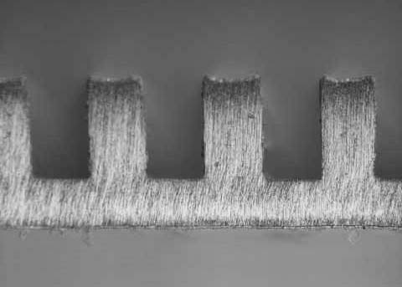
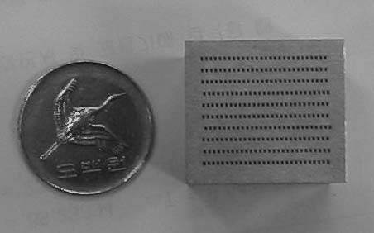

Figure 2. Processed metal plate : SUS 304 Figure 3. Photograph of a diffusion bonded
(Stainless steel). micro heat exchanger made of SUS 304.

Figure 4. The development of the mean log- Figure 5. The dependence of the thermal
arithmic differential temperature calculated power transfer Q on the water flow rate.
from the measured temperature versus the
water flow rate.

Figure 6. The coefficient k of heat transfer from water to water, calculated from the measured data as a function of the water flow rate.

