증류 단에서의 기-액 흐름 거동에 관한 수식적 연구

Valery A. Danilov, 문일†
연세대학교 화학공학과

Numerical Study of Flow Patterns in Gas -Liquid Stream on a Tray

Valery A. Danilov and Il Moon†
Department of Chemical Engineering, Yonsei University,

1. Introduction
Tray columns are widely used in chemical industry and description of hydrodynamics of two phase flow on a tray is of great importance. As is known, Computational Fluid Dynamics (CFD) can be used for solving a wide range of fluid flow problems and applications. There are various approaches to modeling transfer processes in two-phase flow. Most commonly used for gas liquid stream modelling is the two fluid model. Complication of the problem is of necessity for closure of mathematical model by the definition of the coefficients of turbulent exchange and transfer in phases. Considerable progress has been made in CFD modelling of gas-liquid flows in bubble column.

2.Model Formulation
It is suggested a mathematical model of hydrodynamics of gas liquid flow on a tray of column. The description of transfer processes in gas – liquid stream is based on two fluid model. To simplify a model the uniform distribution of disperse (gas) phase in steady state two phase flow is accepted ($ϕ=\text{const}$). Foam regime of a tray is characterized by well-developed turbulence in liquid phase, which results in full mixing throughout the height of liquid layer ($\frac{∂u_{l}}{∂z}=0, \frac{∂v_{l}}{∂z}=0, \frac{∂w_{l}}{∂z}=0, \frac{∂C_{l}}{∂z}=0$). In the bulk of liquid phase the isotropic turbulence is accepted ($ν_{T,L}=\text{const}$).

Taking into consideration the accepted presumptions momentum and continuity equations for the liquid phase are written in two-dimensional form as:
$u_{L}\frac{∂u_{L}}{∂x}+v_{L}\frac{∂u_{L}}{∂y}=\frac{1}{ρ_{L}}\frac{∂P}{∂x}+\frac{∂}{∂x}\left[\left(ν_{L}+ν_{\text{TL}}\right)\frac{∂u_{L}}{∂x}\right]+\frac{∂}{∂y}\left[\left(ν_{L}+ν_{\text{TL}}\right)\frac{∂u_{L}}{∂y}\right]+\frac{r_{\text{px}}}{ρ_{L}(1−ϕ)}$ (1)
$u_{L}\frac{∂v_{L}}{∂x}+v_{L}\frac{∂v_{L}}{∂y}=\frac{1}{ρ_{L}}\frac{∂P}{∂y}+\frac{∂}{∂x}\left[\left(ν_{L}+ν_{\text{TL}}\right)\frac{∂v_{L}}{∂x}\right]+\frac{∂}{∂y}\left[\left(ν_{L}+ν_{\text{TL}}\right)\frac{∂v_{L}}{∂y}\right]+\frac{r_{\text{py}}}{ρ_{L}(1−ϕ)}$ (2)
$\frac{∂u_{L}}{∂x}+\frac{∂v_{L}}{∂y}=\frac{r_{v}}{ρ_{L}(1−ϕ)}$ (3)
where $u_{L}$, $v_{L}$ - longitudinal and transversal velocity of liquid; P – pressure; x, y - longitudinal and transversal co-ordinate; $ν_{L}$ - kinematic viscosity; $ν_{\text{LT}}$ - turbulence viscosity; $r_{v}$ – total mass source; r_{p} – momentum source term; $ρ_{L}$- density of liquid; $ϕ$ - gas phase volume fraction.

Equation of tracer mass conservation is
$\frac{∂C_{L}}{∂t}+u_{L}\frac{∂C_{L}}{∂x}+v_{L}\frac{∂C_{L}}{∂y}=D_{T,L}\left(\frac{∂^{2}C_{L}}{∂x^{2}}+\frac{∂^{2}C_{L}}{∂y^{2}}\right)$ (4)
where $C_{L}$– mass fraction of tracer in continuous phase; $D_{T,L}$ – coefficient of component turbulence transfer; $t$ - time.

Peculiarity of two-phase motion is cross current of vapor and liquid on a tray. Since $j$=cost and gas velocity in two phase flow is greater then liquid one, therefore momentum sources in equations (1), (2) are equal to zero $r_{\text{px}}=0, r_{\text{py}}=0$.

Definition of turbulent viscosity coefficient allows us to close the set of equations (1) – (4), which describes the fields of velocity, pressure and tracer concentration in continuous phases. The coefficient of turbulent viscosity $ν_{T}$ can be calculated by Laptev’s model. Applying approximate equality ${\text{Sc}}_{t}≈1$ in the bulk of liquid phase we have $ν_{t,l}≈D_{t,l}$. Minimum of experimental data, which is required for flow patterns calculation, includes hydraulic test results of a tray (clear liquid height, pressure drop).
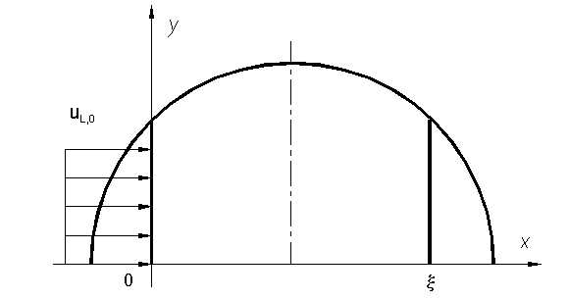Fig 1. Two dimensional model of a tray. ($ξ$-liquid flow path)

Boundary conditions for continuous phase are set at the inlet and outlet on a tray with a no slip condition at the wall. The fields are symmetrical concerning OX axe. Initial condition for tracer concentration is set for pulse tracer injection at the inlet using δ - function of Dirack.

3. Results and Discussion
Commercial CFD package FLOW-3D was used to solve the equations of continuity, momentum and tracer concentration for liquid phase. FLOW-3D uses the well established finite difference method, based on the SOLA-VOF algorithms, to solve fluid flow problems. The SOLA algorithm involves three steps; first from the velocity equations a new time step velocity field is estimated, second, velocity and pressure values are updated simultaneously through iterative adjustment, and third, SOLA updates all remaining scalar variables.

The calculated field of velocity in liquid phase is given in Fig.2. A tray with a diameter of 30.2 centimeters is chosen for presentation. Liquid enters the tray at a uniform velocity of 0.15 m/s. With a specified turbulence viscosity of 4.52 10⁻³ m²/s. The chosen mesh employs 40 cells across the tray and 20 cells along the liquid flow length.

When FLOW-3D is executed a time marching analysis takes place. The step size is reduced until it is small enough to allow a stable time solution. A solution to the equations of hydrodynamics requires an iterative process. The FLOW-3D solver works on a time marching technique. The user specifies the total time the fluid will flow and the intervals in which data is to be printed to the output file. From the initial boundary conditions, FLOW-3D reduces the computational time step to a value for which a converged solution is reached. This value is typically very small and many computational time steps are usually needed to produce one file output step. The resulting flow is then analyzed until the specified time of fluid flow has been reached.

As is obvious from Fig.2, complex liquid motion on the tray leads to appearance of secondary flows near the wall. RTD and coefficient of axial dispersion were calculated for various types of trays from the numerical flow patterns simulation. Calculated RTD curve for pulse tracer injection in liquid phase at the inlet is given in Fig.3 and it corresponds to velocity profile in Fig.2. To validate the model, simulation results were compared with experimental data from literature. Obtained data on axial dispersion coefficient were generalized by criterial equation. Numerical study of flow patterns allows us to transfer from two-dimensional model of hydrodynamics to one dimensional diffusion model of flow structure. Application of diffusion model for separation processes calculation on a tray has been shown by Alexanrov.

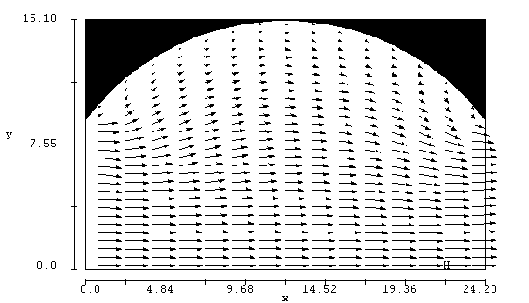
Fig.2. The liquid velocity vector plot on the sieve tray.
Mixture N-Hexane Ethanol MthCyclopentane Benzene.
(liquid phase density 685.71 kg/m³ ; liquid flow rate 913.74 kg/h; vapor flow rate 277.99 kg/h; tray diameter 30.2 centimeters; clear liquid height 0.016 m ;$ν_{T}$ = 4.52 10⁻³ m/s²).

4. Conclusion

A two dimensional model of hydrodynamics of gas liquid stream on a tray has been presented. The simulations were carried out using commercial CFD package FLOW-3D. From numerical study of flow patterns RTD and axial dispersion coefficient for liquid phase were obtained.

Acknowledgements
This work was supported by grant No. R01-2001-00409 from Korean Science & Engineering Foundation.

Fig.3. RTD curve for sieve tray.
(Pe = 14.13; coefficient of axial dispersion 2.7 10⁻³ m²/s; liquid flow rate 913.74 kg/h; vapor flow rate 277.99 kg/h; column diameter 30.2 centimeters; clear liquid height 0.016 m).

References
- Hewitt, G.F. et al., Multiphase science and technology., Washington-N.J.-London, Hemisphere Publishing Corporation, 1987
- Van Baten J.M., Krishna R. Chem. Eng. J, 77, p.143-152, 2000
- Dyakonov S.G., Elizarov V.I., Laptev A.G. Theoretical Foundation of Chemical Engineering, 27, p38-47, 1993.
- Deen N.G., Solberg T., Hjertager B.H. 14th Int. Congr. of Chem. and Process Eng.- Praha, Aug.- 27-13., p.1-18, 2000.
- Alexandrov I.A. Mass Transfer on rectification and absorption of multicomponent mixtures. Moscow, Khimia, 1975. (in Russian)
- Grevskott S., Sannes B.H. Chem. Eng. Sci. , 51, p.1703-1713, 1996.

