셀프어셈블 유기초분자재료의 나노구조

정희태* , 김상욱*, 윤동기, 고영관, S.D. Hudson**
*한국과학기술원 화학공학과, **Dept. of Macromolecular Sci. & Eng. Case Western Reserve Univ.

Nanostructure of Supramolecular Self-Assembled Liquid Crystals

Hee-Tae Jung*, S. O. Kim*, D. K. Yoon, Y. K. Ko and S. D. Hudson**
*Dept. of Chemical Engineering, Korea Advanced Institute of Science and Technology,
e-mail: heetae@kaist.ac.kr, Tel: +82-42-869-3931, Fax: +82-42-869-3910
**Dept. of Macromolecular Science & Engineering, Case Western Reserve Uiversity

1. INTRODUCTION
New types of amphiphilic molecules have been synthesized which are structurally intermediate between the above well-established structure. These molecules form thermotropic mesophases but their structural elements are no longer individual molecules but assemblies of molecules. The shape of the molecules and micro-phase separation between the rigid core and the liquid aliphatic chains affect the phase symmetry and properties of the material. Therefore, depending on the temperature, smectic, columnar and also cubic mesophases could be formed, and their polymorphism is comparable to the rich polymorphism of lyotropic mesophases. Thus it has been stated that the same physical concepts may apply to the organization of molecules in thermotropic and lyotropic mesophases, and amphiphilicity was used to rationalize the formation of cubic and columnar liquid crystalline phases in rod-like and discotic mesogens as well as for block copolymers. [1-2]
The present work concern effects of chemical architectures on mesophase properties by TEM. Alignment of the columns are examined by surface condition, and compare with different molecular architectures. We show direct visual evidence of the phase symmetry, dimension and stability of hexagonal columnar and cubic packing, and investigate defects which occur in the system.

2. EXPERIMENTAL SECTION
Different molecular groups have been employed to investigate the ability of the structure units to self assemble by combination of the groups. Orientation of hexagonal columnar mesophases was controlled in thin films by surface anchoring conditions. For planar alignment of the columnar materials, the thin films suitable for electron microscopy examination were cast from solution (~0.5wt%) onto distilled water (or glycerin), held at temperature at which the columnar phase is stable, and retrieved on copper grid. Homeotropically aligned columnar specimens were obtained by annealing thin films supported on carbon. Casted thin films were placed on copper grids, coated with carbon, heated to the isotropic phase and cooled (at the ratio of 5ºC/min to a particular temperature, before final quenching). The films (either by casting or melt-shearing) were then mounted on Cu screening, and these were then given the desired thermal history before TEM observation. Bright field transmission electron micrographs were provided by staining with RuO₄ vapors (solutions of 0.5wt% aqueous RuO₄). [3]

3. RESULTS & DISCUSSION
Phase identification was clearly proved by controlling orientation of columns, and examined by TEM. Depending on the chemical architecture of the components, different molecular association were observed. TEM micrograph of 1 prepared by solution-casted thin films, present end (Fig. 1a) and side view (Fig. 1b) of the columnar assemblies. For homeotropically aligned thin film (Fig. 1a) in which the column axis is perpendicular to the film surface, a thin film was heated from isotropic to φ_{h} on a carbon substrate. The images show regular lattice symmetry with alternating bright and dark regions. Staining is found to enhance image contrast and to increase the beam resistance of these specimens. A hexagonal columnar structure is identified by the hexagon pattern that is evident in the image. There is a high degree of perfection in the packing of cylinder, in which cylindrical moieties are packed on hexagonal lattice showing six-fold symmetry (Fig. 1a). ED patterns (inset) corresponding to the image further support φ_{h,} which exhibit six sharp reflections in the small angle region. At wide angle, only a diffuse scattering is observed, indicating that the structure at the atomic level is disordered. The column diameter and Bragg spacing were determined from direct visualization of image as well as ED (d-spacings by ED was determined by calibrating standard Au crystal). Side view of the columns exhibit that the columns are coherently aligned, are elongated along the column axis (Fig. 1b). The image represents a projection through a film having a thickness equal to approximately 15 column diameter (diameter, a=49Å). And, hexagonal packing within the planar specimen was confirmed by examination of the (1210) projection upon tilting the specimen 30º above the cylinder axis, representing another identification of the hexagonal columnar mesophase. Similar images were obtained for all materials investigated, on carbon (homeotropic) and water (planar texture) surfaces [4].

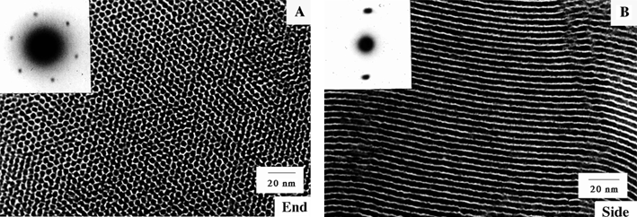
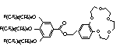
Fig. 1 Chemical structure and TEM micrographs of: a) homeotropically and b) planar aligned Φ_{h} LC assembly generated by supramolecular cylinders self-assembled from 1. Insets are electron diffraction patterns obtained from these specimens.

The phase of the other compound was clearly identified by electron microscopy (Fig. 2). Previous study by x-ray scattering determined the space group to be Pm3n from the spacing ratio and the conditions of the observed low-angle reflections for the compounds. The observed reflections (110, 200, 210, 211, 220, 310, 320, 321, 400) and the absence of reflections (111, 113, 221) is consistent with the rule of the space group Pm3n. The structure of the cubic phase was performed by calculating the electron density of the unit cell using the observed diffraction, based on assumption of the phase separation between aromatic and aliphatic moieties. However, two structures compatible with this symmetry have been considered, which are crystallographic identical. A cubic structure is suggested by the square pattern that is evident in the image. ED further supports cubic structure showing the dimension (a = 87.3Å at 58ºC) which is consistent with XRD [5]. The [001] zone axis is typically perpendicular to the film surface, and the ED pattern shown in Fig. 2 [containing the (200) and (210) reflections], is obtained at normal beam incidence. In addition, the following low angle reflections in the [001] zone are observed: (400), (320), (220) and (310), listed in order of decreasing intensity. At wide angles, a diffuse ring is observed, centered at 4.6Å, indicating that the structure at the atomic level is disordered. The (211) reflection, which is strong and of comparable intensity to the (200) and (210) reflections, can be observed as expected, if the specimen is tilted 27º or 45º about the [100] axis. On further cooling (0.1ºC/min) from the cubic mesophase, the compounds exhibit a crystalline phase that is characterized by a set of small angles (s~55Å) as before and six new sharp reflections at wide angle (Fig. 2). Same reflections with cubic mesophase are observed on small angles indicating long-range, three dimensional cubic ordering, but the presence of sharp reflections in wide angle suggest crystalline ordering with in the cubic structure, i.e., ordered state of the hydrocarbon chains.
The power spectrum (that is the Fourier transform multiplied by its complex conjugate, reproduces the ED pattern. Each of the six reflections of the [001] zone observed by ED are present in the power spectrum, yet because the defocus was selected for high resolution, the relative intensity of the (400) reflection, for example, is enhanced. The (100) and (300) reflections are absent, as expected. Also absent is the (110) reflection which, though an allowed reflection for the Pm3n space group, was only very weakly detected by XRD. From analysis of the diffuse background, the resolution of the image is calculated to be 20Å and the circular symmetry of the background indicates that no astigmatism is present.

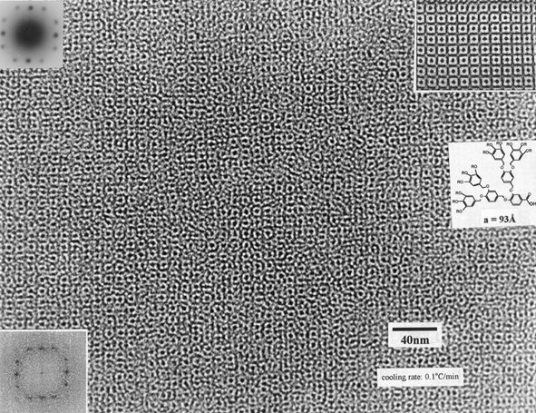
Figure 2. Chemical structure and TEM micrographs of the Pm3n Cub LC phase of the supramolecular dendrimer Insets are electron diffraction patterns obtained from these specimens.

Since the above reflections are present in the power spectrum, and because their phases are preserved in the TEM image, the structure can be determined directly by comparison of the image with projections from the two rival models, shown schematically in Fig. 2. The [001] projection of each contains two sets of perpendicular dark lines. At their intersection, the columnar model produces a dark spot, whereas the spherical model produces a white one, it becomes more clear through the use of Fourier filtering, an averaging technique. The Fourier transform is filtered by setting the transform to zero everywhere except in the neighborhood of these diffraction peaks. If the neighborhood is chosen to be narrow, then the averaging is extensive, whereas is the neighborhood centered on each, having a diameter of 0.003 Å⁻¹ was used. The extent of averaging is therefore approximately 4 x 4 unit cells. The bright spot at the intersection of the dark lines can now be observed easily. This provides definitive confirmation for the spherical model. The most common defects observed in the cubic phase of the specimen are partial dislocations and grain boundaries comprising arrays of such dislocations. These defects are also consistent with the spherical model.

4. CONCLUSIONS
The micro-structure and morphology of various amphiphilic and dendrimeric liquid crystalline materials are studied, based on investigation of textures and defects using high resolution electron microscopy and diffraction (ED + XRD) methods. The phase symmetry, dimension and local structure of the amphiphilic and dendrimeric molecules have been clearly determined by controlling the orientation of the columnar mesophase by surface condition, so that both homeotropic and planar ordering of columns have been achieved. Low surface energy planes are identified through examination of the morphology of ultrathin films, which contain holes or terraces on a free surface. The stiffness of such columns could be evaluated, both quantitatively and qualitatively, based on examination of the planar texture, and of the defects contained therein. A cubic mesophase has been identified, and comprises spherical assemblies of dendrimeric molecules.

ACKNOWLEDGMENT
This work was supported by the KAIST, Center for Ultra-microchemical Process Systems and the Brain Korea 21 Project.
5. REFERENCES
[1] Larson, R.G. “The Structure and Rheology of Complex Fluids”, Oxford University Press, (1999).
[2] Tsukruk, V. V., “Assembly of supramolecular polymers in ultrathin films”
Prog. Polym. Sci. 22, 247 (1997).
[3] Hudson, S. D., Jung, H.-T., Percec, V., Cho, W.-D., Johansson G., Ungar, G.,
Balagurusamy, V. S. K., “Direct visualization of individual cylindrical and spherical supramolecular dendrimers”, Science, 278, 449 (1997).
[4] H.-T. Jung, S. O. Kim, Y. K. Ko and D. K. Yoon, S. D. Hudson, V. Percec, M. N. Holerca, W.-D. Cho and P. E. Mosier, “Surface Order in Thin Films of Self-Assembled Columnar Liquid Crystals”, Macromolecules, submitted.
[5] Balagurusamy, V.S.K, Ungar, G., Percec, V., Johansson, G., “Rational Design of the First Spherical Supramolecular Dendrimers Self-Organized in a Novel Thermotropic Cubic Liquid-Crystalline Phase and the Determination of Their Shape by X-ray Analysis”, J. Am. Chem. Soc., 119, 1539 (1997).

