자동차 실내공기 정화용 puri-filter의 성능 향상기술 개발 및 평가

나임 하솔리**, 박영옥*, 박석주*, 임정환*, 김상도*, 최호경*, 박현설*
*한국에너지기술연구원 집진기술연구센터
**독일 파다본대학 에너지환경연구소

Efficiency Evaluation and Development of Technology for Enhancing the Performance of
Puri-filter for Purifying the Car Cabin Air

Naim Hasolli**, Young-Ok Park*, Seok-Joo Park*, Jeong-Hwan Lim*,
Sang-Do Kim*, Ho-Kyung Choi*, Hyun-Seol Park*
*Particle Technology Research Center, Korea Institute of Energy Research, Daejeon, Korea
**University of Paderborn, Department of Mechanical Engineering,
Institute of Energy and Environmental Engineering, Paderborn, Germany

Introduction
Due to rapid deterioration of air quality following the industrialization and increase of number of vehicles in the recent few years there has been a raising interest regarding the car cabin air pollution matter. Consequently the related automobile enterprises are becoming more aware of the importance of research regarding the improvement of car cabin air quality.
The main cause generating such pollutants is the waste gas of the vehicle, but there are other known sources responsible for the deterioration of indoor air quality such as factories, urban city area, smoking inside the car and the interior cabin material.
The start of the product, which was applied at the beginning, is the passenger car dust removal filter produced in the late 80s in northern Europe. The application of this product was limited collection of pollen and dust. But, the interest shown regarding the vehicle indoor air pollution control and removal of material as the soot of diesel cars engine and other pollutant materials like SOx, NOx, ammonia and benzene as well as the dust particle rose with the necessity for their control. In Europe, the absorption filter system, which uses the active carbon was developed. As the filter technology was further developed and new demands were set on car production as well as introducing the new car types. A challenge was to be faced, concerning the removal of not only dust, but other chemical compounds, which are responsible for the indoor air quality deterioration, as to meet the very recent air quality standards as well.
Recent development mainly involving various chemical water absorber, the efficiency of the cabin filter came to be high very, also the price came to be low consequently about the quarter below the initially product. Recently in Europe the ratio of the vehicle, which are equipped with the filter goes over 90%. The ratio of the introduced filter, which introduces the duplex absorption material is about 50%

Testing Method and Standard
Testing apparatus used in this study was a testing chamber testing car. Testing chamber [Fig.2] was used first to evaluate the chamber conditions of the indoor air flow and the problems occurred by using this testing device were performed in real scale testing where the testing car was used. Inside chamber the gas was allowed to flow after it has been tightly closed. The activated carbon was used mainly for the removal of offensive odour material, specially there was an effect to the HC which is an important ingredient of offensive odour. The removal of offensive odour as small physical absorption, by a London-van der Waals force the element of offensive odour composing elements were collected in the surface of activated carbon. But the waste gas of the automobile back and the presence of SO₂and NO disregarded the activated carbon, which is used for the chemical control of the HC, also there was an effect from outside due to incomplete combustion of the fuel.
The standard regulation for the test performed for the aim of the removal of car indoor air pollutants are established in paper of the German Standard DIN in the year 1991 by German VDA (Society of the German Automotive Industry). The results of the test performed by the Institute of Toxicology and Aerosol Research of the Fraunhofer Gesellschaft has shown the electrostatic effect, which was later taken in consideration and completed in the Part 1 of official standard paper DIN 71460 in 1992. The final test standard regulation was set in the year 1994 by ISO /TR 11155-1 and later in the 1999 year paper ISO/CD TS 11155-1 and 2001 year paper ISO/PRF TS 11155-1 standard regarding the test method and test material regulations.

Numerical Analysis
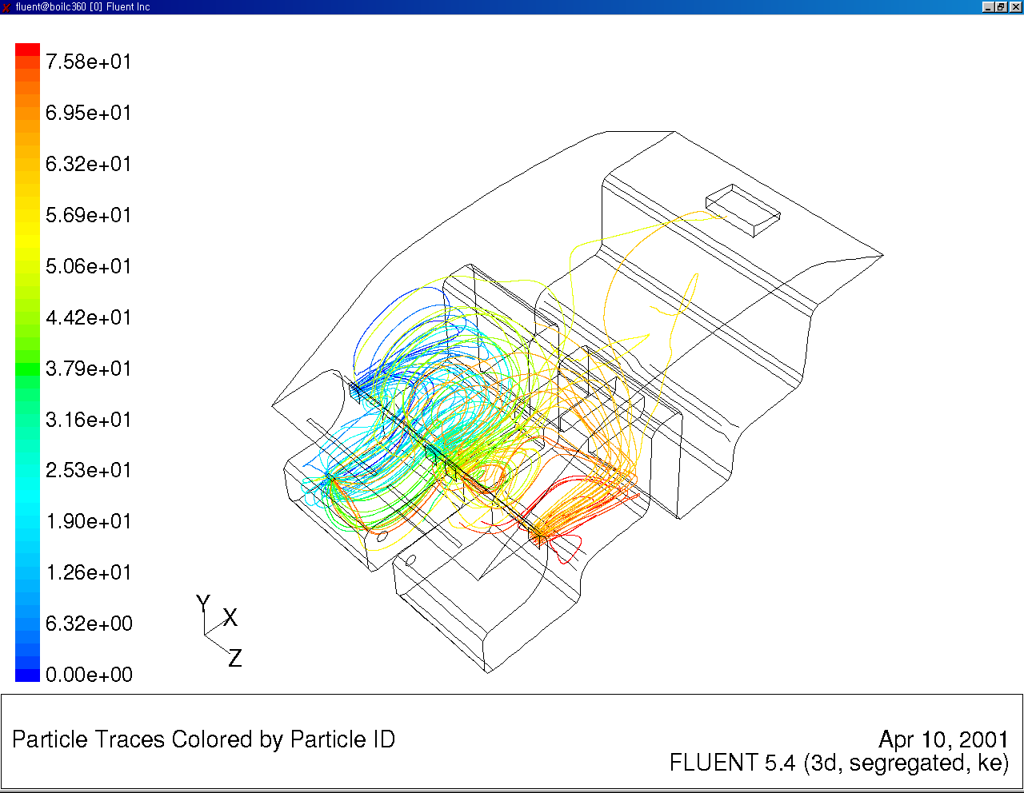
For the computer simulation of the test device Puri-Filter the program FLUENT v5 was
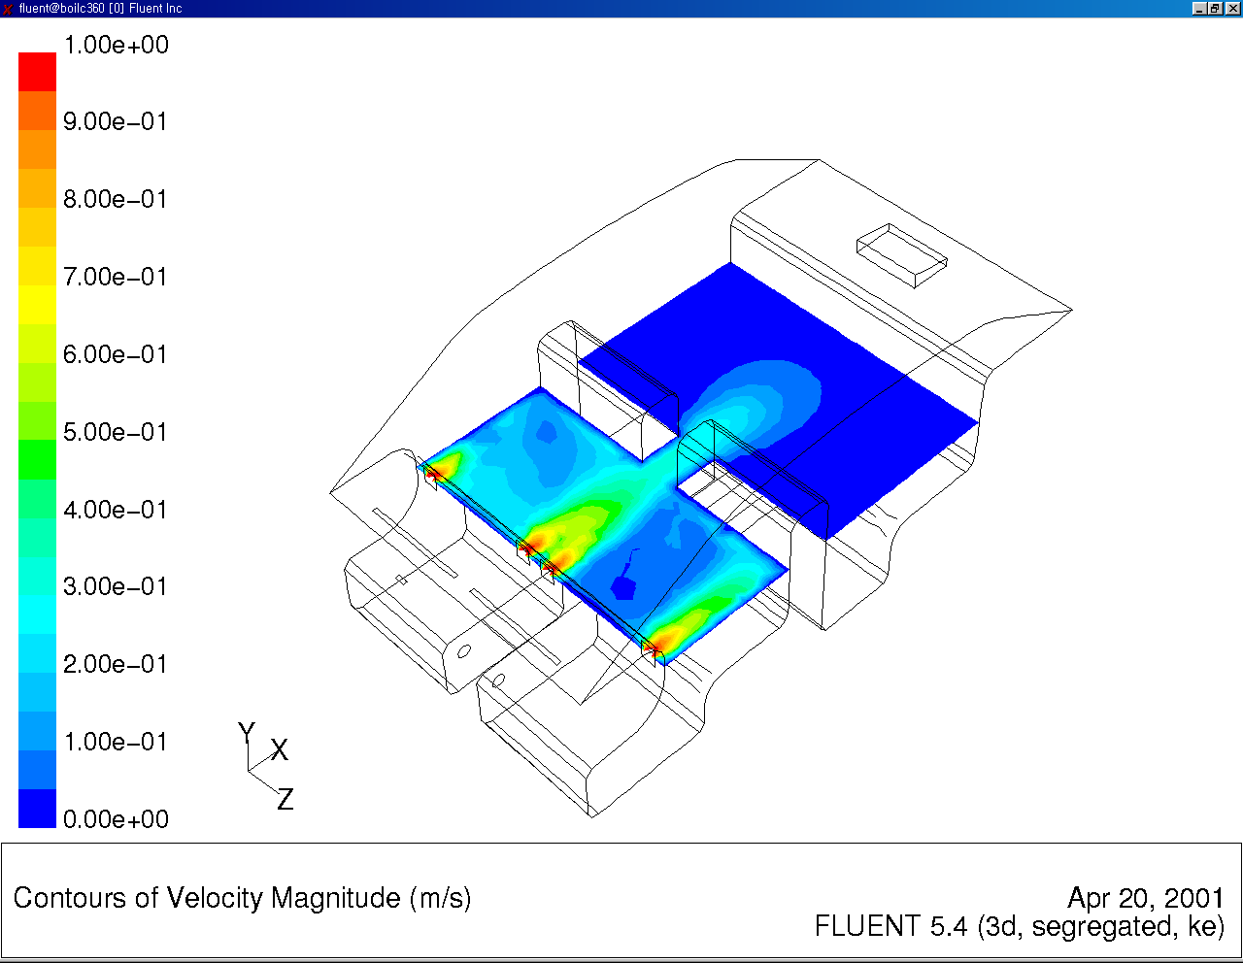 Warm current model Particle trajectory tracking model
Fig.1 Computer simulation models
used. Warm current model and Particle Trajectory Tracking model were used to show the efficiency of the collecting performance of Puri-Filter. The Lagrangian model of Particle Trajectory Tracking model which shows the motion and a particle flow track of continuous equation, momentum equation, energy equation, warm current kinetic energy equation, warm current dispersion equation and the incompressible normal flow equation were calculated. In order to predict the flow trajectory of particles the commercial program GAMBIT 1 was used based on the results of which the interior grid structure was designed for the performance of numerical analysis.

Test Apparatus
The first test was performed using the testing chamber made especially for the purpose of this test. The chamber [Fig.2] is made from the transparent plastic material and serves as the device to evaluate small scale testing conditions as well as to evaluate the performance technology of Puri-Filter. Problem that occurred in the chamber test later were tested in the testing vehicle, where various devices were used for the performance of the particle dispersion and composure. Indoor air circulation control device as well as other devices make the total system as a complete assembly called Puri-Filter. The filter is designed to be mounted in the back space of the car, behind the back seats [Fig.2]. Usually the test device is designed for the automatic regulation of the filtration velocity but for the purpose of this test the high speed filtration mode was chosen. The flow rate of the entering gas is controlled by a ball-type flow meter in order to maintain the constant gas flow. Particle distribution of gas is measured by Aerodynamic Particle Sizer.
As a testing car the new EF-Sonata Model made by Hyundai Company was used [Fig.2]
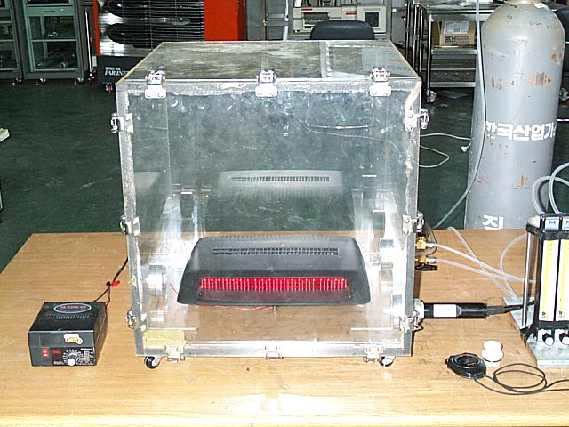

Fig.2 Test Chamber and Puri-Filter mounted inside the testing car

Conclusion
The Puri-Filter provides air purification device that reduces substantially the amount of specific major air pollutants found car cabin, thus increasing comfort in motor vehicles and provide better health environment for passengers. The apparatus is not added to the existing ventilation system but operates as independent control device, which operating at variable speed on 12 volts direct current. A principal object of this test was to enhance the performance of filtering system and thus to maintain vehicle cabin air free of harmful respirable particles, noxious and other gases, which present serious health risk.
After making a summary of the results from the test we can conclude that the device as tested here in this experiment has shown the possibility of its successful application. In order to evaluate the performance the numerical simulation as well as the test results has shown that the application of HVAC system for control of indoor air pollution and is able of keeping the pollutant quantity within the allowed boundary values. During the operation of the Puri-Filter there was testing of its efficiency running alone and at the same time with the already applied HVAC system together. The result has shown that the removal efficiency turn out to be very high if both systems are operating and the range of particles hazardous for human health was effectively removed.
Fig.3 Test results of removal efficiency

Bibliography

- S. J. Ilkla, V. Neveling, and Y. M. Tang, "Practical Aspects of Testing Gas Removal Filters for Cabin Air Filtration", SAE 940320(1994).
- B. McDonald, M. Gogins, J. Rothman, and J. Scott, "Discriminating Tests for Automobile Cabin Air Filter Media", SAE 970670(1997).
- S. Kalatoor, P. Legare, and S. Smith, "Filtration Efficiency of Automotive Cabin Air Filter Media Subjected to Different Aerosols Under Various Environmental Conditions", SAE 970669(1997).
- N. Lmaitre and Y. Godet, "In-Vehicle Adsorptive Filters Efficiency", SAE 970114(1997).
- U. Mohr and F. Rohde, "Cabin Air Filter with Activated Carbon", SAE 970672(1997).
- J. W. Cobes, III and D. T. Doughty, "The Use of Activated Carbon in Passenger Cabin Air Purification Systems"
- H. H. Bitterman, "History and World Wide Trends in Cabin Air Filter Testing", Fluid/Particle Separation Journal, Vol. 13, No. 2, August(2000).

