콜로이드 주형법을 이용한 광결정 물질의 제조

이기라, 양승만
한국과학기술원 화학공학과

Preparation of photonic crystals by colloidal templating

Gi-Ra Yi, Seung-Man Yang
Department of Chemical Engineering, Korea Advanced Institute of Science and Technology
373-1 Kusong-dong, Yusong-gu, Taejon 305-701 Korea

Introduction
Materials with a spatial periodic dielectric constant in nanometer scale are called photonic crystals or photonic band gap materials and have elicited much interest. [1] The main thrust of the intensive investigations stems from their wide variety of application areas ranging from microwave to optical devices. [2] Even with modern nanolithography, fabrication of nanostructured materials that are patterned and highly ordered in three dimensions remains a challenge. Self-assembly of colloids and emulsions with macrocrystalline structure has been explored as an alternative route to such intricate materials, which with long range periodicity at visible wavelength scales may have a photonic band gap. [3] Recently, inverted structures of self-assembly have been prepared by infiltration materials into self-organized templates and then removing the template (so-called templating method). [4]
Here, we present the simple way to produce the colloidal crystals of polystyrene beads that produced by emulsion polymerization and inverted structures from polymeric colloidal crystals by colloidal templating. In addition, optical properties of those self-assembly are predicted by numerical simulations and reported.

Numerical Simulations
In order to determine the photonic band structure of self-organized structures, we start with the wave equation satisfied by the magnetic field for a 3-D periodic array of scatterers.
$∇×\left(\frac{1}{ε(r)}∇×H(r)\right)={\left(\frac{ω}{c}\right)}^{2}H(r)$ (1)
where, $∇×H(r)=0$. The dielectric tensor $ε(r+R)=ε(r)$is periodic with respect to the set $R=\left\{n_{1}a_{1}+n_{2}a_{2}+n_{3}a_{3};(n_{3},n_{3},n_{3})∈Z^{3}\right\}$ of lattice vectors $R$generated by the primitive translation $a_{i},i=1,2,3$ that describe the structure of the photonic crystal.
Electric field can be computed from following, which is induced from Maxwell’s equation.
$E(r)=\left(\frac{−\text{ic}}{\text{ωε}(r)}\right)∇×H(r)$ (2)
We have computed the band structure and output fields for 3-D photonic crystals using MIT Photonic-Bands package. [5]

Experimentals
Monodisperse polystyrene latex particles were synthesized by emulsion polymerization, of which full detail was given in previous work [6]. In table 1, the relevant particle properties were detailed. Particle size and distribution were examined by scanning electron microscopy and photon correlation spectroscopy which has been carried out on the brookhaven system with BI200SM goniometer. Zeta potential of latices was measured from electrophoretic mobility by ZetaPlus (Brookhaven).
From monodisperse polystyrene suspensions, colloidal crystals were deposited by simple evaporation of water at 60 degree of Celsius. Then, chelated titanium precursor

Table 1. Recipes and particle characteristics for the latices used in this work
Sample | NaSS (g) | Monomer(g) | Size/Dist(DLS) | Size(SEM) | ζ (mV) | PH
A | 0.50 | 50 | 445nm/0.001 | 423nm | -28.5 | 4.25
B | 0.10 | 50 | 293nm/0.005 | 275nm | -37.5 | 4.20
C | 0.15 | 50 | 235nm/0.005 | 230nm | -39.3 | 4.27

solution (Tyzor GBO and TE, Dupont) was brought into the voids of the colloidal template. In about one day, titanium oxide and polystyrene were formed by sol-gel reaction in voids. Then, that composite was heated to 550 degree of Celsius in electric furnace.

Results and Discussions
With three kinds of polystyrene latices with different diameter, which could produced by controlling the functional comonomer in emulsion polymerization, polymeric colloids were deposited to make the colloidal crystals. As shown in figure 1, we have successfully produced the polymeric colloidal crystals with face-centered-cubic(FCC) lattice. Although it’s not certain since figure 1 is (111) plane of FCC lattice, we could be checked by cross section view in other SEM images of previous work.
From numerical simulation of colloidal crystals (ε=2.528) with FCC structure, we predicted the photonic band gap in [111] direction, which is indicated with black box between L and Gamma in figure 3. Dimensionless frequency range ($\text{ωa/2πc}$)of photonic band gap in [111] direction of FCC structure is 0.59-0.62, which corresponds to 964-1013nm, 627-659nm, and 524-551nm in each case of polymeric colloidal crystals named A, B, and C in figure 1. Theoretical prediction by simulation of Maxwell’s equations agreed reasonably well with experimental results shown in figure 2.
Finally, by colloidal templating, inverted opal structures have successfully produced as shown in figure 4. This order is clearly seen in Fourier-transforms of images (see inset in figure 4)

References
- Jacoby, M. Chem. Eng. News 1998, 76 (47), 38.
- Joannopoulos, J. D.; Meade, R. D.; Winn, J. N. Photonic crystals: Molding the flow of light; Princeton University Press: Princeton, 1995; Chapter 6.
- Van Blaaderen, A. MRS Bull. 1998, 23(10), 39.
- Yi, G.-R.; Yang, S.-M. Chem. Meter. 1999, 11, 2322.
- Available at ab-initio.mit.edu/mpb/.
- Yi, G.-R.; Yang, S.-M. The 12th symposium on Chemical Eng. Taejon/Chungnam-Kyushu 1999, 137.

Figure 1. SEM images of colloidal crystals with different diameter produced by evaporation.

C

B

A
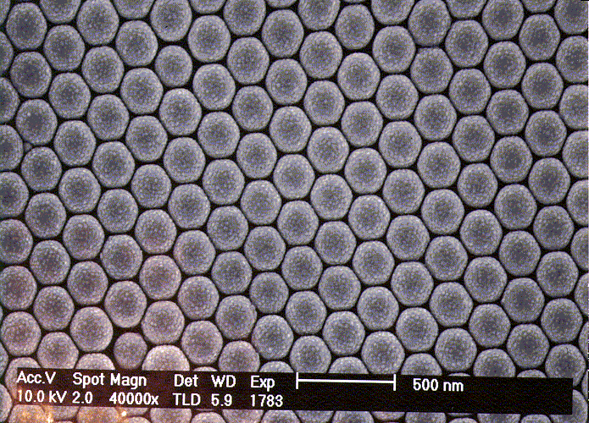
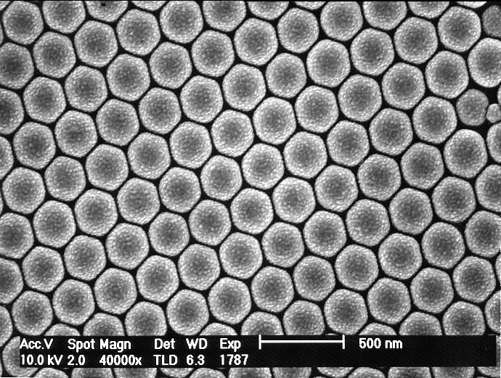
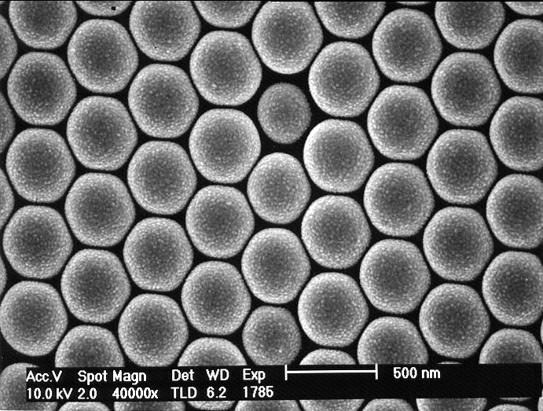
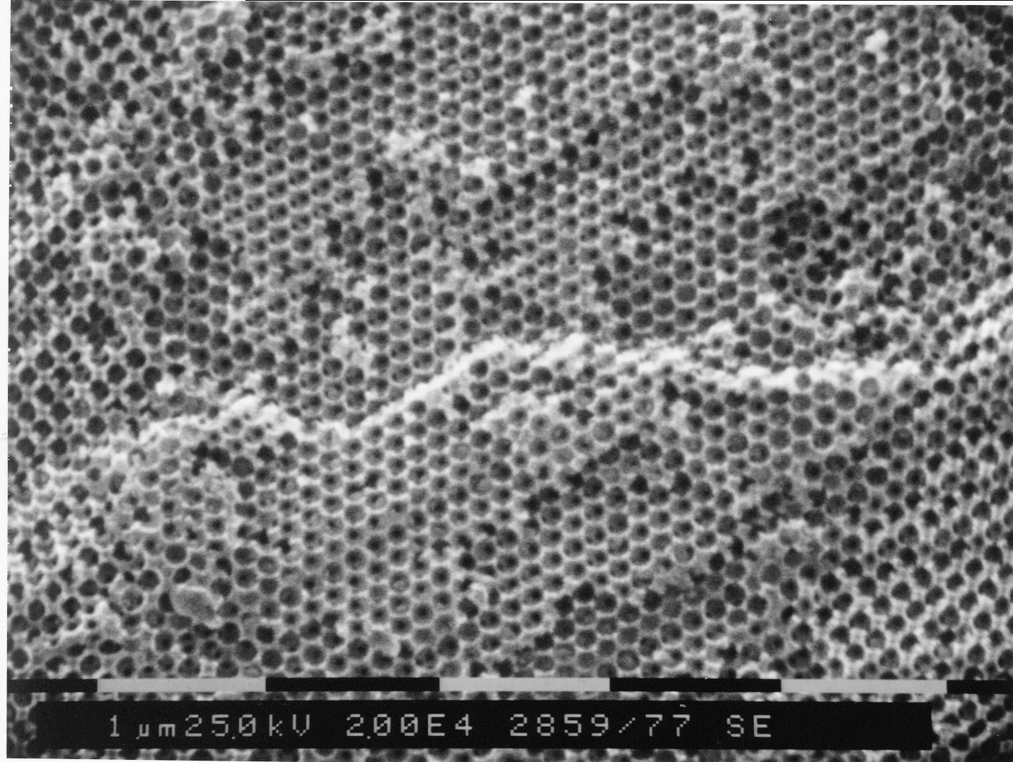
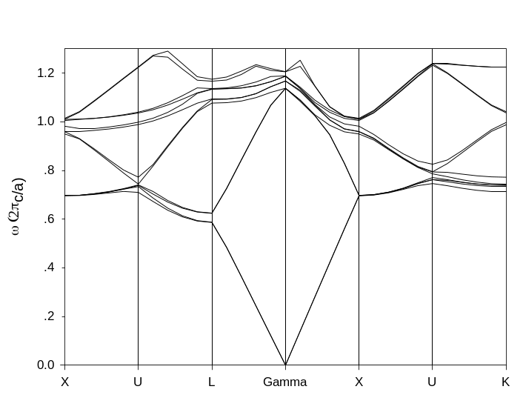
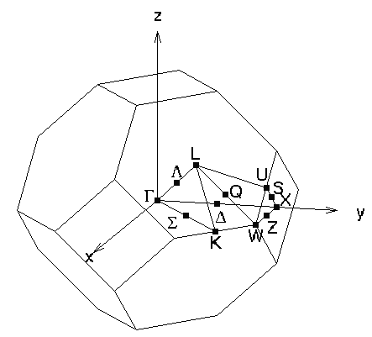
Figure 2. Reflectivity of polymeric colloidal crystals
A
B
C
Figure 3. Photonic band structure of PS spheres Figure 4. Inverted opal structure produced
in air with fcc lattice by colloidal templating

