Quinoline + TFE 계의 열용량 및 증기압 측정

이 종원, 박 성범, 이 흔
한국과학기술원 화학공학과

Heat Capacity and Vapor Pressure of Quinoline + TFE

Jong-won Lee, Sung-bum Park, Huen Lee
Department of Chemical Engineering, KAIST

Introduction
A working fluid for the absorption heat pump consists of two substances, refrigerant and absorbent. The refrigerant does remove the heat of surrounding by phase transition and the absorbent circulates the refrigerant by continuous process of absorption and desorption. Practical combinations of this pair require that large quantities of one should be easily absorbed into the other. So far, the conventional salt/water solution has been used. However, they were found to be unsatisfactory because of their easily crystallizing and highly corrosive characteristics. Thus, it was necessary to search for new working fluids. The other alternative, a possibility of organic chemicals is reported by Girsberger, 1981, Mashimo et al., 1989 and Kashiwagi, 1990. These reports encouraged further research in organic working fluids.⁽³⁾
The most important criteria for a working fluid are thermal and chemical stability and large solubility of the refrigerant in the absorbent. The molecular basis for good solubility and thermal stability can be found with fluoridized alcohols. Based on this idea TFE was chosen for the promising refrigerant. The properties of the fluoroalcohols and their mixtures with other compounds are related to the hydrogen bonding properties of the alcohols. These substances have the activated hydrogen atom of their hydroxyl group available for interaction with a proton acceptor. The suitable absorbent therefore must be an electron donor that can achieve effective hydrogen bonds with a center of high electron density.^{(1,2)}
In our laboratory, TFE + quinoline system was chosen for the new organic working fluid because of its high boiling point difference and large bipolar moment. And to check the validity of a possible working fluid, we measured major properties of the system including heat capacity and vapor pressure, which are needed for the optimum design of air-cooled absorption chiller.

Experimental Section
The heat capacity and vapor pressure measurements have the accuracy of maximum ±1.5%, which were examined in the previous works done with the same experimental apparatuses.^{(6,7,8)}
The vapor pressures were measured by a boiling point method Figure 1 also shows the diagram of apparatus for measuring the vapor pressure. The apparatus primarily consisted of an equilibrium vessel with an internal volume of 500 cm³, a constant temperature bath, a condenser, a U-tube mercury manometer capable of reading to 0.05 mm, a K-type thermocouple with the accuracy of ± 0.4% of reading, and two stirrers. A sample solution was initially prepared to the desired absorbent concentration and placed in the vessel with an approximate volume of 250 cm³. The entire apparatus was evacuated to a proper degree of pressure after charging the solution. This sample solution was then heated and stirred well with a magnetic stirrer to prevent superheating. After thermal equilibrium reached, the temperature of the sample solution and the corresponding pressure were measured.
An isoperibol solution calorimeter (CSC4300) was used to measure the heat capacities of absorbent solutions. The temperature resolution of the calorimeter was 2 μK, the temperature noise level ± 30 μK, and the bath temperature stability ± 0.0005 K. For the measurement of heat capacity, accurately weighed sample solution (approximate volume of 25 cm³) of a desired concentration was placed into the Dewar vessel. The thermistor, calibration heater, and stirring rod were immersed when the vessel was clamped on the isoperibol solution calorimeter. The stirrer and heater were then turned on to heat up the sample solution to slightly lower temperature than the desired one. After 300 seconds passed from that point, an actual measuring process including 200 seconds of holding time without heating, 400 seconds of heating, and 200 seconds of holding time began. The accurate value of the added heat in the heating process was calculated through measuring the current and voltage values with a built-in digital voltmeter. All the measuring procedures were completely controlled by a computer, and the calculated temperature difference was used to obtain the heat capacity of the sample solution through the following equation.
$Q = ({\text{mC}}_{p}+ε) ΔT$ (1)
where Q is the total amount of heat added, m the mass of the sample solution, C_{p} the heat capacity of the sample, ε the heat capacity of the apparatus including Dewar vessel, stirring rod, heater, and thermistor. The value of ε was calculated by the experimental result using water as a reference solution and its known heat capacity value at each temperature.

Results and Discussion
Vapor pressures were measured in the various temperature and concentration ranges 0.0 to 100.0 mass %. The measured results are plotted and regressed as a common linear relationship between log P and 1000/(T-43.15) at a given concentration over the entire temperature range.⁽⁶⁾
$\text{log}P = \sum_{i=0}^{3}{[A_{i}+\text{1000}{B_{i}}/(T−\text{43}\text{.}\text{15})]X^{i}}$ (2)
Heat capacities were measured at various temperatures and for the absorbent concentration range of 0.0 to 100.0 mass %. The measured data set was fitted by following simple polynomial equation.⁽⁸⁾ Figure 3 shows a typical resulting graph of the heat capacity measurement. The heat capacity of a sample can be obtained from the slope of this figure.
$C_{p} = \sum_{i=0}^{3}{(A_{i}+B_{i}T)X^{i}}$ (3)
In order to easily extend the enthalpy calculation to higher temperature region, a first order polynomial along temperature was selected for enthalpy regression. The experimental results show that the solution heat capacity decreases with increasing the absorbent (quinoline) concentration due to the amount of quinoline. Also the heat capacity of solution increases as temperature increases.

Conclusion
The heat capacity and vapor pressure of quinoline + TFE system were measured at various temperature and concentration ranges. Also, these results were successfully regressed with common polynomial equation. A general procedure of checking the validity of a possible working fluid includes the measurements of various thermodynamic properties of the solution. The investigation of operation range, cycle simulation, and optimum design of the heat pump thus come to be possible with those properties. The six major properties of solubility, vapor pressure, heat capacity, differential heat of dilution, density, and viscosity needed for the optimum design of air-cooled absorption chiller were needed for a newly proposed working fluid. For a first step of validating a new organic working fluid, quinoline + TFE, we measured the heat capacity and vapor pressure of the system. To simulate the heat pump cycle, the remaining properties were needed, so they will be measured and used to get a simulation result of a theoretical operation.

References
1. Nowaczyk, U.; Steimle, F., Thermophysical Properties of New Working Fluid Systems for Absorption Processes, Int. J. Refrig., 1992, 15, 10-15.
2. Coronas, A.; Valles, M.; Chaudhari, S.K.; Patil, K.R., Absorption Heat Pump with the TFE-TEGDME and TFE-H₂O-TEGDME Systems, Applied Thermal Engineering, 1996, 16, 335-345.
3. Ishikawa, M.; Kayanuma, H.; Isshiki, N., Absorption Heat Pump Using New Organic Working Fluids, Proc. Of the Int. Sorption Heat Pump Conf., Munich, Germany, 1999.
4. Iyoki, S.; Ohmori, S.; Uemura, T., Heat Capacities of the Water-Lithium Bromide-Lithium Iodide System, J. Chem. Eng. Data, 1990, 35, 317.
5. Iyoki, S.; Yamanaka, R.; Uemura, T., Physical and Thermal Properties of the Water-Lithium Bromide-Lithium Nitrate System, Int. J. Refrig., 1993, 16, 191
6. Kim, J.S.; Park, Y.; Lee, H., Solubilities and Vapor Pressures of the Water + Lithium Bromide + Ethanolamine System, J. Chem. Eng. Data, 1996, 41, 279
7. Park, Y.; Kim, J.S.; Lee, H., Physical Properties of the Lithium Bromide + 1,3-Propanediol + Water System, Int. J. Refrig., 1997, 20, 319
8. Park, Y.; Kim, J.S.; Lee, H., Thermodynamic Properties of the Lithium Bromide + Diethanolamine + Water System, ASHRAE Trans. 1997, 103, 175

Figure 1.Experimental apparatus for measuring vapor pressure, 1: sample vessel, 2: condenser, 3: mercury manometer, 4: thermocouple, 5: bath, 6: vacuum pump, 7,8: stirrer, 9: circulator, 10: needle valve, 11: trap.

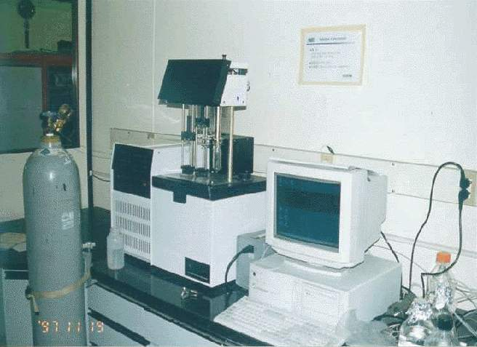
Figure 2. Isoperibol solution calorimeter (ISC) CSC4300.

Figure 3. Vapor Pressures of the LiBr + LiI + HO(CH₂)₃OH + H₂O (LiBr/LiI mole ratio = 4 and (LiBr+LiI)/HO(CH₂)₃OH mass ratio = 4) System: , 55.0 %; , 60.0 %; , 65.0 %; Ο, 70.0 %; , 75.0 %; △, 80 %; ⎯, calculated.

Figure 4. The resulting graph of the heat capacity measurement.

