실시간 근적외선 분광분석법을 활용한
상압증류공정의 온라인 최적화
김광은, 조인호, 박준구
SK 주식회사
Use of Real-Time NIR (Near-Infrared) Spectroscopy for the On-line Optimization of Crude Distillation Units
K.E.Kim, In-Ho Cho, Jun-Ku Park
SK Corporation, Ulsan, Korea

Introduction
Near-Infrared (NIR) Spectroscopy is a newly emerging and very powerful vibrational analytical technique. While the conventional analyzers in refinery require the analysis time of 20 to 180 minutes, NIR can provide highly accurate real-time analytical data in less than one minute. In addition, NIR is cost effective because multiple properties can be simultaneously measured using a single spectrum and it is also safe because the measurement instrument can be located away from hazardous environments using optical fibers. These advantages of NIR Spectroscopy make itself an efficient tool when combined with recent advanced process control or real-time optimization techniques. Since the first application of NIR to gasoline blending in 1993, SK corporation (formerly Yukong) has made an outstanding technology development for the application of NIR spectroscopy into various refinery and petrochemical processes such as Gasoline Blending, Diesel Blending, Crude Distillation, p-Xylene, Naphtha Cracking, Lube Base Oil, Solvent, etc.
In this paper, basic introduction to NIR Spectroscopy will be briefly given first and then the actual use of real-time NIR data for the improvement of APC and optimization will be discussed. In the discussion, new concepts of APC and On-line optimization using real-time NIR property data are introduced with the actual examples in SK’s plant sites.

NIR Spectroscopy

General Introduction to NIR Spectroscopy
Near-Infrared (NIR) spectroscopy is a vibrational analytical technique. The NIR frequency is located in a region between the visible mid-infrared (Mid-IR) and 780 to 2500 nm of electromagnetic spectrum. Absorption bands in the NIR region are related to the overtone and combination bands of fundamental vibrations of –CH, –NH, and –OH groups in the mid-infrared. Highly overlapping absorption peaks make spectra too complex to interpret qualitatively and the dramatic loss of sensitivity (low absorptivity) limits the qualitative analysis. NIR intensities are much weaker than Mid-IR intensities by a factor of 10 to 1000.
However, with advances in chemometrics NIR spectroscopy is emerging as a valuable analytical tool. At first, NIR spectroscopy was applied to the analysis of agricultural products. And its application has been expanded to the measurements in clinical chemistry and in the petrochemical, pharmaceutical and beverage industries. The most important advantage of NIR is that it provides highly precise real-time analytical data in less than one minute while the conventional analyzers in refinery requires 20 to 180 minutes of analysis time depending on the properties to be analyzed. This highly precise and fast NIR measurement can be efficiently combined with advanced process control and real-time optimization which is practically impossible with conventional analyzers. In addition, NIR is more practical for remote sensing and on-line measurement because NIR can be easily combined with fiber optic technology for the transmission of NIR radiation. Using optical fibers, the measurement instrumentation can be located away from hazardous, radioactive or explosive environments. Additionally multiple properties can be simultaneously measured by using only one spectrum. As a result, not only the efficiency of analysis is improved but also the investment cost for analyzer is greatly decreased.

NIR Spectroscopy in Crude Distillation Unit
The on-line property measurement of feed and product streams in Crude Distillation Unit (CDU) using NIR spectroscopy is much more difficult than any other clean and pure streams such as in petrochemical processes. Because the light transmittability of crude oil is very low due to its dark color, it is very difficult to obtain a clear NIR spectrum from a crude oil. And because there are too many sources of crude oils available around the world, the development of one robust method of NIR analysis is also very difficult. Besides the crude oils, the on-line analysis of product streams out of CDU has also many complications. During the crude distillation process water or chemicals should be inevitably added, and those added components work as impurities from the viewpoint of NIR spectroscopy. Those impurities make the NIR spectrum very poor and the correct property measurement becomes almost impossible.
After several years of efforts, SK has developed its own method to apply the NIR technology in real-time to CDU. Two most important factors for the success of the method are the performance of sample conditioning system and the precision of calibration model. These two factors cannot be satisfactory if not based on the deep process knowledge and the close communication between model developer and lab technician. Typical process streams in CDU and the available on-line NIR data are shown in Fig.1.
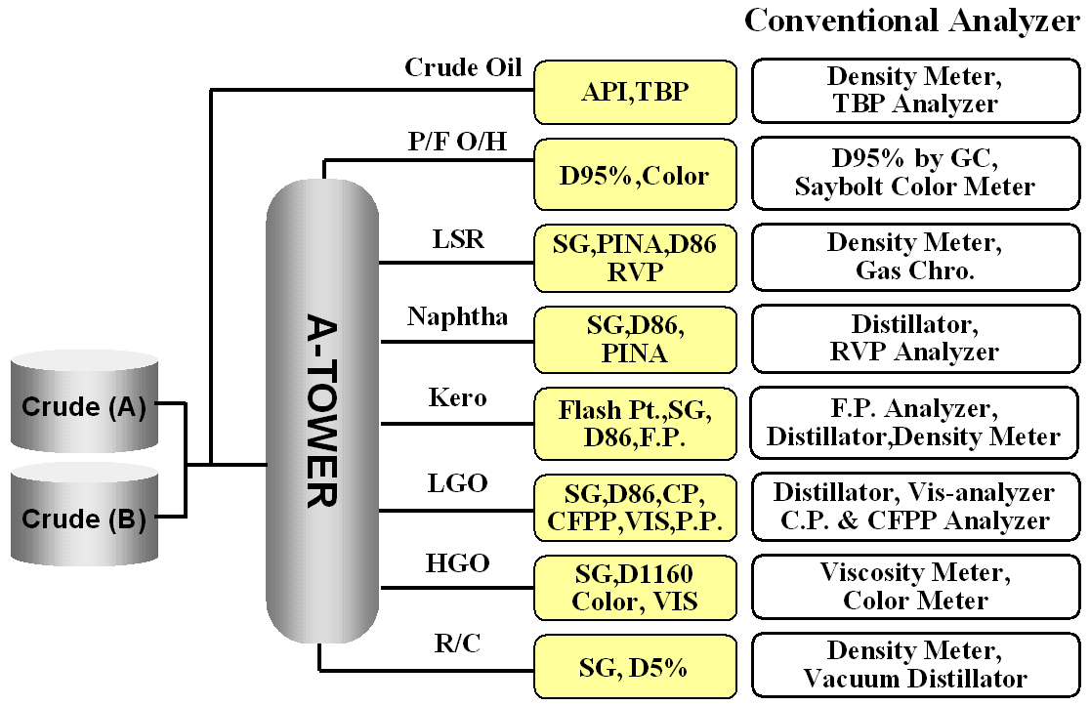
Fig.1. Required analysis for crude unit operation

On-line Application of NIR to Crude Distillation Unit
The improvement of CDU operation by using real-time NIR data can be explained straightforwardly if the limitations of conventional CDU operation are understood. Conceptual diagram of CDU operation with NIR is given in Fig.2.
First, if we can know in priori the optimal yields of each product to be produced corresponding to current crude being charged, neither too much product nor too small product would be drawn off, so that we can avoid the yield loss or the process instability during crude switching period. Graphical example of benefit during crude switch is given in Fig.3. And as can be easily seen without detailed explanation, very tight quality control of products also becomes possible by knowing the accurate property data of products in real time. These advantages of real-time NIR can be easily combined with existing APC by defining the crude NIR data as feed-forward variable and replacing the existing inferential model with the product NIR data even though a little tricky operation of raw NIR data is required before the actual use.
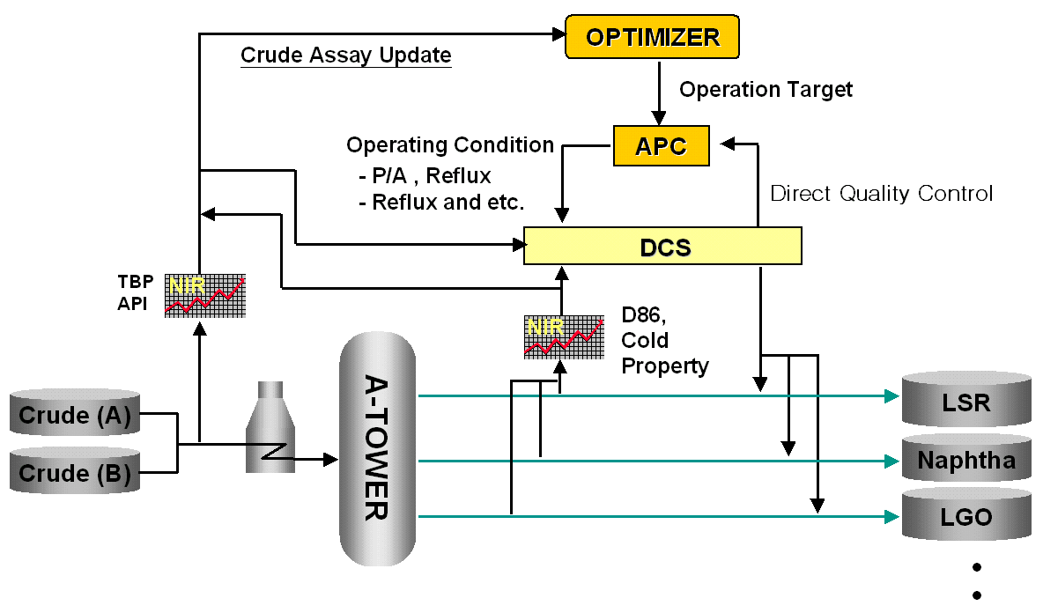
Fig.2. CDU operation with NIR
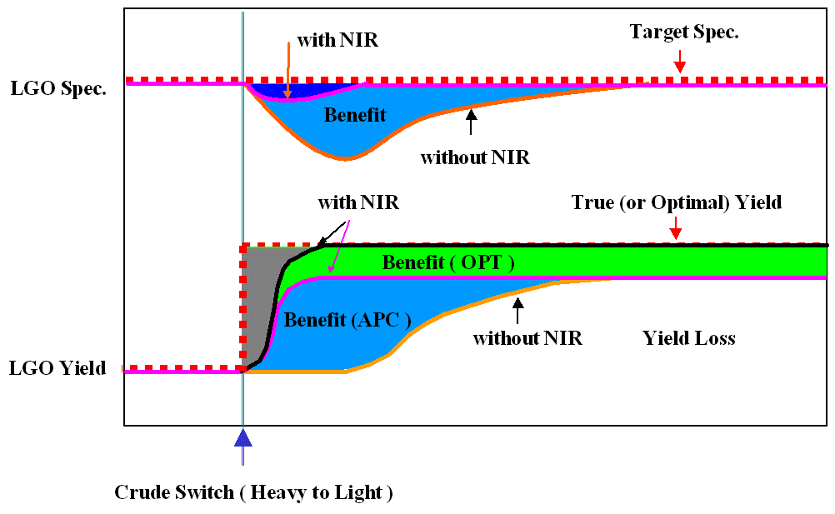
Fig.3. Benefits of APC & OPT with NIR during crude switch
Second, quality of optimization is improved drastically by using the property data of feed and products in real time. The current heat and material balance based optimization is upgraded to a quality (or property) based optimization. An example is a naphtha stream optimization. Even though the distillation cut points of two different naphthas are the same, the other properties such as PIONA may be different. If a naphtha is reach in aromatics content it is more economical to use the naphtha as a feedstock of an aromatics process instead of naphtha cracking process, and vice versa for the other case. The benefit which can be obtained by an optimal distribution of naphtha will be explained in the presentation. There may be many other examples for different products where we can extract more benefit by utilizing on-line property data such as freezing point and flash point of kerosene, cloud point or pour point of LGO and so on. An example of actual optimization result of SK #3 CDU plant is given in Table 1.

Table 1. Example of actual optimization result

Third, given the on-line NIR data the crude assay updating is improved and consequently performance of the other applications such as scheduling and planning can also be improved. Given more redundant measurements with property data, the data reconciliation and consequently the optimization become more reliable.
Finally, the on-line property data becomes a basis for an integrated optimization across refinery and petrochemical processes. As explained in the case of LSR/Naphtha optimization, the yield of petrochemical processes is significantly affected by the quality of feed stock coming from refinery side. Simultaneous optimization of crude column cut-points and the yield of petrochemical processes can only be achieved when reliable on-line property data is available.
It will be a stepping step toward a perfectly automated plant where only one watching dog and one person to feed the dog live.

