상압하에서 Quinoline + Trifluoroethanol 계의 기액상평형

김기섭 , 박성범 , 이종원, 이흔
한국과학기술원 화학공학과

Vapor-Liquid Equilibrium at normal pressure for Quinoline + Trifluoroethanol system

Ki-sub Kim, Sung-bum Park, Jong-won Lee and Huen Lee
Dept. of Chem. Eng. KAIST

1.Introduction
Until now, H₂O-LiBr and NH₃-H₂O have been the most widely used working pairs for absorption heat pump system. However, they still have some disadvantages which are corrosion and solubility problems for H₂O-LiBr and high working pressure and toxicity for NH₃-H₂O. The 2,2,2-trifluoroethanol(TFE) and quinoline system was chosen as a new working pair to overcome the known problems of H₂O-LiBr and NH₃-H₂O system. TFE acts as a refrigerant and quinoline does as an absorbent.
The most important criteria for an organic working pair are the thermal and chemical stability, large boiling points difference, and good solubility of refrigerant into the absorbent. It has been found that TFE has a good stability and solubility as a refrigerant in quinoline. Also the boiling point difference between TFE and quinoline is about 164K, which is sutible for organic pairs.
In order to optimally design an absorption heat pump and decide whether the TFE-quinoline system is suitable as the new working pair for absorption heat transformers or not, the density, viscosity and surface tension measuremests together with the solubility, thermal conductivity, vapor pressure and VLE data must be required. These properties were closely related to the performance of an absorption heat pump.
In our previous work, densities , viscosities and surface tensions of the quinoline + 2,2,2- TFE were measured. To add to these physical properties, the VLE data treated in this study can be a useful information for the design of the absorption heat pump.

2.Experimental
chemicals. The quinoline(98%) and 2,2,2-trifluoroethanol(99+%) were supplied by Aldrich chemical Co. and used without any further purification.
Procedure. The recirculation used is shown in Figure1. Liquid sample, about 150~ 200ml, was fed into equilibrium vessel A through port B. Energy was supplied through silicone oil heated by external electrical heater. By increasing the temperature of silicone oil gradually, the superheat of either liquid or vapor phase may be prevented.
When sufficient time had elapsed and the system was thought to have achieved equilibrium, a sample was taken in a very short time in each phase.
Method of analysis. The compositions of the vapor and liquid phase samples are determined using GC (Gas Chromatography) at 260 ºC. The accuracies in the calibrations were within ±0.005 mole fractions. The temperature in the equilibrium vessel was measured with an accuracy of ΔT=±0.05K.

3.Results and Discussion
Vapor-liquid equilibrium for quinoline-2,2,2-TFE was measured at normal pressure. A thermodynamic consistency test was applied to the experimental data. Thermodynamic consistency was also confirmed.
Experimental data for quinoline-2,2,2-TFE were correlated using Wilson(1964), NRTL(1968) and the UNIQUAC(1975) models for liquid-phase activity coefficients. The bubble point , T, and vapor composition , y, were calculated from these models.

4.Conclusion
The experimental VLE data at normal pressure for the system of quinoline-2,2,2-TFE were measured. Experimental data are very well correlated using the Wilson, NRTL, UNIQUAC models. Model parameters are obtained and used to calculate the VLE for the binary liquid. The isobaric VLE data obtained in this work indicate that quinoline and TFE are appropriate working pair for the absorption heat pump.

5.References
1.A.coronas, M.vallés, S.K. chaudhari, and K.R. patil, Applied Thermal Eng. 16:335(1996)
2.U.nowaczyk and F.steimle, Rev.Int.Froid. 15, No.1(1992)
3.David R. Lide, CRC Handbook of Chemistry and Physics, 76th ed, CRC Press, New York, 1995-1996, pp.6-10
4.K.Stephan and R.Hengerer, Int. J. Refrig. 16, No2 (1993)
5.C.Z.Zhuo and C.H.M.Machielsen, Rev. Int. Froid. 16, No.5(1993)
6.W.Lee, S.B.Park, and H.Lee, J.Chem.Eng.Data 45:166(2000)
7.S.Kim, Y.park, and H.Lee, J.Chem.Eng.Data 41:678(1996)

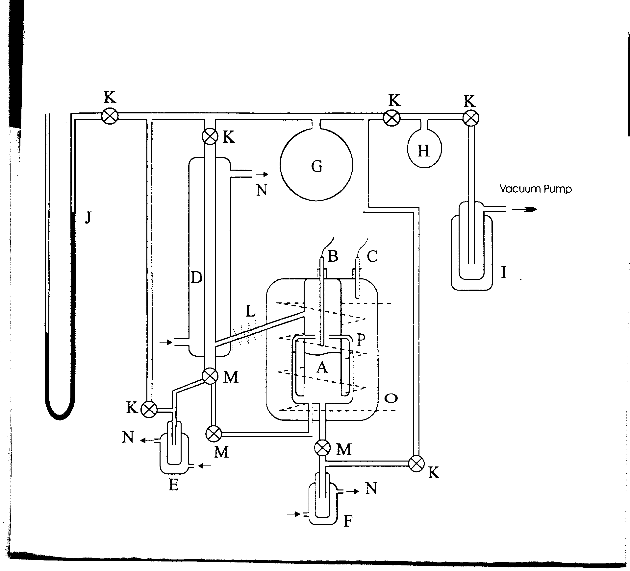

Figure 1. VLE apparatus , (A)Equilibrium cell, (B,C)Resistance thermometer, (D)Condenser, (E)Vapor sampling port, (F) Liquid sampling Port, (G)Large flask, (H)Small flask, (I)Liquid nitrogen, (J)U-tube manometer, (K)Needle valve, (L)Heating tape, (M)3-way valve, (N) Cooling water, (O)Heating coil, (P)Silicon oil

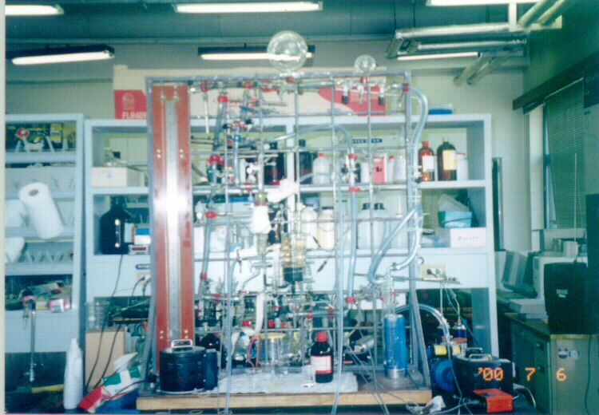

Figure 2. VLE apparatus

