AFM을 이용한 DNA 분석을 위한 전압제어방식에 따른
λ-phage DNA stretching

박 진영*, 김 종민**, 村松 宏**, 장 상목*
동아대학교 화학공학과*, 일본 세이코 연구소**

Stretching λ-phage DNA by voltage control method for DNA analysis with AFM

Jin-Young Park*, Jong-Min Kim**, Hiroshi Muramatsu**, Sang-Mok Chang*
Dept. of Chem. Eng., Dong-A University, Pusan 604-714, Korea*
Research Lab. for Adv. Tech., Seiko Instruments Inc., Chiba 270-2222, Japan**

Introduction
In the field of biochemistry, gel electrophoresis has been used widely in the analysis of DNA, RNA and protein, for example, the DNA physical mapping by restriction nuclease, DNA sequencing decision by polymerase, and southern blotting for finding the specific DNA fragment by gel-transition hybridization.[1]
Carrilho has reported the issues regarding high-throughput DNA sequencing by electrophoretic methods in miniaturized systems, such as capillaries, capillary arrays, and microchannels.[2] In recent years, the analysis of DNA fragments by microchip electrophoresis in polymer solution and/or substrates, and especially the study on stretching chromosomal DNA were fulfilled as first step for the obtainment of the total location information in the cell level by performing in-line on a microchip capillary electrophoresis (μ-CE) [3-4].
Moreover, it has been reported about DNA stretching in polyacrylamide solution for an optical mapping of restriction nuclease[5], as well as DNA motion in host polymer solution, especially, the analysis of the motion mode with the dependence of the electric field.[6] In this report, apart from using the established electrophoresis fabricated by other professional means, the voltage control method for λ-phage DNA stretching on an electrode is proposed, and the aspect and the direction change of the stretched λ-phage DNA with respect to electric field by an applied voltage are observed by AFM.

Experiment
An interdigital tranducer (IDT) electrode was deposited with silver on one side of a glass substrate using a vacuum evaporation method. A silver electrode thickness used in the IDT electrode was about 1500 Å. The pre-cleaned microcover glass (24 × 50 mm, thickness: 0.12 ~ 0.17 mm) was purchased from Matsunami glass IND., LTD. and used as received.
1 μl λ-phage DNA (48.5 kbp) solution, with average molecular weights of 2.8 million Da, dyed with fluorescene pigment, YOYO-1, was cast on a mica (φ = 2.2 mm), which is adhered on IDT/glass substrate. And then, we monitored λ-phage DNA stretching by a personal computer (Epson, PCV-590F) connected with a video fluorescence microscopy (Olympus, object lense: 60×). Furthermore, the λDNA molecules stretched on mica surface with respect of the electric field were investigated by the AFM system (Seiko Inst. Inc., SPI 3800, DFM mode).
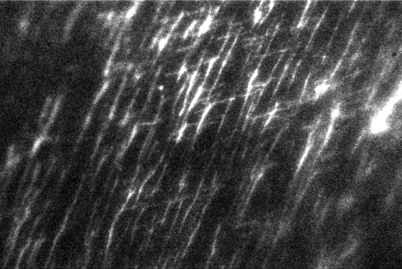
Figure 1. The fluorescent image of the stretched λ-phage DNA molecules on the electrode.(60 × 1.5 = 90×)
Results and Discussions
Figure 1 shows the fluorescent image of λ-phage DNA molecules when the voltage of AC 150 V is applied on both electrodes of IDT/glass substrate for about 10 min. It is shown that λ-phage DNA molecules on mica/IDT/glass substrate are stretched wholly with any specific direction. But, the only image identified is a little short of information for getting the clue that λ-phage DNA is stretched with the direction of the formed electric field. Therefore, in order to obtain the more detail information of the stretched λ-phage DNA molecules, one performed AFM measurement.

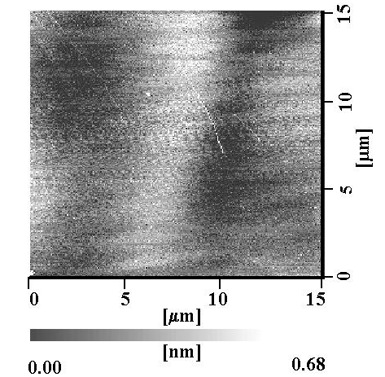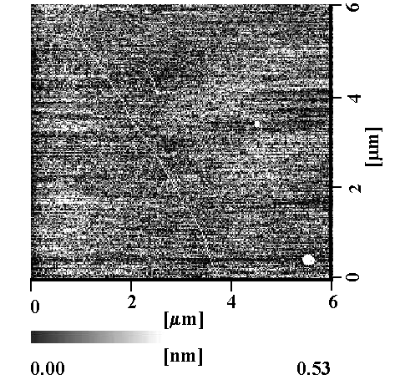
(a) (b)
Figure 2. AFM topography of the stretched λ-phage DNA molecules on the electrode
(a) 15 × 15 μm², (b) 6 × 6μm² (enlarged area).

In figure 2, it can be known that all λ-phage DNA molecules are stretched with the same direction and the several molecules are overlapped as the analytical result of the enlarged image. We also observed that the arrangement direction of the stretched λ-phage DNA changed as the formed electric field, although the concerned images do not appear in here. It implies that λ-phage DNA molecules can be easily stretched at the desired place and direction by the effect of formed electric field.

Conclusions
In this paper, we suggested a new method, an electrophoresis on the electrode, to stretch λ-phage DNA and showed that it could be possible sufficiently to stretch it on the electrode. In the future, the more consideration about the effect of the parameters such as λDNA solution concentration, an applied voltage and electrode type becomes required.

Reference
[1] Wang XL., Sawaguchi T. and Sawaguchi A., Electrophoresis , 21 (2), 334-337, 2000.
[2] Carrilho E., Electrophoresis , 21 (1), 55-65, 2000.
[3] 上田正則, 馬場嘉信, バイオイメ－ジング, 7 (2), 31-37, 1998.
[4] Chen YH. and Chen SH., Electrophoresis , 21 (1), 165-170, 2000.
[5] Oana H., Ueda M. and Washizu M., Biochem. Biophys. Res. Commun., 265, 140-143, 1999.
[6] Unda M., Yoshikawa K. and Doi M., polym. J., 31, 637-644, 1999.

