동시공학의 구현을 위한 화학 공정 장치 설계 모델

한승엽, 김영수, 윤태성*, 이태용
한국과학기술원 화학공학과, 동경공업대학 자원화학연구소*

Chemical Equipment Data Model for Concurrent Engineering

Seung-youp Han, Young-soo Kim, TaeSung Yoon*, Tai-yong Lee
Dept. of Chem. Eng. KAIST,
Research Laboratory of Resources Utilization, Tokyo Institute of Technology*

Introduction
Concurrent Engineering(CE) is a systematic approach to the integrated, concurrent design of products and their related processes, including manufacture and support. This approach is intended to cause the developers, from the outset, consider all elements of the product life-cycle from conception through disposal, including quality, cost, schedule, and user requirements[1]. In mechanical engineering, the concept of CE has been implemented in CAD/CAM/CAE. Various applications were proposed for CAPP (Computer Aided Process Planning) to form a link between CAD and CAM[2,3]. Recently many researchers in chemical engineering are interested in CE. Natori et al. mentioned that CE and re-engineering would be key technologies for system development of their company, Mizushima Plant[4]. To accomplish integration of design process through CE, current researches have two kinds of trends. One is to make data sharing environment among different systems by STEP (STandard for the Exchange of Product data model), which is embraced in ISO 10303. It adopts a neutral file format together with APs(Application Protocols) which allows exchange through a standard data access interface. Such a format provides a mechanism for description of product data consistently. With such a support environment, it is possible to build real life-cycle models and provide a systematic methodology for integrating different data requirements to share data[5,6]. The other is to construct integrated environment for design process. Gani et al. proposed an Integrated Computer Aided System(ICAS), which is particularly suitable for solving problems related to integrated design of chemical processes. It include a model generator, a simulator, toolboxes, and an interface for problem definition[7]. Hofmeister developed a knowledge integration environment called BatchKit. It provides a broad range of problem representation using logic programming and solving capabilities by an optimization solver and a simulator[8].

Concurrent Engineering
Generally, three possible strategies can be identified as CE guiding principles, parallelization, integration, standardization as shown in Figure 1. Parallelization in the product development process implies the cutting and optimization of time. The first step is to remove existing float time in the development process. This means that processes which do not have any dependencies on other processes are carried out simultaneously, i.e., all information is not required to start a new process. The result of this approach is the advantage of accelerated execution of linked processes, but also the disadvantage of higher decision complexity. This higher decision complexity is caused by an increased amount of information transfer between departments or teams. Integration is the measure to overcome these interface problems. Integration demands working in interdisciplinary teams, thinking and behaving in a process oriented way, realizing a common objective instead of several objectives that are department specific, and finally being entrepreneurial instead of putting through interests of
Figure 1. PSI strategy in CE

departments. Another important aspect of integration is data integration within a company.
Finally standardization of process is needed so as to avoid repetition and needless work as well as to learn from existing experience of the company. Standardization of product is related to technical/structural aspects such as the usage of modules or components in the final products, and it can be supported by STEP[1].

Concurrent Engineering in Chemical Process Design
The three guiding principles of CE which are defined by general methodology can be specified and applied to chemical process design. From the point of view, we can consider three kinds of areas corresponding to the principles respectively as shown in Figure 2 in order to accomplish CE in chemical process design. Project planning means setting up, specifying and structuring the different activities of a project[9]. Recently activity models are broadly used to perform project planning. Figure 3 is an example of activity model for process plant engineering which are proposed by PISTEP. Each box stands for a unit of task and it can be divided into sub-tasks through analyzing dependency among them. Then they can be rearranged using the concept of parallelization in Figure 1. The modified activity model has to be supported by functional data model to explain what kind of information is transferred between connected activities, and how the information is controlled. The functional data model should include design and design evaluation activities to deal with requirements throughout chemical process life-cycle. Therefore the functional data model should have flexible structure and contain mapping relations among the activities. Standardization is supported by STEP, of which purpose is to share information between different systems.

Figure 2. PSI strategy in chemical process design
Figure 3. Process plant engineering activity model

Facility Modeling by Feature Based Design
In this study facility modeling for chemical equipment is performed as a basis of functional data model for chemical process. Features are defined as meaningful abstractions with which human reasons about components and products for a variety of purposes, or as a model of the form and intent of some aspects of a design which is of direct interest in a CIM viewpoint[10]. There are many extended definitions of features. One of them is a carrier of product information that may aid design or communication between design and manufacturing, or between other engineering tasks. From above definitions, feature can be viewed as information sets that refer to aspects of form or other attributes of a part such that these sets can be used in reasoning about the design, engineering analysis or manufacture of the part or assemblies they constitute.

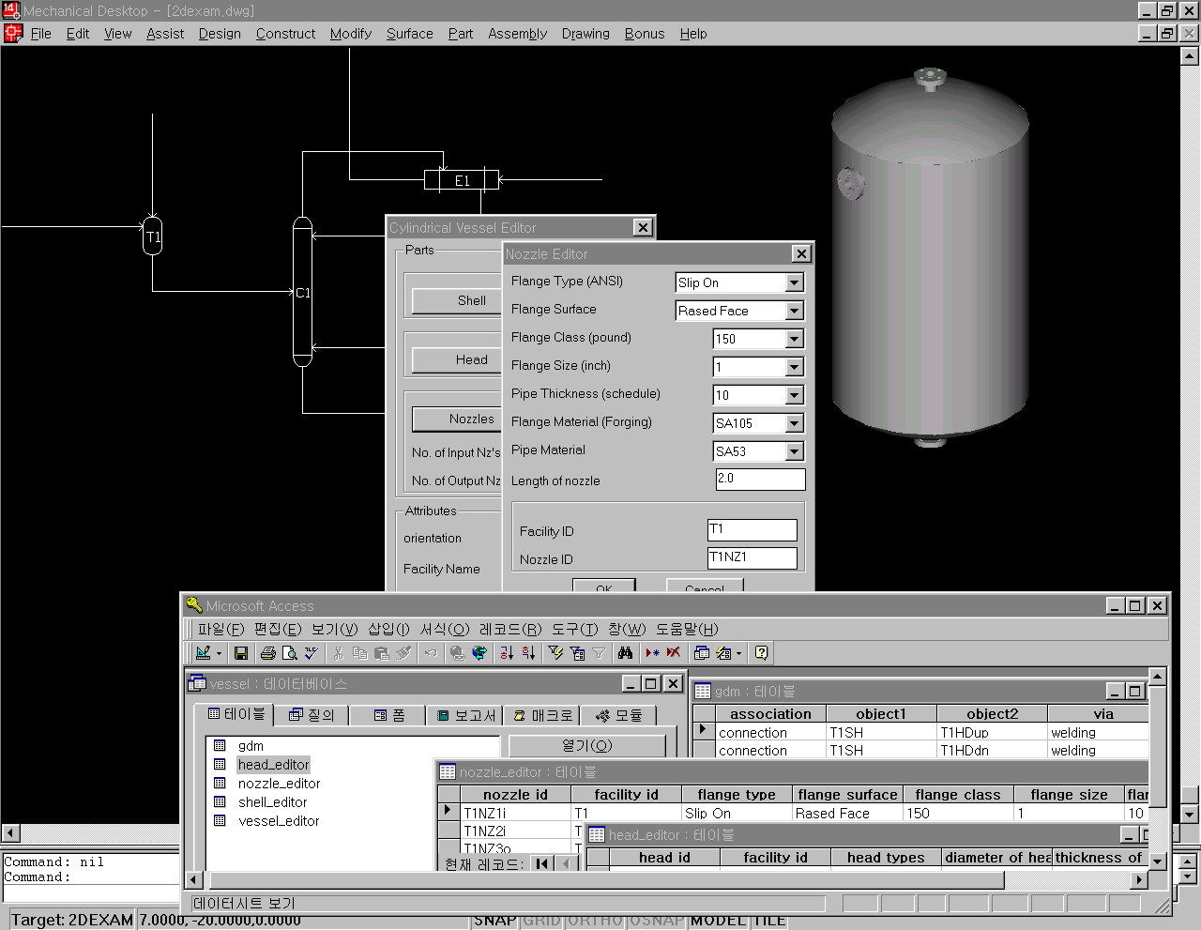
PFD : 2D expression for process
3D geometrical expression
for equipment
Dialogboxes to input parameters
Database for design data
Figure 4. Screen view of prototype

A product model can be built by using design feature; this is known as design-by-features or feature based modeling. Features are functional elements to designers. However, design features often differ from application features[11]. We can define some features from process and engineering design activities according to their application domains. Facility model can be regarded as a product model focused on design feature of facilities of chemical plant rather than other application domains, such as safety, maintenance and so on. The application domains will be characterized to their own application features, but the most part of information for application features can be shared with information of facility model defined by design features using mapping among the features. In the case of user interface, parametric expression of features can give a user great flexibility to design geometrically similar equipment, such as vessel and agitator and so on. A prototype is constructed in CAD environment as shown in Figure 4.

Conclusion
Concurrent engineering applied to chemical process design were reviewed. The three guiding principles of CE, parallelization, integration, standardization were specified into project planning, functional data model, STEP, respectively. They can be considered basic requirements to achieve CE in viewpoint of information technology. Facility model was suggested to manage process and engineering design information interactively as a functional data model.

Acknowledgement
The work was supported by the Science and Technology Policy Institute (STEPI) through contact number, 97-NE-05-02-A, the Korea Science and Engineering Foundation (KOSEF) through the Automation Research Center at POSTECH.

References
- H.J.Bullinger, J.Warschat, "Concurrent Simultaneous Engineering Systems", Springer (1995)
- Y.Zhang, C.Zhang, H.Wang, "Interoperation of STEP Application Protocols for Product Data Management", Concurrent Engineering 6,(2), 161-168 (1998)
- Otto Salomons, "Computer Support in the Design of Mecanical Products", Ph.D. Dissertation, Mechanical Engineering, Univ. of Twente, Netherlands (1995)
- Y.Natori, L.O'young, "Vision of 21st Century's Plant and How to Get There", Computers Chem. Engng. 20 Suppl. S1469-S1479 (1996)
- X.Yang, C.McGreavy, "Requirement for Sharing Process data in the Life Cycle of Process Plants", Computers Chem. Engng. 20 Suppl. S363-S368 (1996)
- C.McGreavy, X.Z.Wang, M.L.Lu, Y.Naka, "A Concurrent Engineering Environment for Chemical Manufacturing", Concurrent Engineering 3(4), 281-293 (1995)
- R.Gani, G.Hytoft, C.Jaksland, A.K. Jensen, "An Integrated Computer Aided System for integrated Design of Chemical Proceeses", Computers Chem. Engng. 21(10), 1135-1146 (1997)
- M. Hofmeister, "BatchKit-A knowledge integration environment for process engineering", Computers Chem. Engng. 22(1-2), 109-123 (1998)
- J.W.Hawtin and P.W.H.Chung, "Concurrent Engineering System for Supporting STEP Based Activity Model", Computers Chem. Engng. 22 Suppl. S781-S784 (1998)
- D.W.Rosen, "Feature-Based Design: Four Hypotheses for Future CAD Systems", Research in Engineering Design, 5, 125-139 (1993)
- O.W.Salomons, F.J.A.M.Houten, H.J.J.Kals, "Review of Research in Feature-Based Design", Journal of Manufacturing Systems, 12(2), 113-132(1993)

