풀린 단백질과 접힌 단백질의 구조변화에 대한 모니터링

조태훈, 안상점*, 채영규**, 이은규
한양대학교 화학공학과, 생화학과**, ㈜녹십자*

Monitoring of structural changes during in vitro unfolding and refolding of recombinant human growth hormone

Tae Hoon Cho, Sang Jeom Ahn*, Young Gyu Chai** and Eun Kyu Lee
Korea Green Cross Corp.*, Bioprocessing Research Laboratory, Dept. of Chem. Eng., and Dept. of Biochemistry**, Hanyang University , Ansan, KOREA 425-791

Introduction

Various techniques for in vitro refolding proteins from their denatured state are widely practiced in the biopharmaceutical protein industry. Although the exact process varies widely depending on the type and the characteristics of each protein, it is a central theme that a protein undergoes structural changes during the course of refolding. The important structural changes include surface hydrophobicity and secondary structures (i.e., α-helices and β-sheets). In this study, using recombinant human growth hormone as a model protein, we carried out unfolding by adding a denaturant such as urea, guanidine HCl, or SDS followed by refolding by dilution or dialysis. The objectives were to compare the refolding performance of each denaturant and to investigate the kinetics of refolding. The changes in surface hydrophobicity were measured by fluorescence tagging of 1-anilinonaphthalene-8-sulfonate (1,8-ANS) to the hydrophobic portions. The changes in the secondary structure were monitored by using far UV-CD (circular dichroism) spectroscopy. Also, we used RP-HPLC to separate and quantify the folded and unfolded proteins to correlate the result with the structure analysis.

Materials and Methods

Pure rhGH monomers in lyophilized powder were gifted from Korean Green Cross Corp. The unfolding step was started by adding the 46mM sodium bicarbonate (pH 9.1) containing 6M GuHCl, 8M Urea, or 0.5% SDS and 5mM DTT. It was carried out at room temperature for 2 h. Initial rhGH concentration was set at 0.5mg/ml. To start refolding, the solution was fourfold to reduce the denaturant concentration. And, to completely eliminate residual urea or Gu-HCl, dialysis was carried out at 4°C for 16 h[1]. SDS was removed by anion exchange chromatography[2]. The resulting solution was subjected to air oxidation at room temperature for 24 h. The fluorescence from the bound 1,8-ANS was measured by Turner Designs fluorometer (model 10-AU). The excitation and the emission wavelengths were 390nm and 475nm, respectively[3]. This method is based on the affinity of the fluorescent probe for hydrophobic surfaces on the molten globule protein structure. The RP-HPLC was performed on a Gilson (model 302) as described elsewhere[2]. The CD experiments were performed on Jasco spectropolarimeter (model J-715) at 25 °C. A path length of 0.5mm was used for the far-UV CD.

Results and Conclusions

Fluorescence measurement. 1,8-ANS fluoresces when it binds to hydrophobic surfaces or finds itself in a highly nonpolar environment[4]. First of all, the effect of denaturants (GuHCl, urea, SDS, Sarkosyl) and reducing agent (DTT) without proteins on the fluorescence reading was measured, and it turned out they showed no significant effect. Upon unfolding, rhGH showed significant increase in the fluorescence intensity. This means that upon unfolding there was a significant but slow increase in the surface hydrophobicity of the protein, which indicated the hydrophobic pockets normally buried in the interior of the protein were exposed to the solvent, due to the breakdown of the tertiary structure. The rate of the fluorescence increase was rather constant and independent of the denaturant used. However, the amplitude of the increase was dependent on the denaturant used; the largest increase was resulted by SDS or Sarkosyl followed by urea and GuHCl. When being refolded the protein showed gradual decrease in the fluorescence to ca. 90% level of the native protein. This result suggests the changes in the surface hydrophobicity plays indeed the central role in unfolding-refolding process of proteins.
Comparison of denaturants in unfolding-refolding Fig. 1 shows the fluorescence profiles with respect to concentration of the denaturants tested. Urea and GuHCl showed similar profiles whereas SDS and Sarkosyl demonstrated similar behavior. For SDS and Sarkosyl, the fluorescence increased with concentration, which was probably related to micelle formation. Other investigators used this method to identify the denaturant’s concentration for ‘molten globule intermediate’[4-6], in which a protein contains significant naïve-like secondary structure but little or no native tertiary structure. This intermediate concentration is known to allow the linearized random coils to form three-dimensional conformation and yet to prevent excessive intermolecular interaction to minimize aggregate formation. Our result showed that of urea and GuHCl was ca. 7M and 4.5M, respectively, which agreed well with the literature. Unlike urea and GuHCl, SDS and Sarkosyl each showed two local maxima at 0.35% and 0.15%. The reason for the two maxima is not clear yet.
RP-HPLC separation The best separation of oxidized (or folded) and reduced (or unfolded) forms of rhGH was obtained with a linear gradient from 24% to 75% of acetonitrile in 35min[2]. During refolding, it was observed on the chromatogram the reduced form gradually switched into the oxidized form (Fig. 2). The rate and the profile of this change in oxidized rhGH peak area was quite similar to the change in fluorescence (Fig. 3). Note that the peak area changes in opposite direction to that of fluorescence. This result confirmed the surface hydrohpobicity changes coincided with the oxidation by disulfide bonds formation.
Secondary structure (far UV CD spectra) The far UV-CD spectrum of rhGH consisted of three peaks at 192, 209, and 222nm. The peaks at 222 and 209nm correspond to α-helices. These spectra reflect a structure that is typical of a molten globule contains nearly the same content of α-helices at that of the native state. Fig.4 shows the CD spectra of the fully unfolded, air-oxidized, dialyzed (or fully refolded), and the native rhGH. With SDS, much higher degree of the α-helices disruption was observed in the unfolded state than with GuHCl. The molar ellipticity at 222nm of the refolded rhGH was close to that of the native protein. Compared with the native form, the refolded form regained approximately 90% of the original secondary structure.

References

- Kelly, R.F. and Winklen, M.E., “Floding of Eukaryotic Proteins Produced in Escherichia coli”, Genetic Engineering, 12, 5-7, (1990)
- Cleland, J.L. and Wang, L.C., “Refolding and Aggregation of Bovine Carbonic Anhydrase B: Quasi-Elastic Light Scattering Analysis”, Biochemistry, 29, 11072-11078 (1990)
- Bam, N.B., Cleland, J.L. and Rnadolph, T.W., “Molten Globule Intermediate of Recombinant Human Growth Hormone: Stabilization with Surfactants”, Biotechnol. Prog., 12, 801-809 (1996)
- Turner, D.C. and Brand, L., “Quantitative Estimation of Protein Binding Site Polarity Fluorescence of N-Arylaminonaphthalenesulfonates”, Biochemistry, 7, 3381-3390 (1968)
- Goto, Y. and Fink, A.L., “Conformational States of β-Lactamase: Molten Globule states at Alkaline and Alkaline pH with High Salt”, Biochemistry, 28, 945-952 (1989)
- Kim, C.S. and Lee, E.K., “Comparative Analysis of Dissolution and Refolding Processes for Inclusion Body Protein Renaturation”, Korean J. Biotechnol. Bioeng., 2, 133-140 (1998)

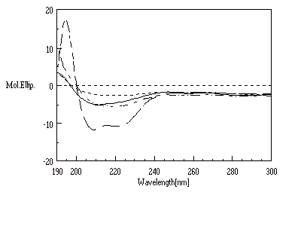
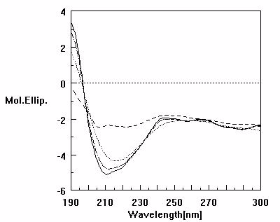
(A) (B)
Fig. 4. Comparison of CD spectra of the unfolded, air-oxidized, fully refolded, and native
rhGH. (A) : with guanidine hydrochloride, and (B) : with SDS.

