낙농산업의 부산물로부터 발효에 의한 숙신산 생산

이평천, 이우기, 권선훈, 이상엽, 장호남
한국과학기술원 생물공정연구센타/화학공학과

Production of succinic acid from by-product in dairy industry by fermentation

Pyung Cheon Lee, Woo Gi Lee, Sunhoon Kwon, Sang Yup Lee, Ho Nam Chang

Department of Chemical Engineering and BioProcess Engineering Research Center
Korea Advanced Institute of Science and Technology

Introduction

Succinic acid is being considered to be important because it can be used for the manufacture of synthetic resins and biodegradable polymers and as an intermediate for chemical synthesis. To date, succinic acid has mostly been produced by chemical processes. Recently, however, fermentative production of succinic acid from renewable biomass by anaerobic bacteria has attracted great interest (1). An anaerobic bacterium Anaerobiospirillum succiniciproducens has been considered as one of the best succinic acid producers because it can produce a significant amount of succinic acid from glucose (2-3).
Whey is produced in large quantities as a by-product of the cheese and milk industry. A large amount of whey is disposed, which can cause considerable environmental problems due to its high biological oxygen demand (BOD). Therefore, several environmentally friendly processes based on microbial fermentation have been proposed for whey utilization. Recently, we have demonstrated that A. succiniciproducens could produce succinic acid from lactose (2). Therefore, it was reasoned that succinic acid might be produced economically from whey. In this study, we report on the production of succinic acid from whey by A. succiniciproducens. Production of succinic acid from whey with high productivity by continuous fermentation is also reported.

Materials and methods

Organism and growth conditions. Anaerobiospirillum succiniciproducens (ATCC 29305) was obtained from the American Type Culture Collection (Rockville, MD). Cells were grown in sealed anaerobic bottles containing 100 mL minimal salts medium1 (AnS1) containing 5 g/L lactose, 2.5 g/L polypeptone and 2.5 g/L yeast extract with CO₂ as the gas phase. The AnS1 medium contains per liter, 3 g K₂HPO₄, 1 g NaCl, 1 g (NH₄)₂SO₄, 0.2 g CaCl₂2H₂O, 0.2 g MgCl₂6H₂O, and 1 g Na₂CO₃. To the sterile medium, concentrated H₂SO₄ was added to adjust the pH to 6.5. Batch cultures were carried out at 39 ºC in a 2.5 L jar fermenter containing 1 L of minimal salts medium2 (AnS2) containing 20 g/L whey or lactose with 5 g polypeptone and 5 g yeast extract. In case of cofermentation, the AnS2 medium containing whey or lactose was supplemented with glucose. The AnS2 medium contains per liter: 3 g K₂HPO₄, 1 g NaCl, 5 g (NH₄)₂SO₄, 0.2 g CaCl₂2H₂O, 0.4 g MgCl₂6H₂O, 5 mg FeSO₄7H₂O, and 5 g Na₂CO₃. The pH was controlled at 6.5 using 1.5 M Na₂CO₃. CO₂ gas sparging rate and agitation speed were controlled at 0.25 vvm and 200 rpm, respectively. Continuous cultures were carried out with working volume of 500 mL in the jar fermenter, and the AnS2 medium containing 20 g/L whey, 5 g/L polypeptone and 5 g/L yeast extract was used as a feeding solution. After 56 h of batch operation, feeding solution was added at various dilution rates while an equal volume of spent medium was removed from the fermenter. Bovine whey powder containing 11% (w/w) of proteins and 65% (w/w) of lactose was purchased from Sigma Chemical Co. When indicated, proteins present in whey were precipitated by heating the whey solution at 90 ºC for 20 min, and were removed by centrifugation at 8000 x g for 20 min. The supernatant was heat-sterilized at 121 ºC for 30 min (hereafter “treated whey”).
Analytical methods. The concentrations of sugars, succinic acid and acetic acid were measured by high-performance liquid chromatography equipped with an ion exchange column (Aminex HPX-87H) using 0.012 N H₂SO₄ as a mobile phase. Cell growth was monitored by measuring the absorbance at 660 nm (OD₆₆₀) using a spectrophotometer. Beta-galactosidase activity was measured with o-nitrophenyl-β-D-galactropyranoside as a substrate in Z-buffer as described by Miller (5). The unit for the volumetric β-galactosidase activity was defined as μ-mole o-nitrophenol formed per mL of culture per min at 28 ºC, pH 7.0.

Results and discussions

Batch fermentation of lactose or whey. When a minimal salt medium containing whey without any complex nitrogen source was used, A. succiniciproducens did not grow probably due to the deficiency of the essential nutritional components. However, when a medium containing 2.5 g/L yeast extract and 2.5 g/L polypeptone per 10 g/L non-treated whey was used, cells grew well and succinic acid production was enhanced.
With the above formula of medium, batch cultivation was carried out using lactose as a carbon source. After a long lag period (33 h), cells grew rapidly to reach a maximum OD₆₆₀ of 2.3 at the end of fermentation. Even though lactose-grown cells were used as inoculum, there was a relatively long lag period in batch cultures. However, when glucose-grown cells were used as inoculum, cells did not grow in media containing whey or lactose even after 100 hours cultivation. This means that the state of the precultivation is very important for the growth of A. succiniciproducens. The volumetric β-galactosidase activity increased to 3003 units proportionally to the cell concentration. The lactose consumption rate changed from 0.08 to 1.02 g/h. A small amount of galactose was detected at 36 h mainly due to the hydrolysis of lactose by the β-galactosidase released from cells. However, galactose was completely consumed at the end of fermentation. The concentration, yield and productivity of succinic acid were 16.5 g/L, 87%, 0.33 g/L/h, respectively.
When A. succiniciproducens was grown in a medium containing 20 g/L of non-treated whey, the lactose present in the non-treated whey was consumed steadily until 46 h, after which it was consumed rapidly coinciding with the rapid increase in the volumetric β-galactosidase activity. Again, a small amount of galactose was detected and completely consumed as lactose was depleted. At the end of the fermentation, the concentration, yield and productivity of succinic acid were 15.5 g/L, 93%, and 0.24 g/L/h, respectively.

Effect of glucose on the fermentation of lactose or whey. Fermentation time was rather long as indicated above, which reduced productivity. As a strategy to reduce the fermentation time, cofermentations of glucose/lactose and glucose/whey were carried out. During the cofermentation of glucose and lactose, glucose was rapidly utilized followed by lactose. Volumetric β-galactosidase activity increased rapidly after glucose was almost depleted, and it stayed at a similar level during the fermentation. The lactose consumption rate increased from 0.19 to 0.35 g/h after glucose was almost depleted. The concentration, yield and productivity of succinic acid were 16 g/L, 86% and 0.62 g/L/h, respectively.

When glucose and non-treated whey were cofermented, glucose was consumed followed by lactose present in whey, which was similar to the above. After glucose was depleted, the lactose consumption rate was almost constant (0.4 g/h), but higher than that obtained by the fermentation of glucose and lactose (0.35 g/h). The succinic acid yield (95%) based on glucose and lactose consumed was higher than that obtained using non-treated whey alone (93%). However, the succinic acid productivity (0.46 g/L/h) was in between those obtained using non-treated whey alone (0.24 g/L/h) and using glucose and lactose together (0.62 g/L/h).
Continuous fermentation of whey. Continuous fermentations were carried out anaerobically to increase the succinic acid productivity. Fresh medium was supplied into the reactor under anaerobic condition at dilution rates of 0.03 to 0.14 h⁻¹. At new steady states for each dilution rate, the concentrations of succinic acid, acetic acid, lactose, succinic acid productivity and volumetric β-galactosidase activity were determined and shown in Fig. 1. Succinic acid productivity increased from 0.4 g/L/h at the dilution rate of 0.03 h⁻¹ to 1.35 g/L/h at 0.11 h⁻¹, which was 5.6 times higher than that (0.24 g/L/h) obtained by batch fermentation. However, the productivity deceased to 1.20 g/L/h at a higher dilution of 0.14 h⁻¹. For the continuous cultures with the dilution rate up to 0.11 h⁻¹, succinic acid yield and volumetric β-galactosidase activity were almost constant at 93% and at 3300 units, respectively, for the dilution rate up to 0.11 h⁻¹ (Fig. 2). During the continuous culture, the ratios of succinic acid to acetic acid (g/g) decreased from 5.8:1 to 5.1:1 with increasing dilution rate.

Conclusion

In conclusion, this study shows that succinic acid can be produced efficiently by A. succiniciproducens from whey, a waste product of the dairy industry, by batch and continuous fermentation. Also, the results obtained in this study suggest that non-treated whey can be directly used for succinic acid production, which allows savings in whey preparation.

Acknowledgment
This work was supported by the Korean Ministry of Science and Technology

References
1. Landucci R, Goodman B, Wyman C (1994). Appl Biochem Biotechnol 45-46: 678-696
2. Lee PC, Lee WG, Kwon S, Lee SY, Chang HN (1999). Enzyme Microb Technol 24:549-554
3. Lee PC, Lee WG, Lee SY, Chang HN (1999). Process Biochem, in press
4. Samuelov NS, Lamed R, Lowe S, Zeikus JG (1991). Appl Environ Microbiol 57: 3013-3019
5. Miller JH (1972) Experiments in molecular genetics. Cold Spring Harbor Laboratory, Cold Spring Harbor, NY, p 352-355

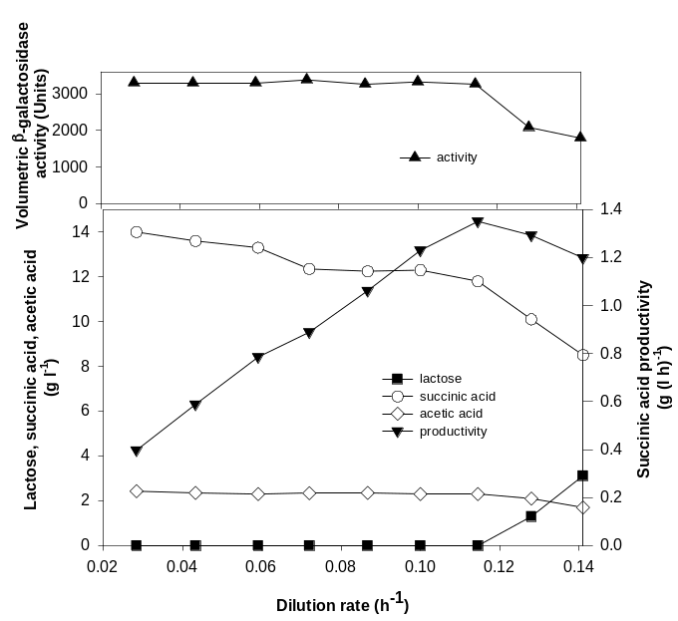
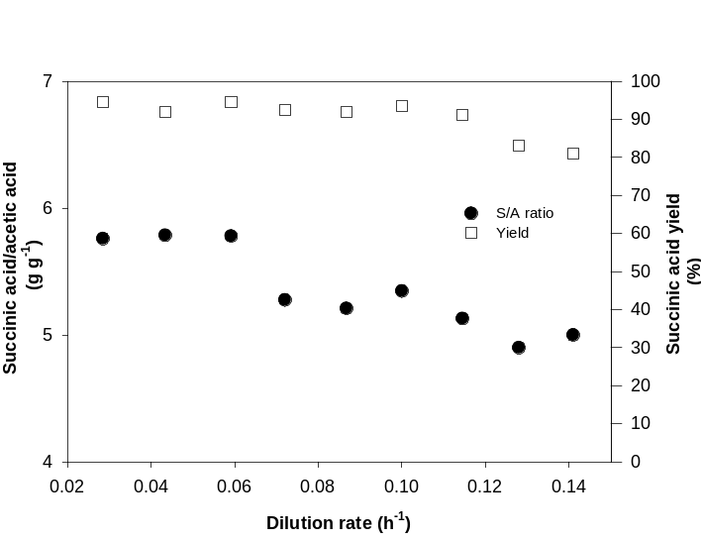
Figure.1 Figure. 2

