담지된 금 촉매에 의한 일산화탄소의 산화 반응에서의 전처리 효과
박은덕, 이재성
포항 공과 대학교 화학공학과/ 환경 공학부

Effects of Pretreatment Conditions on CO Oxidation over Supported Au Catalysts
Eun Duck Park and Jae Sung Lee
Department of Chemical Engineering and School of Environmental Engineering, Pohang University of Science and Technology(POSTECH)

INTRODUCTION
Since Haruta and co-workers discovered the high activities for CO and H₂ oxidation over supported Au catalysts that were prepared by the coprecipitation or deposition-precipitation method, numerous synthetic methods and characterization studies have been conducted [1-5]. These novel supported Au catalysts have attracted much attention in the practical point of view because they were reported to show the increasing activity in the presence of water unlike traditional metal oxide catalysts such as Hopcalite catalysts (mixed oxides composed mainly of Mn and Cu). Until now, the active phase of gold has been studied with catalysts prepared mostly by coprecipitation whose surface area and exposed gold concentration change with pretreatment conditions [2-4]. Even for TiO₂-supported Au catalysts prepared by deposition-precipitation, the catalytic activity has been compared after fully reducing gold compound into metallic Au. This might have made the conclusions regarding the active phase of gold equivocal. In this study, similar surface areas and exposed gold concentrations are established by preparing catalysts with the deposition-precipitation method where gold particles deposit onto a preformed oxide from a Au-containing solution. In addition to known active supports of TiO₂ and Fe₂O₃, gold supported on γ-Al₂O₃ is also studied for comparison. The effects of the oxidation state of gold on the catalytic activity for CO oxidation in dry and wet conditions are studied.

EXPERIMENTAL
The deposition-precipitation method was used to prepare the supported Au catalysts. Support material was Fe₂O₃(calcined at 873K after precipitation from Fe(NO₃)₂⋅6H₂O with 1N NaOH, surface area = 16 m²/g). Gold precursor was HAuCl₄⋅3H₂O(Aldrich, 99.9%). Each of these supports was dispersed in an aqueous solution of HAuCl₄ at 343 K. The pH of the support dispersion was adjusted to 8 with addition of 0.1N NaOH. This aqueous dispersion was stirred for 2h at the adjusted pH, filtered and then washed with hot distilled water several times to remove residual Cl⁻ species. The cake was dried at 373 K in a dry oven and calcined for 5h at different temperatures and conditions. The gold contents were determined with Perkin-Elmer AAS 5100PC.
The rates of CO oxidation were measured in a small fixed bed reactor packed with catalyst powders of 100/120 mesh. All the experiments in the dry condition were performed after pretreatment of the sample with air at 373 K for 1 h to remove adsorbed H₂O. The conversion of CO was determined through gas chromatographic analysis (HP5890A, molecular sieve 13X column) of the effluent from the reactor.
X-ray photoelectron spectroscopy (XPS) measurements were conducted with a Perkin-Elmer PHI 5400 ESCA spectrophotometer with monochromatic Mg Kα radiation (1253.6 eV). Spectra were collected with an analyzer pass energy of 89.45 eV. Binding energies were corrected for surface charging by referencing them to the energy of C1s peak of contaminant carbon at 285.0 eV. The XPS Au 4f binding energies of bulk metallic Au, Au₂O₃, and Au(OH)₃ are 83.9, 86.3, and 87.7 eV for 4f_{7/2} and 87.7, 89.6, and 91.4 eV for 4f_{5/2}, respectively. The 4f_{5/2} and 4f_{7/2} doublet corresponds to final states with total angular momentum J₋ = L - S = 5/2 and J₊ = L + S = 7/2, respectively. The intensity ratio of these lines is given by the ratio (2J₋ + 1)/(2J₊ + 1). Thus, the value is 3:4 for f_{5/2} to f_{7/2}. We made an attempt to decompose the two envelopes of multiplet peaks by fixing components at 83.9, 86.3, 87.7, 89.6, and 91.4 eV using a curve fitting procedure based on a nonlinear-least-square algorithm. Because the component at 87.7 eV reflects both metallic Au and Au(OH)₃, the intensity ratio described above was taken into account when this peak was deconvoluted. The homogeneous assumption was adopted for sensitivity factors of Au compounds.
The XAFS spectra were taken in a transmission mode for L_{III}-edge of Au at beamline 10B of the Photon Factory in the National Laboratory for High Energy Physics (KEK). Spectra of the Au L_{III} edge were recorded at room temperature after the pretreatment in air and during the CO oxidation reaction for the samples still under the atmosphere of treating gases in the cell. In addition to catalysts samples, XAFS data were also obtained for Au foil, Au₂O₃, and Au(OH)₃ samples as references. They were analyzed by the UWXAFS 3.0 package licensed from University of Washington.
Bright field images of transmission electron microscopy (TEM) was obtained using a Philips CM 200 TEM operated at 200 KV. The mean diameter of the Au particles was determined through the observation of more than 100 particles.

RESULTS

The rates of CO oxidation over Au/Fe₂O₃ shown in Fig.1 indicated that with increasing calcination temperatures the catalytic activity decreased both in the presence and absence of water vapor. Again, the wet condition gave higher rates of CO oxidation. The technique of XPS was employed in order to obtain information on the state of gold in Au/Fe₂O₃ catalysts prepared at increasing calcination temperatures. The Au/Fe₂O₃ catalyst calcined at 373 K shows the peaks at 86.5 eV and 90.1 eV for Au 4f_{7/2} and Au 4f_{5/2} lines, which are close to Au 4f binding energies of Au₂O₃. After pretreatment with air at 473 K, three broad peaks appeared near Au 4f binding energies of Au₂O₃ and metallic Au. This can be interpreted as Au₂O₃ and metallic Au coexisting. For Au/Fe₂O₃ catalysts calcined above 573 K, two distinct peaks appears at 84.3 eV and 87.9 eV, which are close to Au 4f binding energies of metallic Au. Therefore gold phase was found to be changed from Au₂O₃

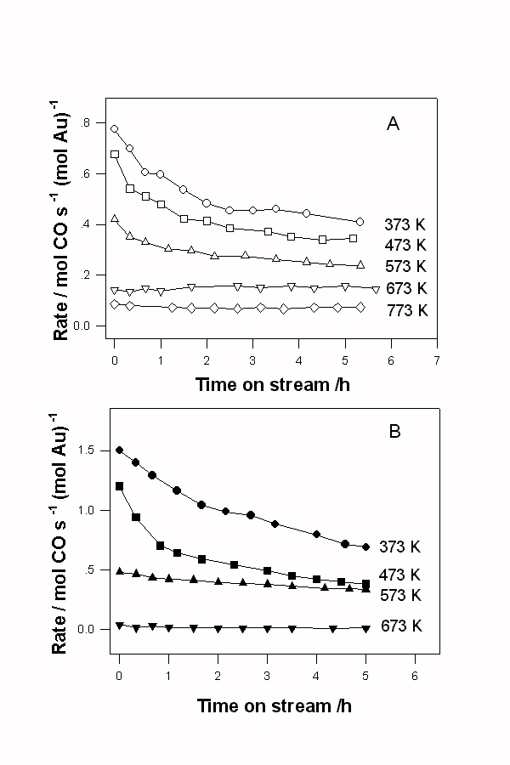
FIG. 1. XPS of Au 4f obtained for 1.16 wt.% Au/Fe₂O₃ catalysts prepared at increasing calcination temperatures. The catalyst calcined at 373 K was used for CO oxidation at 313 K for 10 h in dry and wet conditions.

to metallic Au as calcination temperature increased for Au/Fe₂O₃ catalysts.
Pure metallic Au phase was formed upon calcination above 573 K. XPS spectra were also obtained to determine the oxidation states of Au after CO oxidation at 363 K for Au/ Fe₂O₃ catalysts which had been calcined at 373 K. The results depended on whether the reaction took place in the dry or wet condition. In the dry condition, two distinct peaks appeared at 84.1 eV and 87.8 eV, which were close to Au 4f binding energies of metallic Au. Thus, the oxidized gold phase was reduced
TABLE 1.
Surface composition of Au/Fe₂O₃ catalysts prepared with different calcination temperatures obtained by deconvolution of Au 4f peaks

Calcination temperature | Au₂O₃ | Au metal
373 K  473 K  573 K  673 K | 0.86  0.59  0.0  0.0 | 0.14  0.41  1.0  1.0

almost completely to metallic Au during the reaction. However, about 40% of gold remained as Au₂O₃ after the reaction in wet condition. Hence, an important role of water appears to suppress the reaction of gold during the reaction. To determine the relative portion of Au₂O₃ and metallic Au quantitatively, deconvolution of Au 4f peaks was conducted, and the result was listed in Table 1. It also showed that gold phase was transformed progressively from Au₂O₃ to metallic Au as calcination temperature increased. Pure metallic Au phase was formed after calcination above 573 K.
Bright field images of Au/Fe₂O₃ catalysts prepared at increasing calcination temperatures in air were obtained. At the calcination temprature of 373 K, the particle size of Au was too small to be observed. However, it appeared to increase with calcination temperatures and Au particles were seen for catalysts calcined above 573 K. The mean diameters of Au particles in catalysts calcined at 573 K and 773 K were estimated by averaging diameters of more than 100 individual particles and they were about 4 nm and 6 nm, respectively.

DISCUSSION
Fe₂O₃ is one of support materials most favored by Haruta and coworkers who discovered the activity of these catalysts. As calcination temperatures increased, the CO oxidation activity decreased and the gold phase was changed from Au(OH)₃ and Au₂O₃ to metallic Au, which was determined by XPS. Most previous studies for Au/Fe₂O₃ employed catalysts prepared by the coprecipitation method [2,4]. Hatuta et al. showed how gold species in the Au-Fe coprecipitated precursors changed after drying and calcination in air at different temperatures with XAFS [4]. At 473 K and below, gold existed as an oxidized species similar to hydrous gold oxide and Au₂O₃. At 573 K the oxidized gold species were mostly decomposed into metallic species. However, at this temperature, the coexistence of oxidized species was also seen in XANES. At 673 K, almost all oxidized gold species was decomposed into metallic species. The change in gold species from oxidic to metallic phase was accompanied by the transformation of amorphous ferric hydroxide into crystalline hematite (α-Fe₂O₃). They observed that Au-Fe coprecipitate calcined at 573 K showed the maximum activity and concluded that the presence of metallic Au was indispensable for the low temperature CO oxidation [4]. However, they did not consider the change in the surface gold concentration and surface area with calcination temperatures which should have been accompanied by the change in the phase and surface area of the support itself.
To relate the catalytic activity in CO oxidation directly with the phase of gold, Fe₂O₃ calcined at 873 K was chosen here as a support and the deposition-precipitation method was selected instead of the coprecipitation method. At least, there will be no significant change in support during calcination after the deposition of gold. As the calcination temperature increased, the catalytic activity decreased and the decreasing activity over Au/Fe₂O₃ catalyst calcined at 373 K accompanied the phase transition of gold from the oxidized gold to the metallic gold. Unfortunately, the particle size of Au also increased with increasing calcination temperatures and could also account for the observed change in CO oxidation rates with calcination temperatures. Thus, we can safely state that the effect of gold phase is at least as important as that of the particle size of the metallic gold. Furthermore, it appears that oxidized gold is more active than metallic gold in CO oxidation. There are several observations that support this proposition. First, catalysts calcined below 573 K showed decreasing catalytic activity at the initial stage and reached a steady-state activity at the reaction temperature of 363 K. This suggests that the active oxidized gold transforms into less active metallic Au during the reaction at this temperature. This was confirmed by the fact that Au 4f XPS peaks of Au/ Fe₂O₃ catalyst at steady state for CO oxidation in dry conditions were the same as those of metallic Au (Fig. 2). Still, the activities of these catalysts were always higher than those catalysts calcined at higher temperatures. Second, the rates of CO oxidation are substantially higher in the wet condition than in the dry condition for all catalysts. It was found by XPS for Au/Fe₂O₃ catalysts that a role of water was to suppress the reduction of oxidized gold to less active metallic gold. There were also some studies which proposed the oxidized gold species as the active sites of Au for CO oxidation. Minico et al. (5) studied coprecipitated Au/Fe₂O₃ catalysts by FT-IR spectroscopy of adsorbed CO and found that in the CO oxidation cationic gold was more active but less stable than the metallic gold. The particle size of Au should also be important in case when only metallic Au is present. The decreasing catalytic activity with increasing calcination temperatures above 673 K could be understood as due to reduced gold surface areas by enhanced sintering of metallic gold particles.

CONCLUSIONS
In oxidation of CO at a low temperature, gold catalysts supported on Fe₂O₃ showed the decreasing activity with increasing calcination temperatures. XPS study showed the phase transition of gold from Au(OH)₃ through Au₂O₃ to metallic Au with increasing calcination temperatures for all catalysts. In addition to the particle size of metallic Au, the oxidation state of gold was proved to be important for CO oxidation. Oxidized gold is more active than metallic gold.

REFERENCES
1. Haruta, M., Catal. Today 36, 153 (1997).
2. Haruta, M., Yamada, N., Kobayashi, T., and Iijima, S., J. Catal. 115, 301 (1989).
3. Haruta, M., Tsubota, S., Kobauashi, T., Kageyama, H., Genet, M.J., and Delmon,
B., J. Catal. 144, 175 (1993).
4. Haruta, M., Kobayashi, T., Sano, H., Yamada, N., Chem. Lett. 405 (1987).
5. Minico, S., Scire, S., Crisafulli, C., Visco, A.M., and Galvagno, S., Catal. Lett., 47,
273 (1997)

