NaCl 용액의 축전식 이온제거 조작에서 활성탄소천에 고정된 티타니아의 역할

류민웅, 김종호, 서 곤

전남대학교 응용화학부

The Role of Titania Incorporated on Activated Carbon Cloth for
Capacitive Deionization of NaCl Solution

Min-Woong Ryoo, Jong-Ho Kim and Gon Seo*

Department of Chemical Technology Chonnam National University, Gwangju 500-757
* gseo@chonnam.ac.kr

INTRODUCTION

Deionization of water has become an essential technology for the manufacture of semiconductive devices and electric power plants to obtain feasible production yields by eliminating contamination of ultra fine products and reducing insoluble deposits of ions on the surface of turbines or pipes, respectively. Ultra high-grade deionization of water, therefore, is considered to be a basic technique for the production processes of nano-sized extremely pure materials.
Ions can be removed from water using several traditional methods: distillation, filtration, adsorption and ion-exchange, reverse osmosis (RO) and electrodialysis reversal (EDR). Capacitive deionization (CDI) methods operated under low electric field, are taken a increasing interest to obtain highly deionized water not only because its easy regeneration but also because high energy efficiency, chemical stabilities, rapid electrosorption-desorption, and so on.
A large ion adsorption capacity on electrodes under an electric field is very important for high CDI performance. Activated carbon and activated carbon cloth (ACC) have been employed as CDI electrodes because of their large surface areas and high electrical conductance (1). The chemical inertness of carbon also provides reversible CDI operation during deionization operation.
The adsorption of ions on a carbon surface is classified as physical adsorption and electrosorption. Since ion removal by CDI is based on electrosorption, physical adsorption lowers CDI efficiency by holding ions on the surface during the regenerating step. Therefore, a decrease in physical adsorption with an increase in electrosorption is a promising way to enhance CDI performance.
Introduction of titania on the surface of ACC significantly enhances electrosorption, accompanied by a considerable decrease in physical adsorption (2). Since titania requires a small electric potential difference for its oxidation and reduction changes, they work as adsorption sites for ions when electric potential is applied. Incorporation of titania, however, by reacting titanium alkoxide with polar groups of ACC, diminishes surface polar groups, reducing physical adsorption.
Adsorption isotherms provide a quantitative interpretation for the enhancement of electrosorption by titania incorporation in terms of number and strength of adsorption sites. We measured electrosorption isotherms of sodium chloride on titania-incorporated ACC electrodes and performed analysis using several adsorption models such as Langmuir, Freundlich and Frumkin isotherms. The enhancement of electrosorption and CDI perfomance of ACC by titania-incorporation was discussed.
EXPERIMENTAL

Materials and characterization
ACC (CH900-20, Kuraray Chem.) was used as an electrode material. Titania was incorporated on ACC by reacting titanium(IV)-butoxide (99%, Johnson Matthey Company) with ACC at room temperature for 3 days as described in our previous paper (2). A thermogravimetric analysis was carried out to obtain the incorporated amount of titania and nitrogen adsorption isotherms of the ACC and Ti-ACC were obtained using a home-built volumetric adsorption apparatus. Surface morphology and composition of the ACC and Ti-ACC were inspected by a FE-SEM/EDX (S-470, Hitachi, Korea Basic Science Institute/Gwangju Branch) and their X-ray diffraction patterns were recorded on an X-ray diffractometer (DMAX/1200, Rigaku).

CDI performance
Electrodes with 5x5 cm² were prepared using the ACC and Ti-ACC. Current collectors made of titanium mesh with 0.6 mm thickness, had the same dimension. Electrodes were placed face-to-face at both sides of an insulating polyethylene film (Cellgard 3501) and put in contact with the current collectors.
Adsorption of ions on electrodes was measured using a batch type measuring apparatus described in the previous paper (2). The concentration of sodium chloride was adjusted to 0.01-4.30 mM by adding a certain amount of specially prepared sodium chloride solution of 0.10 M using a micropipet to a carefully measured amount of deionized water. The solution was stirred by a teflon impeller at 400 rpm to exclude mass transfer limitation. The change in the concentration of sodium chloride solution due to the adsorption of ions on electrodes was monitored using an ion conductivity meter (455C, istek Inc.). A computerized data acquisition system logged measured concentrations at every minute.
Physically adsorbed amounts of ions were measured without applying electric potential. On the other hand, electrical adsorptions were measured under given electric potential which maintained a constant voltage of 0.3-1.2 V between two electrodes during electrosorption. The cyclic voltagrams of the ACC and Ti-ACC electrodes in a NaCl solution were recorded on an automatic cycle tester (WBCS3000, Wonatech) in a voltage range of 0.0-1.0 V with a scan rate of 50 mV/sec at room temperature. During a cyclic voltammetric measurement, the solution was stirred at 400 rpm.

RESULTS AND DISCUSSION

Characterization of Ti-incorporated ACC electrode
The TG result of the ACC and Ti-ACC showed that the loading amount of titania was 14.5 wt%. The X-ray diffraction pattern of the Ti-ACC did not show any diffraction peaks relating to crystalline titania, indicating that incorporated titania was highly dispersed. The surface composition of the Ti-ACC measured using EDX of the FE-SEM also confirmed this. The specific surface area of the ACC decreased by titania incorporation from 1980 m²/g to 1180 m²/g. Highly dispersed titania on the ACC surface blocks micropores, resulting in a considerable decrease in its surface area.

CDI performance of Ti-incorporated ACC electrode
Since ACC has polar functional groups on its surface, ions can be adsorbed on the surface of the ACC without applying any electric field (3). The adsorbed amount of ions on the ACC, however, increases by applying an electric field because of the strengthened interaction between polar groups of the surface and adsorbed ions. Fig. 1 shows adsorption of ions on the ACC and Ti-ACC electrodes with applying electric field of various voltages. Adsorption of ions causes a decrease in the NaCl concentration of the reactor containing the CDI cell. Physical adsorptions of ions on both electrodes were small. Electrosorption, however, was considerably large on the Ti-ACC electrode compared to that on the ACC electrode. The increase in electrosorption and the decrease in physical adsorption of the ACC by titania incorporation brings about a significant enhancement of its ion removal capacity and regeneration efficiency.
Three adsorption models such as Langmuir, Freundlich and Frumkin isotherms, were employed for the simulation of the ion adsorption on the ACC and Ti-ACC electrodes. Parameters for each adsorption model were determined from their best fits using a pattern search algorithm - the so-called Nelder-Mead simplex method. The average relative deviation (ARD), representing the deviation of experimental data from simulated ones, was also calculated.
Determined parameters and ARD are listed in Table 1. ARD values of the simulation based on Langmuir isotherms were considerably small compared to those obtained using other isotherms. This high coincidence is caused by the characteristics of ion adsorption: ions are adsorbed only on polar groups of an ACC surface. Since an ion adsorption on electrode is determined by applied electric field and electric neutralization principle, the adsorption amount of ion on electrode must be limited. Furthermore, the free movement of ions on the surface is not allowed. These properties of ion adsorption are in agreement with the assumptions of the Langmuir isotherm, resulting in small values of ARD.
Variances of q_{m} and b determined from the best fits of Langmuir isotherms with applied electric potential may provide a plausible explanation about the increase in the electrosorption by titania incorporation. Fig. 2 shows the changes of q_{m} and b with applied electric potential. The proportional increase in q_{m} with electric potential suggests that ions are adsorbed on electrodes primarily due to applied electric field. The higher slope of q_{m} on the Ti-ACC electrode than that of the ACC electrode indicates that the number of ions adsorbed on a site under electric field increase with titania incorporation. The attached titania enlarges the surface area for electrosorbed ions. The decrease in the b values of both the ACC and Ti-ACC electrodes with applied electric field reveals that electric potential provides sufficient attraction force for ions to be adsorbed even with weak adsorption strength. Larger values of b on the Ti-ACC electrode compared to the ACC electrode, however, indicate that adsorption of ions on the Ti-ACC electrode is relatively strong due to easy polarizable property of titania (2). The role of titania incorporation, as a result, can be summarized like this: incorporated titania works as electrosorption sites with enhanced adsorption strength and masks the polar groups for physical adsorption of ions, resulting in the improvement of CDI performance.

CONCLUSIONS

The CDI performance of titania-incorporated ACC electrode was investigated at low concentration of NaCl solution. The incorporated titania on ACC was highly dispersed, concentrated on its surface, and worked as electrosorption sites of ions, resulting in a significant increase in electrosorption with a considerable decrease in physical adsorption. The ion adsorptions on the ACC and Ti-ACC electrodes could be simulated by using the Langmuir isotherm because of limited adsorption amount of ions and localization of adsorbed ions. The role of incorporated titania in electrosorption is ascribed to the enhancement of adsorption by an increase in the adsorption strength of ions based on the change of the Langmuir isotherm.

Acknowledgement : This work was supported by the Brain Korea 21 Project (E1238) and by Hankook Joungsoo Industries Co., Ltd.
REFERENCES

- K. Kinoshita, ‘Carbon-Electrical and Physicochemical Properties’ A Wiley-Interscience Publication, (1987).
- M.-W. Ryoo and G. Seo, Water Res. in press (2003).
- H. Marsh and F.R. Reinoso, ‘Science of Carbon Materials’ de la Universidal de Alicante, (2000).

Table 1. Parameters determined from various adsorption isotherms of NaCl on the ACC and Ti-ACC electrodes at 25 ℃ with and without an applied electric potential.

ª without electric field. , ^{b} with electric potential.
Isotherm | Model equation | Parameter | ACC |  | Ti-ACC
Isotherm | Model equation | Parameter | 0.0 Vª | 1.0 V^{b} | 0.0 Vª | 1.0 V^{b}
Langmuir | $$q=\frac{q_{m}\text{bC}}{1+\text{bC}}$$ | q_{m} | 0.056 | 0.205 | 0.023 | 0.386
Langmuir | $$q=\frac{q_{m}\text{bC}}{1+\text{bC}}$$ | b | 2.03 | 1.00 | 4.480 | 3.21
Langmuir | $$q=\frac{q_{m}\text{bC}}{1+\text{bC}}$$ | ARD | 7.20 | 2.32 | 11.4 | 6.20
Freundlich | $$q=K_{F}C^{\frac{1}{n}}$$ | K_{F} | 0.033 | 0.089 | 0.017 | 0.266
Freundlich | $$q=K_{F}C^{\frac{1}{n}}$$ | n | 2.90 | 2.12 | 4.10 | 2.56
Freundlich | $$q=K_{F}C^{\frac{1}{n}}$$ | ARD | 20.6 | 18.0 | 4.20 | 23.3
Frumkin | $$\frac{θ}{1−θ}e^{−2Aθ}=βC$$ | q_{m} | 0.061 | 0.173 | 0.026 | 0.427
Frumkin | $$\frac{θ}{1−θ}e^{−2Aθ}=βC$$ | β | 1.64 | 0.442 | 3.46 | 2.00
Frumkin | $$\frac{θ}{1−θ}e^{−2Aθ}=βC$$ | A | 0.189 | -1.02 | 0.290 | 0.208
Frumkin | $$\frac{θ}{1−θ}e^{−2Aθ}=βC$$ | ARD | 19.3 | 27.5 | 28.6 | 8.03

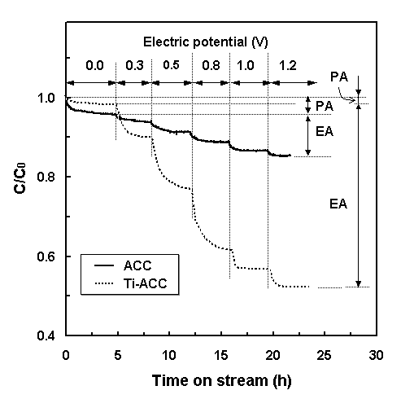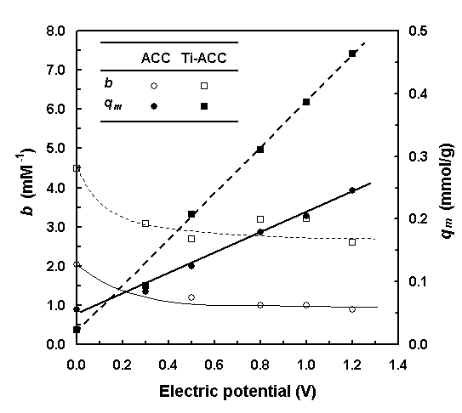
Fig. 1. Adsorption of NaCl on the ACC and Ti-ACC electrodes under various electric potentials. Physical adsorption (PA) and electrosorption (EA) were defined as in this figure. [NaCl]₀ = 0.1 mM.
Fig. 2. Variances of q_{m} and b determined from best fits of the Langmuir isotherms with electric potential in the adsorption of NaCl on the ACC and Ti-ACC electrodes at 25 ℃.

