졸-겔법에 의해 PET 필름에 코팅된
Silica/Poly(acrylonitrile) 박막의 차단 특성

성원영, 김성우
경기대학교 화학공학과

Barrier Characteristics of Silica/Poly(acrylonitrile)

Thin Films Coated on Poly(ethylene terephthalate) Substrate

by Sol-Gel Method

Won Young Sung and Seong Woo Kim
Department of Chemical Engineering, Kyonggi University

Introduction

The sol-gel process is a method to produce oxide thin coating layers at relatively low temperatures on variety of substrates such as polymer, metal, glasses, etc.⁽¹⁻⁴⁾ The three dimensional metal oxide network is formed by hydrolysis and condensation reaction of organometallic materials in alcoholic solutions under acidic or basic conditions. In particular, sol-gel coating on polymer substrates has been performed to provide various characteristics like abrasion resistance, barrier property, antistatic and antireflective properties, so on. However, thin coating layer obtained from only metal alkoxide as a starting material exhibits a phenomena of crack during gelling process and lack of adhesion to organic polymer substrates. Recently, in order to overcome these shortcomings, the coated polymer films with special functions have been produced by using organic/inorganic hybrid materials.⁽¹⁾ The organic/inorganic materials incorporated by organic structural units are also prepared by the sol-gel method. Silica thin films combined with poly(vinyl alcohol) as an organic material such as and have been coated on various polymer substrates such as polypropylene, nylon, and poly(ethylene terephthalate) which are widely used for wrapping materials to provide an improved barrier property and also to offer flexibility of coated films.⁽⁵⁻⁷⁾ In addition, functionalized organic alkoxy silanes such as methyltriethoxysilane(MTES), vinyltriethoxysilan(VTES), phenyltriethoxysilane(PhTES), and γ-aminopropyltriethoxysilane have also been used to modify the coating surfaces resulting in hydrophilic or hydrophobic properties.
In this study, the oxygen barrier property of silica coated polyethyleneterephthalate (PET) film was studied. Polyacrylonitrile (PAN) with superior barrier property was used as an organic material to obtain hybrid sol system. In addition, the effect of solvent systems for dissolving PAN on the barrier property of coating layer was investigated.

Experimental

Polyethyleneterephthalate (PET) was used as a substrate in this study (SM30 ; density(g/ml) = 1.4, Tm = 225~260℃). It was provided by SKC. The PET substrate films were supplied by film. Its average thickness was about 38 μm. Tetraethoxysilane (TEOS, C₈H₂₀O₄Si : ACROS Organics, 98%) was used as the starting material of sol system. Ethylalcohol (EtOH, C₂H₅OH : J.T.Baker, GR grade)

was used as the cosolvent of sol system. Vinyltriethoxysilane (VTES, C₈H₁₈O₃Si : ACROS Organics, 97%) was used as a coupling agent. Hydrochloric acid (HCl : Matsunoen Chemicals, GR grade) was used as an acid catalyst. Polyacrylonitrile (PAN, [CH₂CH(CN)-]_{n} : Aldrich) was used as an organic polymer, which was added into silica sol system. The coating was carried out on the substrates with spin coater (Headway Research). The coated films obtained were dried at 60℃ for 5 hours, and kept in a drying oven before other experiments. The hydrolyzed VTES solution as coupling agent was also layered on PET substrates by spin coating and drying in the same manner.
Fourier transform infrared spectroscopy (FT-IR) was used to find out the interaction between organic polymers and silica network. The sample was prepared by KBr dilution. The ratio of KBr to gel was 100. The FT-IR spectra were obtained by FT-IR spectrometer (Perkin-Elmer 1725). The morphology of the coating layers was observed using an atomic force microscope (AFM : Digital Instrument, Nanoscope IIIa, Dimension 3100). The microstructure of coating layers was measured in the contact mode. The scan Hz was 2. The cross sectional images of coated film were observed through scanning electron microscope (SEM : Jeol, JSM-T200) to measure the thickness of coating layers. Oxygen permeability of the samples was examined according to ASTM D3985 method.
Oxygen permeability of the sample was measured according to the method based on ASTM D3985. The permeation cell consisted of stainless steel short cylinder divided into an upper and lower part. The sample with a diameter of 4.4cm was inserted into this permeation cell separated by O-ring for sealing. The permeation system was evacuated at 10⁻³ torr for about one hour, and then oxygen(760 torr) was introduced to the upstream side. The permeated pressure as a function time on the downstream side was monitored by an MKS-Baratron transducer(MKS-627B). The temperature was controlled by water bath and maintained at 25℃ during each measurement. Two cylinders were connected to both upstream and downstream side to minimize the fluctuation of pressure with time by increasing the volume. The oxygen permeability could be determined from the slope in the plot of permeated pressure variation with time.

Result and Discussion

Phase Connection

Figure 1 shows the spectra of gel from TEOS-PAN sol system with nitromethane-TFE-water mixture solvent by FT-IR. The increment of molar ratio of PAN to TEOS increased the relative intensity of the peak at around 2260~2240 cm⁻¹ and 2800~3000 cm⁻¹, which was typical of PAN. The peaks of Si-O-Si bonds at about 1,150 and 840 cm⁻¹ and that of O-H bond at around 3450 and that of Si-OH bonds at around 920 cm⁻¹ were also detected. It was confirmed from these detected peaks that silica thin film with three dimensional network was produced successfully through sol gel process based on the hydrolysis and condensation polymerization of TEOS in solutions mixed with alcohol and water. The intensity of the peaks corresponding to Si-OH bonds was almost invaried with an increase of PAN. This implies that the organic material of PAN used in this study does not affect the sol- gel reaction comprising of hydrolysis and condensation, merely occupies independent locations as a dispersed phase in the entire region of hybrid sol system. It can be deduced that there may be ionic interaction between the nitrile group of PAN and silanol group of the silica, resulting in improved phase connection.

Morphology of Hybrid Coating Layers

Figure 2 shows Atomic Force Microscope (AFM) micrographs of coating layers. The substrates were coated by (a)only TEOS sol system and (b)TEOS-PAN sol system with nitromethane-TFE-water mixture solvent. The reaction temperatures were 25℃, pH was 0.1, the molar ratios of water to TEOS were 2, and the molar ratio of PAN to TEOS was 0.2273. The surfaces of coating layer containing PAN was found to be more smooth than that of silica coating layer, resulting in fine morphology of hybrid coating layers. As the structure of silica particle becomes linear and sparse, coating layer with dense structure could be achieved and the oxygen barrier property was also enhanced. When the silica gel was formed under lower ratio of water to TEOS and sol solution of pH below 0.5, the oxygen barrier property of the coating layer was found to be improved due to dense structure of silica gel. The oxygen barrier property was also affected by a roughness of surface of coating layer. These AFM micrographs give an explanation of the results in Figure 3.

Oxygen Barrier Property

Figure 3 shows the oxygen permeability of coating layers and the films coated by the TEOS-PAN sol system in which various contents of PAN were added. The molar ratios of water to TEOS were 2. The temperature of the solutions was kept at 60℃ to dissolve more amount of PAN. VTES was used as a coupling agent to offer phase connection between inorganic silica phase and organic PAN phase. It was shown that the oxygen permeability decreased when the molar ratio of PAN to TEOS increased. But the oxygen permeability increased when the molar ratio of PAN to TEOS was above 0.2727. In this study, PAN was added not only to overcome cracks of coating layer but to improve the oxygen barrier property with its low oxygen permeability. The addition of PAN decreased the oxygen permeability of coated films. But beyond its saturation point, the phase of PAN was separated from coating solution and then the permeability of coating film was increased slightly after this saturation point.
The results of the oxygen permeabilities of coated films prepared by various conditions were presented in Figure 4. In this figure the oxygen permeabilities of PET film pretreated with partially hydrolyzed VTES and coated with TEOS-PAN sol systems were compared. The oxygen permeabilities of coated films produced in optimal conditions of molar ratio of water to TEOS, pH, and temperature were exhibited. The oxygen permeability of PET film was 2.13 cc⋅mm/m²⋅24hrs⋅atm. and the oxygen permeability of PET film pretreated with partially hydrolyzed VTES and coated with TEOS-PAN sol system and nitromethane-TFE-water mixture solvent was 1.38. It was suppressed by 35.21% of that of non-coated PET film. The oxygen permeability of PET film pretreated with partially hydrolyzed VTES and coated with TEOS-PAN sol system and DMF solvent was 1.09. It was suppressed by 48.82% of that of non-coated PET film.

References
1. B. Wang and G. L. Wikes, J. Macromol. Sci. Pure Appl. Chem., A31, 249 (1994)
2. T. Saegusa, Y. Chujo, Makromol. Chem., Macromol. Symp., 64, 1 (1992)
3. T. Iwamoto and J. D. Mackenzie, J. Mater. Sci., 30, 2566 (1995)
4. M. Benmalek and H. M. Dunlop, Surface and Coatings Tech., 76-77, 821 (1995)
5. J. Kim, K. J. Lee, J. D. Nam, and S. W. Kim, Theories and Applications of Chem. Eng. 7, 2367

(2001)
6. K. Azuta, K. Tadanaga, and T. Minami, J. Ceramic Society of Japan, 107, 293 (1999)
7. K. Iwashita, K. Tadanaga and T. Minami, J. Appl. Polym. Sci., 61, 2173 (1996)

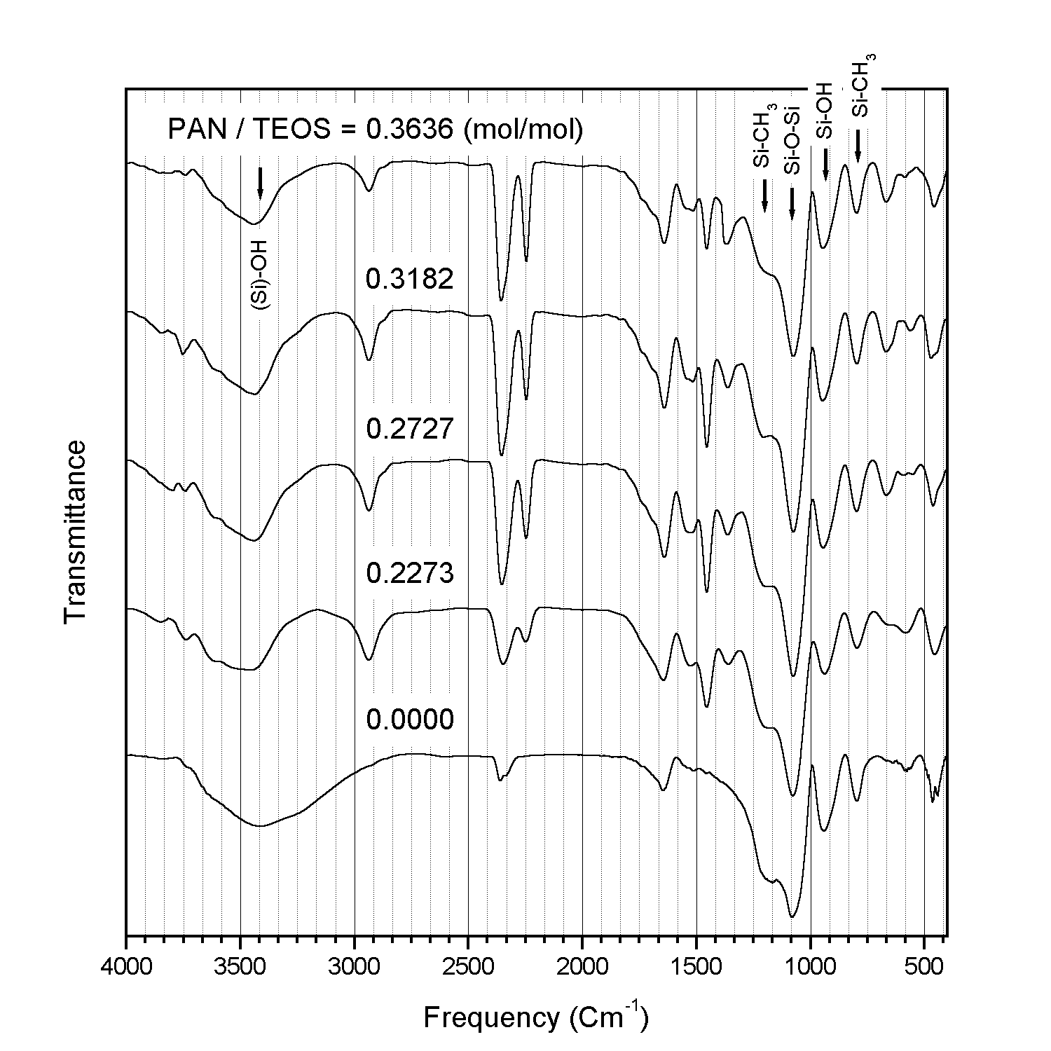
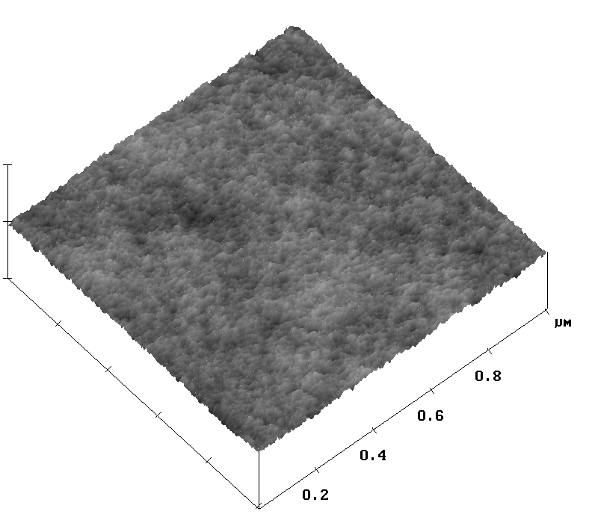
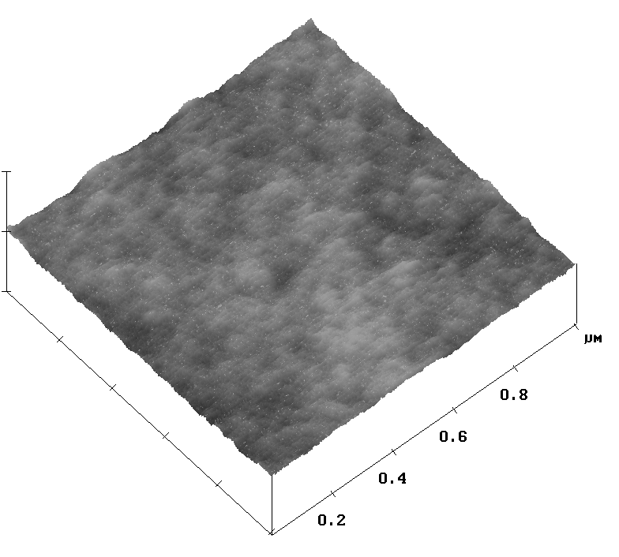
(a)
(b)

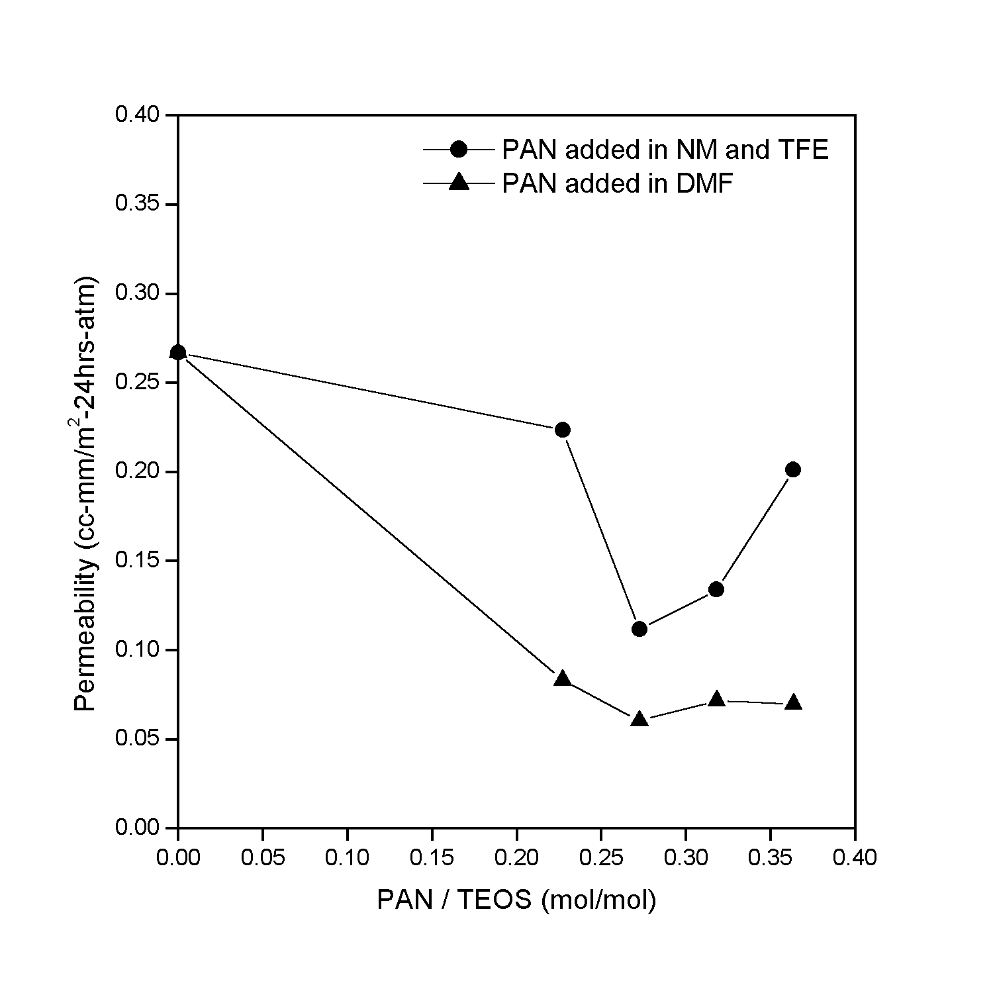
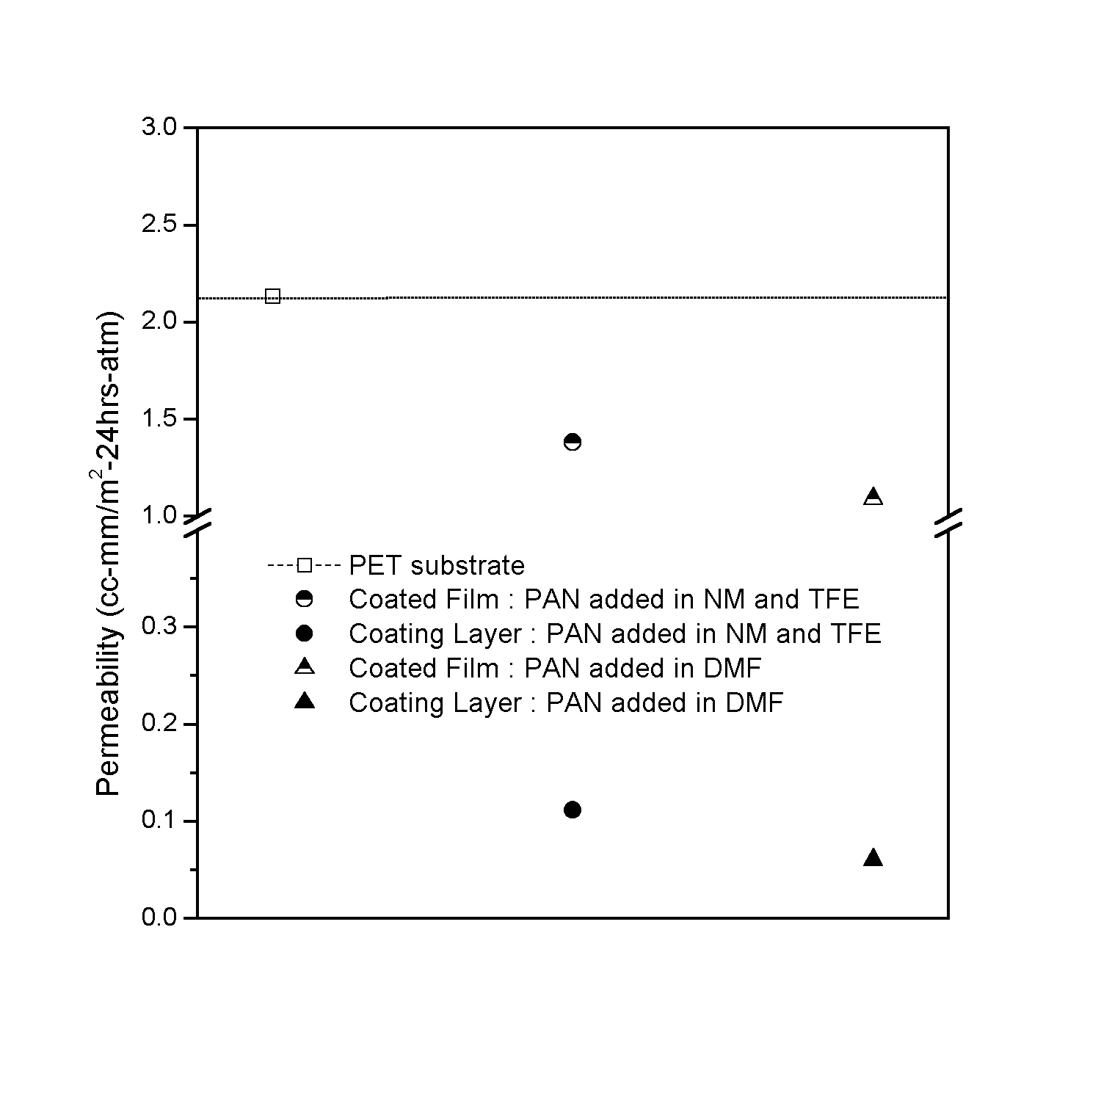
Fig.1. Spectra of gel from TEOS-PAN sol system with nitromethane-TFE-water mixture solvent by FT-IR.

Fig.3. Oxygen permeabilities of the coating layers where the various contents of PAN were prepared.
Fig.4. Arranged results of the oxygen permeabilities of coated PET film prepared by various conditions.
Fig.2. AFM micrographs of coated films by (a)only TEOS sol system and (b) TEOS-PAN sol system with nitromethane-TFE-water mixture solvent.

