자기 조립에 의한 Cytochrome c/GFP 복합박막의 정류특성 분석

변석현, 박세정, 최정우, 이원홍
서강대학교 화학공학과

Investigation of Rectifying Property of Cytochrome c/GFP Hetero Thin Film by Self-assembly Technique

Sukhyun Byun, Sei-Jeong Park, Jeong-Woo Choi and Won Hong Lee
Department of Chemical Engineering, Sogang University
C.P.O. BOX 1142, Seoul 100-611, Korea

Introduction
Ultra-thin film preparation techniques, such as Langmuir-Blodgett (LB) or self-assembly (SA), have been widely used to fabricate the highly ordered and close-packed molecular arrays of biological and/or organic molecules[1-2], and become one of the crucial technologies in the development of bioelectronic and molecular electronic devices. Photoinduced electron transport processes in nature such as photoelectric conversion and long-range electron transfer in photosynthetic organisms are known to occur not only very efficiently but also unidirectionally through the functional groups of biomolecules[3]. Based on the photoinduced electron transport in the initial process of photosynthesis, a bioelectronic device was developed artificially using molecular array consisting of protein/protein hetero films. Proteins (green fluorescent protein and cytochrome c) were introduced and used in fabricating molecular array as an electron sensitizer and electron acceptor, respectively.
In this study, the hetero film, composed of cytochrome c and GFP which used as an electron acceptor and an electron sensitizer, was deposited onto Au substrate by self assembly technique. The unidirectional electron flow from GFP to cytochrome c was confirmed by current-voltage characteristic with STM.

Experiment
1. Materials
Cytochrome c (extracted from horse heart, type VI), green fluorescent protein (GFP), were used as an electron sensitizer and an electron acceptor, respectively. GFP (rEGFP) and cytochrome c were purchased from CLONTECH CO. (Palo Alto, California, USA) and Sigma Chemical Company (St. Louis, USA), respectively. N-succinimidyl-3-(2-pyridyldithio)propionate (SPDP) and dithiothreitol (DTT;99%), also purchased from Sigma Chemical Company, were used as a cross-linker and a cleavage reagent of disulfide bonding for modification of functional group in the cytochrome c surface, respectively.

2. Method
Cytochrome c (type IV, Sigma Chemical Co.; M.W.=12,384) was mixed with phosphate buffer solution (pH 7.4). SPDP (MW.=312.4) and DTT were mixed with deionized distilled water, respectively. Cytochrome c was modified with SPDP for 30 minites at room temperature, and residual N-hydroxysuccinimide were removed by gel filtration. The Self-Assembly (SA) monolayer of GFP was deposited by dipping the cytochrome c film into the GFP solution. The gold was thermally evaporated on to the cleaned glass substrate. To obtain the STM microtopographic images, tunneling current was 0.5μm and a bias voltage V_{bias} was 1V. Rectifying property of the molecular bio-photodiode with nano scale was observed by current-voltage(I-V) measurement. The method of hybrid STM/I-V measurement was described in fig.1

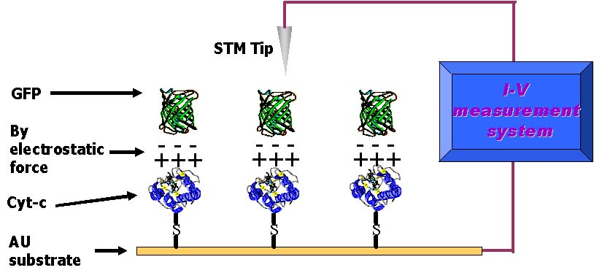
Fig 1. Scheme of a current-voltage (I-V) measurement using STM tip

Result & Discussion
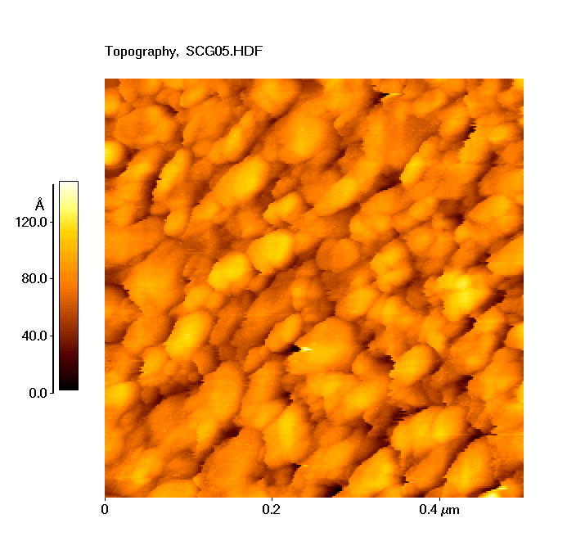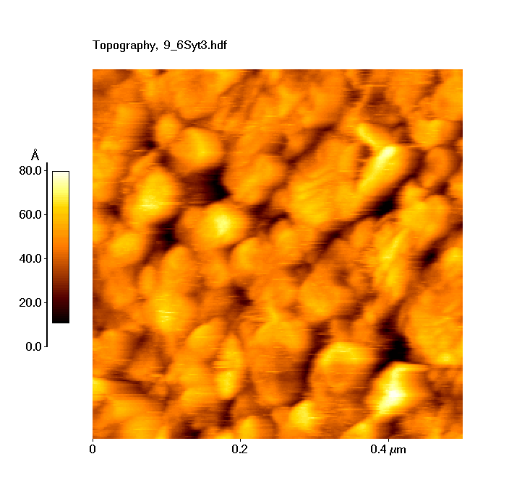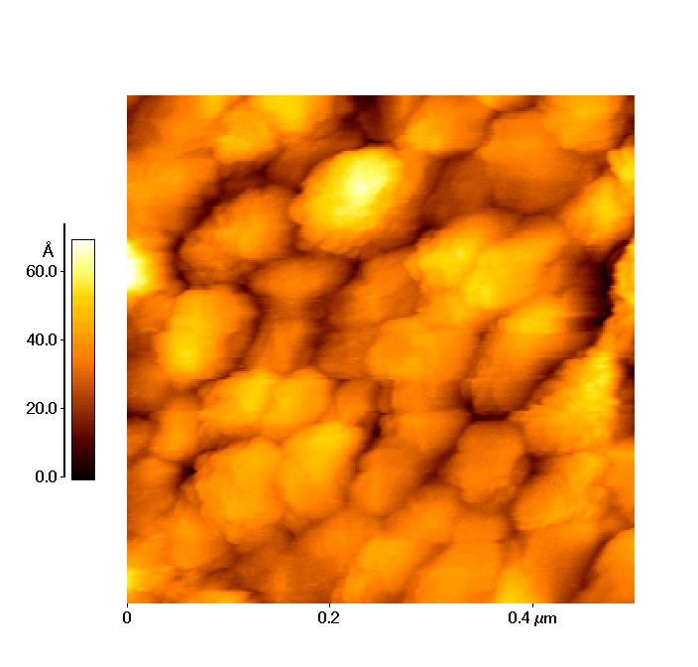
(a) (b) (c)
Fig. 2. STM images of a homo-film and hetero-films deposited onto the gold substrate; (a) gold substrate; (b) modified cyt-c film onto cytochrome-d; (c) cyt-c/GFP hetero film
Fig. 2 shows STM images of gold substrate(a), modified cytochrome c films onto the gold substrate(b) and cytochrome c/GFP hetero film(c). The height of a gold substrate was about 50Å and the size of gold paticle was about 60-80nm. Also, the modified cyt-c film onto the gold substrate has uniform surface morphology. The height of the film was about 90Å and the size of protein aggregation was about 40-50nm. The GFP was adsorbed onto cytochrome c films. The height and the domain size of cytochrome c/GFP hetero films were of about 130Å, 30-40nm, respectively.
As shown in fig. 3 the rectifying characteristic was observed. To verify the rectifying property in the nano scale, STM tip was used as a top electrode and the rectifying characteristics were observed from the measurement of current-voltage characteristics. When a +1V(forward) bias was applied to the molecular photodiode with the light irradiated, the photocurrent was generated with 13 nA. When a -1V(reverse) bias was applied to the molecular photodiode, the photocurrent was about 0.0nA. This property was called rectification property of photodiode. From these results, it can be concluded that the photodiode characteristics of the proposed device was verified with STM system and the proposed method for investigation of rectifying property by the STM system can provide the applicability of molecular electronic device with nano level.

Fig 3. The current-voltage (I-V) measurement using STM tip

The biomolecular device composed of functional proteins based on the electron transport in the biological photosynthesis process was investigated. The hetero-type films consisted of GFP and cytochrome c, which were used as a sensitizer and an electron acceptor, respectively. Based on the topologies by STM measurement, the modified cytochrome c film and the adsorption of GFP film onto cytochrome c film was verified. The photodiode characteristic function of the proposed system with nano scale (gold substrate/hetro-type film(cytochrome c/GFP)/STM tip) were verified by current-voltage characteristic measurement. The directional flow of photocurrent through their redox potential difference occurred efficiently in the proposed molecular device. The diode characteristic of the proposed system was verified with nano scale and thus the proposed molecular system composed of biomolecules could be applied as biomolecular photodiode with nano scale

Acknowledgement
This research was supported by the International Cooperation Research Program of the Ministry of Science & Technology(M1-0027-00-0009)

References
1. Ulman, A.: “An Introduction to Ultrathin Organic Films from Langmuir-Blodgett to Self Assembly”, Academic Press Inc., New York (1991).
2. Allara, D. L.: Biosensors & Bioelectronics, 10, 771 (1995)
3. Kuhn H., Hong F. T.: Molecular Electronics-Biosensors and Biocomputers, Plenium Press, New York (1993)

