이성분 초임계 이산화탄소와 1-알코올과의 혼합물에 대한 용해도
실험 및 모델링

하은숙, 변헌수†, 김낙현*, 곽 철*
여수대학교 생명화학공학부, 경남대학교 화학공학부

Experiment and Modeling of Solubility for Binary Mixtures in Supercritical Carbon Dioxide and Alcohol

Eun-Sook Ha, Hun-Soo Byun,† Nak-Hyun Kim* and Chul Kwak*
Dept. of Chem. Eng., Yosu Natl. Univ. *Dept. of Chem. Eng. Kyungnam Univ.

Introduction
The phase equilibrium of mixtures containing supercritical fluid at high pressure are required for use such as in the plant design and operation of separation process equipment in the fine petroleum, natural gas, and industrial application. In particular, supercritical fluid extraction is important for separation technology. Recently, we have performed phase equilibria experiments for mixtures with supercritical carbon dioxide.[1-3] The experimental phase behavior data relation for the carbon dioxide-1-butanol mixture were reported by Ishihara et al.[4] at 313.15 K and Jenning et al.[5] at 314.8 K.
The primary objective of this study is to expand the high-pressure, experimental phase behavior data base for carbon dioxide-1-alcohol mixtures by investigating mixtures of carbon dioxide with two polar compounds, 1-butanol, which has a large dipole moment of 1.7 D and 1-octanol, which have a very large dipole moment of 2.0 D.
The secondary objective of this work is to compare the performance of the Wong-Sandler (W-S)[6] and modified Huron-Vida (MHV1)[7] free energy-based equation of state mixing rules. The vapor-liquid equilibrium(VLE) of gas containing systems at high pressure with equations of state(EOS) is interesting because of the industrial important of these mixtures, and their asymmetric behavior. The correlation of the VLE of such systems using equations of state and the classic one-fluid mixing rules has not been good at high pressures and temperatures, and especially as the critical point of the mixture is approached. There have been several studies of mixtures with carbon dioxide. Recently, Berro et al.[8] used a excess free energy-equation of state model to predict the solubility of carbon dioxide in high molecular weight solvents.

Equation of state
There are a large number of equations of state available in the literature. In this work we used the Peng-Robinson [9] EOS

$P=\frac{\text{RT}}{\underline{V}−b}−\frac{a(T)}{\underline{V}(\underline{V}+b)+b(\underline{V}−b)}$ (1)

where P is the pressure, T is the temperature, V is the molar volume, R is the gas constant, b is the co-volume parameter and a is the energy parameter. In the PR-EOS, the parameters a and b are

a(T) = 0.457235 α(T) R²T_{c}² / P_{c} (2)

b = 0.077796 RT_{c} / P_{c} (3)

These relations insure that the pure component critical point at the correct temperature and pressure is obtained from the EOS. The term α(T) in Eq.(2) is temperature dependent, is unity at the critical temperature, and has been chosen to insure that the vapor pressure calculated from the EOS at other temperatures is acceptably accurate. One such representation is

α(T) = [1 + k (1 - ( T / T_{c} ) )]² (4)

which is applicable to hydrocarbons and organic gases with the following generalized form

k = 0.37464 + 1.5422 ω – 0.26992 ω² (5)

where ω is the Pitzer acentric factor. In this form the equation is completely predictive once the critical temperature, critical pressure and acentric factor are given.
Here we use the temperature dependence of the α(T) term proposed by Stryjet and Vera in which Eqn.(5) is replaced by the relation

k = k₀ + k₁ ( 1 + T_{r}^{0.5} ) (0.7 – T_{r}) (6)

with

k₀ = 0.378893 + 1.4897153 ω – 0.1713184 ω² + 0.0196554 ω³ (7)

The constant k₁ is specific for each pure compound and used to accurately fit vapor pressures ( P^{vap} ) as a function of temperature. This version of the Peng-Robinson EOS is referred to as the PRSV equation. The Stryjek-Vera modification of α(T) takes care of the inaccuracies in the correlation of vapor pressures at low temperatures. However, since the α(T) term is based on vapor pressure, it is not well defined at temperatures above the critical temperature of a component.

Experimental section
Figure 1 shows a schematic diagram of the experimental apparatus used in this work. Phase behavior data are obtained with a high-pressure, variable-volume cell described in detail elsewhere [3]. For the CO₂-1-butanol and CO₂-1-octanol mixtures studies, the empty cell is purged several times with CO₂ to remove traces of air, the liquid 1-butanol and 1-octanol is loaded into the cell to within 0.002 g using a syringe, and then CO₂ is condensed into the cell to within 0.004 g using a high pressure bomb. The solution in the cell is compressed to the desired operating pressure by displacing a movable piston using water pressurized by a high-pressure generator ( HIP, Model 37-5.75-60). The pressure is measured using a Heise pressure gauge (Dresser Ind., model CM-35790, 0-690 bar, accurate to within ±0.7 bar). The system temperature, maintained to within ±0.2 ºC, is measured with a platinum-resistance device accurate to within ±0.2 ºC (Thermometrics Corp., Class A) placed in a thermowell on the surface of the cell. The contents of the cell are projected onto a video monitor using a camera coupled to a boroscope (Olympus Corp., model F100-038-000-50) placed directly against the sapphire window.
Carbon dioxide was obtained from Daesung Oxygen Co.(99.8 % minimum purity) and used as received. The 1-butanol (no impurity) and 1-octanol (no impurity) used in this work were obtained from Aldrich Inc. Both components were used without further purification in the experiments.

Results and Discussion
For the accuracy and reproducibility of the experimental apparatus, we measured phase behavior data for a carbon dioxide-1-butanol system with the same mole fractions as a mixture measured by Ishihara et al.(4) at 40 ºC. The experimental and calculated data were in good agreement. The phase behavior data(bubble, critical and dew-point) for the two systems CO₂-1-butanol and CO₂-1-octanol mixtures are reproduced to within ±0.3 bar and ±0.2 ºC at least twice for a given loading of the cell. Table 1 and Table 2 present the data obtained in this work for the CO₂-1-butanol and CO₂-1-octanol systems. The mole fractions are accurate to within ±0.002. The mole fractions for the solubility isotherms at 40 – 120 ºC are arranged according to the value of at least two independent data points that have an accumulated error of less than 1.0%.
Figure 2 shows the experimental pressure-composition (P-x) isotherms at 40, 60, 80, 100, and 120 ºC and for the range of pressures from 23 bar to 200 bar for the CO₂-1-butanol system. The CO₂-1-butanol system is not observed to include three phases at any of the five temperatures. The P-x isotherms shown in Figure 2 are consistent with those expected for the type-I system where a maximum occurs in the critical mixture curve.
The figure will presents the phase behavior data at 40, 60, 80, 100, and 120 ºC and for pressures up to 230 bar for the CO₂-1-octanol mixture. Three phases were not observed at any of the five temperatures studied. The CO₂-1-octanol mixture exhibits type-I behavior. A detailed description of the characteristics of this type of phase behavior can be found in Scott and Konynenburg and McHugh and Krukonis.

Acknowledgments
This work was supported by the RRC program of MOST and KOSEF through the Research and Development Center for Facility Automation and Information System (FAIS) at Yosu National University

References
1.Byun, H. S., Kim, K., McHugh, M. A., Ind. Eng. Chem. Res., 39, 4580(2000).
2.Byun, H. S., Hasch, B. M., McHugh, M. A, Fluid Phase Equilibria, 115, 179(1996)
3.Byun, H. S.and Jeon, N. S. , Fluid Phase Equilibria, 167, 113(2000).
4. Ishihara, K., Tsukajima, A., Tanaka, H., Kato, M., Sako, T., Sato, M. and Hakuta, T., J. Chem. Eng. Data, 41, 324(1996).
5. Jenning, D. W., Lee R.-J. and Teja, A. S., J. Chem. Eng. Data, 36, 303(1991).
6. Wong, D. S. H. and Sandler, S. I., AIChE, 38, 671(1992).
7. Huron, M. and Vidal, J., Fluid Phase Equil., 3, 255(1979).
8. Berro, C., Barna, L. and Rauzy, E., Fluid Phase Equil., 114, 63(1996).
9. Peng, D.Y. and Robinson, D. B., Ind. Eng. Chem. Fund., 15, 59(1976).

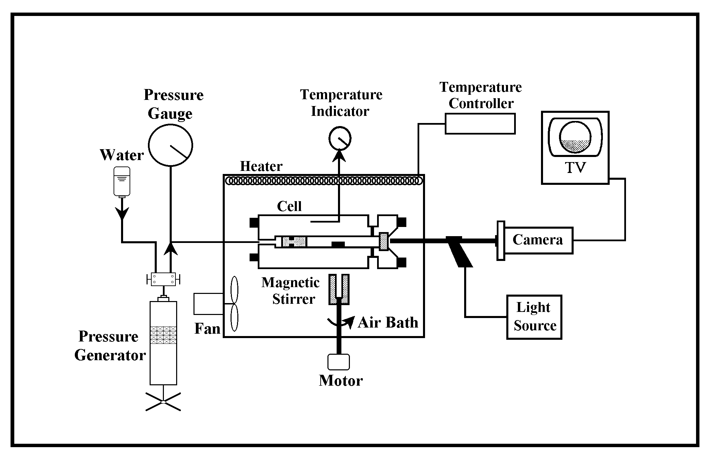

Fig.1. Experimental apparatus used in this work

Fig. 2. Pressure-composition isotherm for the carbon dioxide-1-butanol system

