Reverse Osmosis System을 이용한 축산폐수 처리 공정 개발

박순주, 장호남
한국과학기술원 화학공학과

Development of piggery waste water treatment system using Reverse Osmosis system

Soon Ju Park, Ho Nam Chang
Department of Chemical Engineering, Korea Advanced Institute of Science and Technology 373-1, Kusong-dong, Yusong-gu, Taejon, Korea, 305-701

Introduction
The livestock waste affects largely an economical burden for the use of river and an eutrophication, because it has the very high load of nutritious salts. Also a single farming produces about 15.1 percent of pollutant sources and industrial stock farming is situated in the suburbs of city and in the sources of reserved water service. From the 1999, an applicable discharged water quality standards not only add COD and the number of E.coil but also enforce the concentration of total nitrogen (T-N) and total phosphorous (T-P) in livestock waste water. In according to the enforcement of regulation, the introduction of process for removing nitrogen and phosphorous is necessary.
Up to now, the livestock waste water treatment methods have depended on the biological treatment. Biological treatment needs large site and treatment degree varies according to the growth of microorganism. And its pre-treatment is complicated.
So we tried to find easy and economical process which could remove nitrogen and phosphorous. Reverse Osmosis System which we studied had a good rejection about T-N, T-P and the concentration of its permeate approximated an applicable discharged water quality standards. Furthermore it removed color of waste water.

Materials and methods
Membrane. The membrane was supplied by Saehan. This reverse osmosis membrane had an asymmetric structure with a thin dense toplayer supported by a porous sublayer. A toplayer was composed of polyamide(polymers with an amide group –NH-CO- in general) and microporous layer was polysulfone, the reinforcement layer was polyester.
Piggery waste water. Piggery waste water was obtained from a farm located in Kongju, Chung-Nam. For a pre-experiment, sludge was leached by the mesh made out of steel and particles contained in the waste water were removed by centrifuge. The RPM of centrifuge was 5,000 and the operating time was 10 minute. The volume of waste water was 10L and sampling was carried out every 10 minute.
Measurement of flux. The sampling was carried out every an hour and taken for a minute. So the flux was the volume taken for a minute.
Measurement of concentration for NH₄⁺. NH₄⁺ was measured by Ion Chromatography (Waters) equipped with Waters IC-pak cation column(3.9*150mm HPLC column). The concentration of NH₄⁺ was 1000ppm.
Measurement of concentration for T-N, NH₃-N, NO₃-N, NO₂-N and PO₄³⁻. T-N was measured by TNT Persulfate Digestion Method. NH₃-N, NO₃-N, NO2-N and PO₄³⁻ were nessler Method, Chromotropic Acid Method, Diazotion Chromotropic Method and PhosVer 3 with Acid Persulfate Digestion(HACH Co.) respectively.

Experimental devices
The instrument diagram of equipment for this experiment is as follows (Fig.1). Experimental devices were equipped the pre-filter to remove suspended or large particles and supplied feed using a pump. The valve could control pressure. As the pressure increased, the flow rate of permeate was faster. The flow meter measured it. Retentate was recycled in the feed tank.

Results
Effect of time on flux and rejection. To check time dependence of flux and rejection, we carried out the experiment of flux change over time using NH₄⁺ (Fig.2). As the time elapsed, the flux increased little by little and was not varied after an hour. The steady state was reached after an hour. The rejection little changed over time (Fig.3). As pressure increased, rejection decreased.
Flux and rejection of piggery waste water. An experiment was carried out during 70 min. Flux decreased little by little over time because pressure was fixed at 30kg_{f}/cm² (Fig.4). The rejections of T-N and T-P almost were constant (Fig.5). The concentration of T-N was 57ppm and T-P was 0.07ppm. The rejection of NH₃-N decreased a little over time and those of NO₃-N and NO₂-N didn’t change during 70 min (Fig.6).
Effect of reverse osmosis on color. The original color of piggery waste water was Vandyke brown. The waste water filtered by reverse osmosis was removed and permeate was clear.

Discussion
The T-N and T-P in piggery waste water could be treated by reverse osmosis successfully. The concentrations of T-N and T-P were below an applicable discharged water quality standards. Also the reverse osmosis solved color problem.

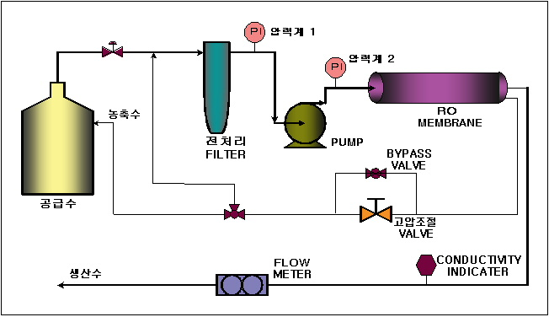
Figure.1. Experimental devices
Figure 2. Effect of Time on flux Figure.3. Effect of Time on rejection
Figure.4. Effect of pressure on flux Figure.5. Effect of pressure on rejection for T-N, T-P
Figure.6. Effect of pressure on rejection
for NH₃-N, NO₃-N, NO₂-N

Acknowledgements
This work was also partially supported by the Brain Korea 21 Project.

References
(1)National livestock Research Institute. “Domestic livestock farming waste water treatment dump maintenance and management profiles”(1990)
(2)Jeong YK. “Proper management alternatives of livestock wastes for protection of water resource”(1990)
(3)The Ministry of Environment . “Livestock waste water management plan”(1997)

