광학이성질체 분리 및 합성에 유용한 호모키랄 금속-유기 다공성 물질

김기문

포항공과대학교 화학과

A homochiral Metal-Organic Porous Material for Enantioselective Separation and Catalysis
Kimoon Kim
National Creative Research Initiative Center for Smart Supramolecules and Department of Chemistry, Division of Molecular and Life Sciences, Pohang University of Science and Technology, San 31 Hyojadong, Pohang 790-784, Republic of Korea
Inorganic zeolites are used for many practical applications that exploit the microporosity intrinsic to their crystal structures. Organic analogues, which are assembled from modular organic building blocks linked through non-covalent interactions, are of interest for similar applications. These range from catalysis, separation and sensor technology to optoelectronics, with enantioselective separation and catalysis being especially important for the chemical and pharmaceutical industries. The modular construction of these analogues allows flexible and rational design, as both the architecture and chemical functionality of the micropores can, in principle, be precisely controlled. Porous organic solids with large voids and high framework stability have been produced, and investigations into the range of accessible pore functionalities have been initiated. For example, catalytically active organic zeolite analogues are known, as are chiral metal-organic open-framework materials. However, the latter are only available as racemic mixtures, or lack the degree of framework stability or void space that is required for practical applications. Here I present the synthesis of a homochiral metal-organic porous material that allows the enantioselective inclusion of metal complexes in its pores and catalyses a transesterification reaction in an enantioselective manner.¹
Our strategy for achieving rigid, homochiral frameworks with large chiral voids exploits large, robust, enantiopure chiral metal-organic clusters as building blocks. Potential candidates for such building blocks include oxo-bridged trinuclear metal carboxylates (often known as 'basic' carboxylates) [M₃(μ₃-O)(O₂CR)₆(H₂O)₃]^{n+} (M = divalent or trivalent transition metal ions, O₂CR = organic carboxylate anions) (Fig. 1), which are commonly found in transition metal coordination chemistry and are readily assembled from metal ions and carboxylates. The water molecules bound to the metal centres are easily replaced by a Lewis base such as pyridine. We therefore thought that a rigid chiral organic molecule with a carboxylic group at one end and a pyridyl group at the other might serve the dual function of forming oxo-bridged trinuclear metal carboxylate units and linking these trimers into two- or three-dimensional frameworks.
The enantiopure chiral organic building block 1, which can be easily synthesized from D-tartaric acid, reacts with Zn²⁺ ions to produce a homochiral open-framework solid whose formula is given as [Zn₃(μ₃-O)(1-H)₆]2H₃O12H₂O (referred to as D-POST-1). The enantiomorphic L-POST-1 is obtained from the enantiomer of 1 and the Zn²⁺ ion under the same conditions.
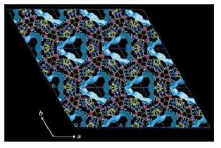
Fig. 1. X-ray crystal structure of POST-1 showing large channels.
In the crystal structure of D-POST-1, three zinc ions are held together with six carboxylate groups of the deprotonated chiral ligands and a bridging oxo oxygen, to form a trinuclear unit, in which a threefold axis parallel to the c axis passes through the centre of the trinuclear unit. The three zinc ions and the bridging oxo oxygen are located on the same plane. In POST-1, the trinuclear units, which behave as a secondary building unit¹⁴, are interconnected through coordinate covalent bonds between the zinc ions and pyridyl groups of 1, thereby generating two-dimensional (2D) infinite layers consisting of large edge-sharing chair-shaped hexagons with a trinuclear unit at each corner. The 2D layers stack along the c axis with a mean interlayer separation of 15.47 Å. The structure is apparently stabilized by efficient van der Waals interactions between the 2D layers arising from their self-complementary structure. Most notably, large chiral 1D channels exist along the c axis, the cross-section of which is best described as an equilateral triangle with a side length of 13.4 Å. The void volume of the channels is estimated to be 47% of the total volume and is filled with water molecules (47 water molecules per unit cell). POST-1 is stable in normal organic solvents, and slightly soluble only in water and DMSO. POST-1 loses crystallinity upon removal of the solvate molecules by evacuation, but restores it upon exposure of the evacuated sample to ethanol or water vapor as judged by powder X-ray diffraction patterns.
There are six pyridyl groups per trinuclear unit ([Zn₃(μ₃-O)(1-H)₆]²⁻) in the structure. Three of them are coordinated to the zinc ions of three neighbouring trinuclear units, the other three extrude into the channel without any interactions with the framework. Considering that the zinc ion, the deprotonated ligand 1 and bridging oxo oxygen have charges of +2, -1 and -2, respectively, we need two additional positive charges per [Zn₃(μ₃-O)(1-H)₆]²⁻ unit for overall neutrality. Given that there are no other counter ions found in the crystal structure, which has been confirmed by elemental analysis, it is reasonable to assume that the two positive charges required are provided by protonation of two of the three pyridyl groups exposed in the channel. Cation exchange experiments subsequently showed that the protons bound to the pyridyl groups can be exchanged with alkali metal ions, such as Na⁺, K⁺ and Rb⁺ without structural change of the host framework.
Owing to the chiral environment of the channel, enantioselective inclusion of cationic metal complexes can also be achieved. Upon suspending L-POST-1 in a methanol solution of racemic [Ru(2,2'-bipy)₃]Cl₂ (bipy = bipyridine), the colour of L-POST-1 changes from white to reddish yellow. NMR, UV-visible and CD measurements showed that 80% of the exchangeable protons are exchanged with [Ru(2,2'-bipy)₃]²⁺ (0.8 Ru complex per [Zn₃(μ₃-O)(1-H)₆]²⁻ unit) with 66% enantiomeric excess in favour of the Δ-form. Such enantioselective inclusion of chiral metal complexes in modular porous materials is unprecedented.
The pyridyl groups exposed in the channels endow POST-1 with unique opportunities for chemical modification of the channel environment. For example, the N-alkylation of all the pyridyl groups can change the framework charge of POST-1 from negative to positive. Treatment of a suspension of crystalline POST-1 in DMF with excess iodomethane at room temperature for 2 h results in the conversion of all the pyridyl groups exposed to the channels to N-methyl pyridinium ions as indicated by ¹H NMR analysis. However, powder X-ray analysis reveals the framework structure to be unchanged. Raman spectroscopy confirmed the presence of I⁻₃ counterions in the methylated POST-1. The anion can be reversibly exchanged with other anions. For example, the addition of a slight excess of NaPF₆ to a suspension of the methylated POST-1 in DMF results in full exchange of I⁻₃ with PF⁻₆ in the modified POST-1, as determined by infrared spectroscopy. The exchanged PF⁻₆ can be in turn exchanged with p-toluenesulphonate (CH₃C₆H₄SO⁻₃).
The pore size of POST-1 is also modulated by N-alkylation of the pyridyl groups. Thermal analysis of the modified porous solids, the channels of which had been filled with DMF molecules, showed that the pore volume of POST-1 shrinks by 14% and 60% upon N-alkylation with iodomethane and 1-iodohexane, respectively. The amount of anions that can be included in the channel also decreases as the pore volume shrinks.
The presence of the pyridyl groups exposed in the channels also provides POST-1 with unique opportunities in catalysis. We examined the catalytic activity of POST-1 for transesterification of ester 2. Treatment of 2 and ethanol with suspension of POST-1 (0.1 equivalents) in carbon tetrachloride for 55 h at 27 ºC produced ethyl acetate in 77% yield. No or little transesterification occurs without POST-1 or with the N-methylated POST-1, respectively. Transesterification of 2 with bulkier alcohols such as isobutanol, neopentanol and 3,3,3-triphenyl-1-propanol occurs with a much slower or even negligible rate under otherwise identical reaction conditions. Such size selectivity suggests that the catalysis mainly occurs in the channels.
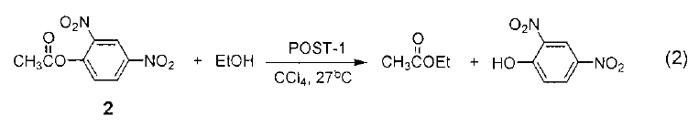
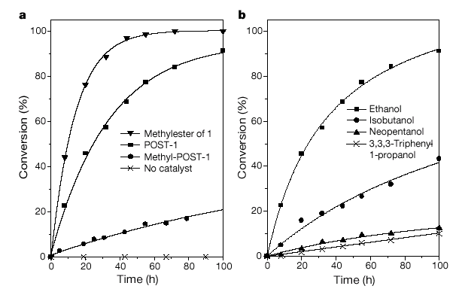
Fig. 2. Catalytic activity of POST-1 in transesterification
POST-1 revealed enantioselective catalytic activity for the transesterification of 2. A preliminary study showed that the reaction of 2 with a large excess of racemic 1-phenyl-2-propanol in the presence of D-POST-1 or the enantiomorphic L-POST-1 produces the corresponding esters with 8% enantiomeric excess in favour of S or R enantiomer, respectively. Although modest, the enantioselectivity of this process is noteworthy because asymmetric induction has never been observed in reactions mediated by modular porous materials. Further studies on enantioselective catalytic activities of POST-1, including a search for reactions and substrates that may lead to higher enantiomeric excess values, are currently underway. We anticipate that this design strategy, applied to chemically modified starting materials, will allow the introduction of other recognition and/or catalytic sites into the channels of analogous porous materials, which may find useful applications.
Acknowledgements. We thank the Korean Ministry of Science and Technology (Creative Research Initiatives Program) for supporting this work.
References
1. J. S. Seo, D. Whang, H. Lee, S. I. Jun, J. Oh, Y. J. Jeon, K. Kim Nature 2000, 404, 982.

