식각용액으로 구성된 냉각패드를 활용한 새로운 개념의
반도체공정용 화학적 기계적 연마공정에 관한 연구

오윤진¹, 박경순¹, 유재옥², 정태우², 김일욱², 정찬화¹

¹성균관대학교 화학공학과
²(주)하이닉스반도체

A New-Concept Chemical Mechanical Polishing Method
using Frozen Chemical Pad for Semiconductor Device Processing

Youn-Jin Oh¹, Gyung-Soon Park¹, Jae-Ok Yoo²,
Tae Woo Jung², Il-Wook Kim², and Chan-Hwa Chung^{1,}

¹ Dept. of Chemical Engineering, Sungkyunkwan Univ., Suwon 440-746, Korea
² Hynix Semiconductor Inc., Ichon 467-701, Korea

Introduction
In sub-micron ULSI semiconductor manufacturing, there were several innovative processes, which devote to reducing the cell size and increasing circuit density drastically, such as the high-resolution lithography, the Shallow Trench Isolation (STI) process, and the Chemical Mechanical Polishing (CMP). Especially, the CMP process was one of the most innovative processes being used in the STI process, metal interconnection (W-plug, Al, and copper metallization with dual-damascene process), pre-poly silicon plug, and Inter Metal Dielectric process (IMD) [1,2]. The conventional CMP process uses various slurries, abrasives, and polishing pads. Recently, However, several difficulties and limitations have been reported in this CMP process, which should be solved before the use in next generation ULSI device manufacturing. The problems are lying in unstable slurries, scratches onto the surface, various metal contaminants, the dishing features, post-cleaning difficulties, selectivity problem, and high costs for equipment and process maintenance [3,4].
In our study, we have proposed and developed a new concept in CMP process, which is called the Frozen Chemical polishing (FCP) process. It uses the frozen etchant pad instead of the conventional polishing pad and slurries. The apparatus and scheme of the FCP process are shown in Fig. 1. The wafer head is also linearly oscillated and rotated. The temperatures of the frozen pad and head are precisely controlled as well as the pressure loaded between the wafer and the pad. Therefore, the frozen etchant pad is melt only at the place where the wafer is touched and the patterned surface is etched and finally polished. Using our FCP process, we can expect several merits. First, there will be no scratches, various metal contaminants, and the dishing features. Secondly, it is more convenient to clean the wafer than that of the complicated conventional CMP process. Therefore, we have concluded that we can expect to resolve the problems in the conventional CMP process and the process steps be drastically reduced, which results in low process cost.
Experiment
We have performed the FCP process using two kinds of the doped poly-silicon wafer for testing an etching rate and global topology planarization. The doped poly- silicon (3400Å) that is deposited by Metal Organic Chemical Vapor Deposition(MOCVD) is plugged at 0.16㎛ contact hole in the patterned PE-TEOS (1500Å)/HDP oxide(6000Å) as shown in Fig.2. The etchant, which is composed of HF, HNO₃, CH₃COOH, and H₂O, is hard-frozen in the cooling reservoir and then used for planarization instead of a conventional hard polishing pad. In our experiment, we have considered the following experimental variables such as the compositions of frozen etchant, the temperatures of a wafer and a frozen etchant pad, and the rotating speeds of a wafer and a frozen etchant pad.
First, we have experimented on the etching rate of poly Silicon wafer at –30 ~ 0℃ with the various time and temperatures using the blanket poly-silicon wafer. The etchant composed with HF, HNO₃, CH₃COOH, and H₂O of several volumetric ratios, of which HF is used as a main etchant, HNO₃ as an oxidant for poly-silicon, and CH₃COOH as etch-suppresser or etchant modulator. From the etching rate test in a low temperature, we could find the etch rate decrease and the roughness of the surface morphology increase as the temperature decreases from 0 to –30℃.
Secondly, we have performed the FCP process on the doped poly-silicon topology wafer. In this experiment, the compositions of frozen etchant are varied in several volumetric ratios. The temperature of the frozen etchant at several composition ratios is maintained in the range of –60 ~ –90℃ as well as the wafer temperature is varied in the range of –40 ~ 0℃. We have also varied the rotational speed of the wafer header and frozen etchant pad in a range of 20 ~ 70 rpm. The etching rate changes with the compositions of the frozen etchant.

Result and Conclusion
In FCP process, we have polished the wafer in various conditions. As mentioned above, the most important parameter is the temperature of wafer because the frozen etchant pad melts only at the place where the wafer surface is touched and finally polished. Therefore, we have polished the wafer in two cases of different wafer temperatures. When we have polished the wafer and its temperature is not controlled, the wafer is not polished as shown in Fig. 3(a). On the other hand, Fig. 3(b), shows the wafer is polished when its temperature is controlled with 0℃. From our experiment for the variation of wafer temperature, we have concluded that the wafer is not polished by only mechanical polishing without the chemical etching by the meltdown of frozen etchant.
We have also found the compositions of the etchant affects our FCP process. The etch rate increases as the HF ration increases in our experiment. Furthermore, the surface morphology is affected by the amount of CH₃COOH that is used as an etch suppressor. Figure 4 shows the surface morphology with the volumetric ratio of CH₃COOH. The surface is rather rough when CH₃COOH is not added as shown in Fig. 4(a). However, the roughness is relatively decreased when we increase the volumetric ratio of CH₃COOH. From our experimental results, the composition of etchant is a key parameter in FCE process. Therefore, our FCE process places more weight on the chemical etching than mechanical polishing.
Finally, we have observed the characteristics of polishing process with the process time. We have polished the wafer with following process times; 2min, 4min, and 7min controlling the wafer temperature with 0℃. In this case, the etch rate is relatively high because the frozen etchant pad is easily melted down by the wafer. When we have polished the wafer in 2min, poly silicon is etched about 2000Å as shown in Fig 5(a). After 4min, Fig 5(b) shows poly silicon is well etched to the borderline of PE-TEOS. When the process time reaches to 7min, plugged poly Si is etched and seams are generated as shown in Fig. 5(c). In this case, the melted etchant penetrate plugged poly silicon. However, If we reduce the temperature difference between frozen etchant pad and wafer by reducing the wafer temperature, we can decrease the etch rate and prevent the penetration rate of melted etchant.

From our experiment, we have observed that the etch rate decreases as the etchant temperature decreases and the etch rate is also varied with the composition of etchant. Furthermore, the surface roughness is controlled by the variation of etchant. The most important parameter is the difference of temperatures between the frozen etchant pad and the wafer. The enhanced etch rate results increases showing the penetration of melted etchant as the difference of temperature increases. In our FCE process, there are several problems to solve such as the controls of etch rate and surface roughness. However, we expect to solve the issued problems of present CMP process such as the high process cost due to slurry and polishing pad, the contaminant, scratches, dishing problem, and the increase of surface roughness after cleaning process.

REFERENCES
1. E. Gaulhofer, Solid State Technology, 34, 57 (1991).
2. D.T. Price, Ronald J. Gutman, and S.P. Murarka, Thin Solid Films, 308, 523 (1997).
3. P.C. Andricacos, C. Uzoh, J.O. Dukovic, J. Horkins, and H. Deligiani, IBM T.J. Wattson Research and Development, 42, 561 (1998).
4. R.J. Contolini, S.T. Mayer, R.T. Graff, L. Tarte, and A. F. Bernhardt, Solid State Technolgy, 155 (1997).
Frozen
etchant pad

Wafer

Fig. 1. The scheme of the polishing apparatus using a frozen etchant pad.

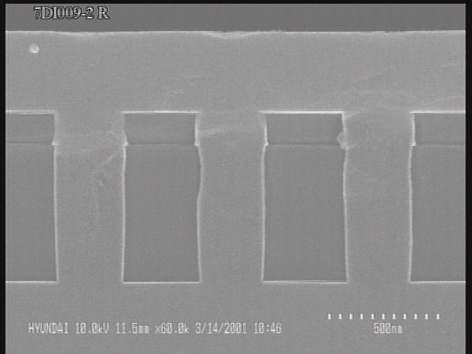
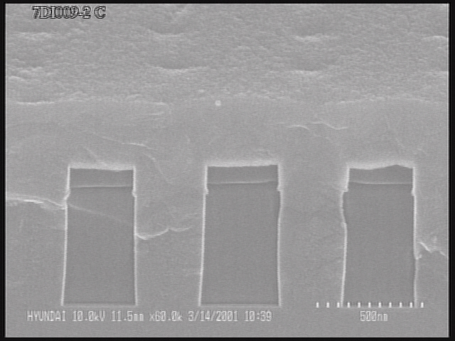
HDP Oxide
Poly Si
PE-TEOS
Plug Poly
Si substrate

Fig. 2. The SEM images cross-section doped poly-silicon (Poly Si/PE-TEOS/HDP oxide/Si substrate)
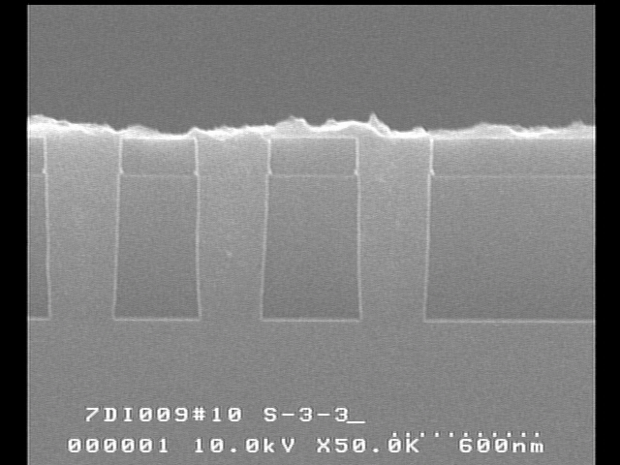
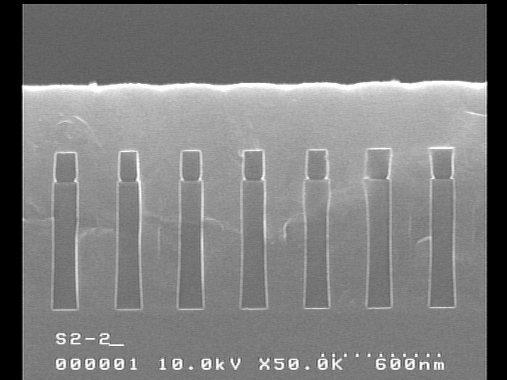
(b)

(a)

Fig. 3. The SEM images after FCE process with the different wafer temperatures; (a) without the control of wafer temperature and (b) when the wafer temperature is controlled with 0℃.
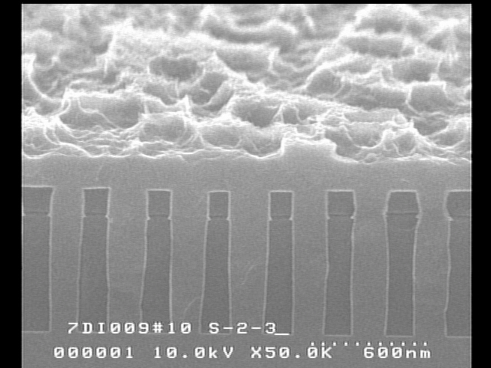
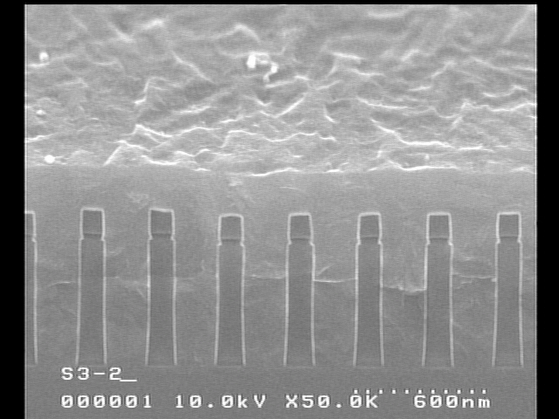
(a)
(b)

Fig. 4. The surface morphology according to the composition of frozen etchant; (a) when CH₃COOH is not added and (b) when CH₃COOH is added.
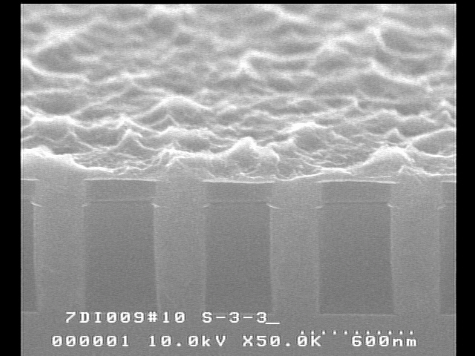
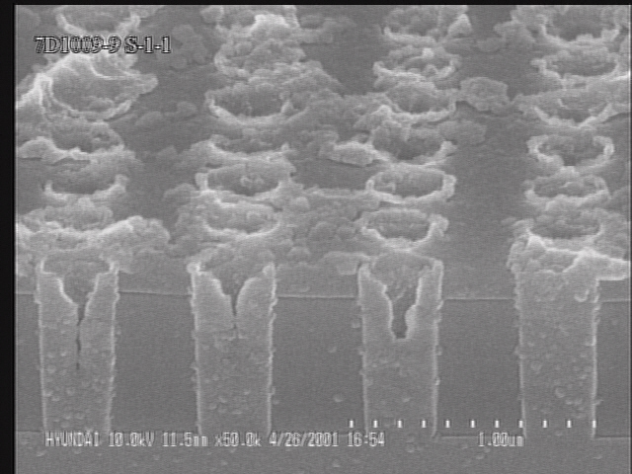
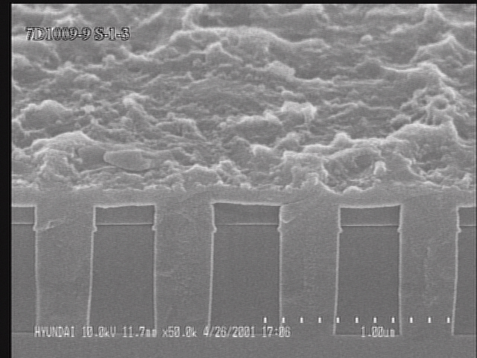
(c)
(b)
(a)
Fig. 5. The SEM images after FCE process with the process time; (a) after 2min, (b) after 4min, and (c) after 7min.

