화염의 이온농도 분포의 측정

최 한욱, 김 영한
동아대학교 화학공학과

Determination of Ion Distribution in Flame

Han Wook Choi and Young Han Kim
Dept. of Chem. Eng., Dong-A University

1. Introduction
There are two methods to measure such a fast process: electrical and optical techniques. Both of them are suitable for fast varying systems. Though recently developed laser measurement techniques scan a whole cross-section at one time and provide information without spatial limitation, the condition of a measurement chamber has to be adequate for the optical measurement. On top of their high cost of measurement instrument, the technique requiring optical path is not applicable to the combustion system having steel wall; most of combustion chambers in practice are made of steel.
An electrostatic measurement system is simple and inexpensive to be implemented in the flame analysis. It detects only a local composition in the flame, but new data acquisition system connected to a personal computer getting multiple measurements [1] at the same moment solves the problem of spatially limited detection. The ion measurement in a laminar flame is conducted by Shcherbakov et al. [2], and in turbulent flames Furukawa et al. [3,4] measured the flame using an electrostatic probe.

In this study, an electrostatic probe system for the ion measurement in a flame is developed and is utilized to butane-air system. The fabrication detail of the measurement system is explained for the researcher being expected to utilize the probe. Also, a numerical calculation using a set of partial differential equations of mass and energy balances is conducted to compare with the experimental measurement.

2. Experimental

2.1 Preparation of probe
Because the electrostatic probe is expected to be utilized in a concealed solid container and to measure a local ion concentration, it is made of a small size of a stainless steel tube with a thin platinum wire. The tip of the wire is extruded by 1 mm from the end of the protective tube. The wire is installed inside the tube, and the wire is insulated from the tube for the measurement of electric current between them during the measurement of ion concentration. The voltage measurement across the resistor gives the current. The supply of dc voltage is provided from the circuit, of which the positive electrode is connected to the center wire and the negative is to the protective tube. For the high voltage supply, the circuit is built with high voltage components. The signal voltage is directly provided to a home-made A/D converter. The digitized measurement from the A/D converter is transferred to a PC through a printer data port. To eliminate noise contained the signal, an integration type A/D converter is used, though its conversion time is longer than that of successive approximation type. The sampling frequency of the home-made converter is 10 Hz, which is high enough for the experiment. Three signals of ion current, temperature, and probe position are separately and sequentially transferred to the A/D converter. The control of the input signal transfer is conducted through a PC. The converter generates four digits of binary coded decimal data, and they are sent to the PC through a parallel port. The conversion of the data is included in the program for the experiment.
The amount of electric current is proportionally related to the ion concentration, but the detection of weak current signal is impossible without applying external voltage supply. The voltage and current have a linear relation within a certain range. Low voltage gives better ion measurement as long as the current signal is detected. A linear relation is observed up to 40 volts, and therefore 20 volts are applied in this experiment after the sensitivity and linearity between the supply voltage and current signal.
For the measurement of temperature a thermocouple thermometer of K type is utilized here. The detail of thermocouple selection is explained in Heitor and Moreira [5]. A temperature indicator (Konics Co., Korea, Model KN-2200) is installed for the monitoring and data transfer to a PC. The indicator generates 4-20 ma current output, and it is converted to voltage signal using a 100 ohm resisitor directly connected to the output port. The voltage signal is fed to the A/D converter. For the calibration of the thermometer, temperature and measured voltage are plotted in Figure 1, which indicates a good linear relation.
In order to adjust the position of a probe and a T/C thermometer, a driving system is constructed. The set of the probe and thermometer moves forward and backward by driving a geared induction motor of which the shaft is coupled with a screw. The motor turns both directions. The turning of the screw pushes or pulls a probe bracket. The location of the bracket is detected from a slide resistor connected to the bracket. A circuit is implemented to measure the position as a voltage signal. The voltage is measured through the A/D converter.

2.2 Burner construction
For the simple assembly of a burner, half-inch fittings are utilized. Fuel is supplied through a 1/8 inch copper tube installed at the center of the burner. The detailed dimension of the burner is given in Figure 2. Air is supplied from the side of the burner.

2.3 Experimental setup
The whole arrangement of experimental equipment is shown in Figure 3. Air is provided from an air blower and a rotameter for the flow measurement. Flow rate is adjusted using a needle valve attached on the rotameter. Fuel is drawn from a cylinder and is supplied by the same manner as for the air supply. The probe signal, signal from temperature indicator, and probe position voltage are directed to the A/D converter. The digitized measurement is provided to the PC, and the data are stored in the PC for the analysis later.

2.4 Experimental procedure
The probe set is positioned at a given height from the top of burner head. The height is set from 0.5 cm, and is increased by 0.5 cm until no current is detected. The air blower is activated for the air supply, and the needle valve on the rotameter is adjusted for a given flow rate. Then fuel is supplied at a desired flow rate. Gas of n-butane is used as the fuel. After a couple of seconds, the flame is ignited. While the computer program for data collection is running, the probe driving motor is activated for forward scanning until the probe passes all the way through the flame and for backward scanning. After the probe returns at its initial position, the program stops and the flame extinguishes.

3. Results and discussion
In order to examine the performance of experimental setup, a test run is conducted and the result is shown in Figure 4. While the probe is moving forward and backward as shown in the figure of position, electric current and temperature are measured and displayed in two left figures. Because of high convective heat transfer near the flame and conduction through the protective tube, an accurate measurement of point temperature is not available as noticed from the broad temperature distribution. Note that a thin thermometer of 1 mm in diameter is utilized here. Therefore, the flame analysis is conducted by examining the current variation only.
When fuel is supplied at the rate of 30 cm³/min., the ion distribution is given in Figure 5. The numbers in the figure indicate the amount of current in microampere unit. A circular pattern is observed at the height of 2.5 cm, and weak signal is detected at bottom. A similar pattern of current measurement is found with the rate of 40 cm³/min., but the strength of the current is twice as much as the previous one. With the rates of 50 and 60 cm³/min., almost identical current distribution is obtained and described in Figure 6. About 5 times as high current as the last one is detected in these cases. And the current distribution in the last two cases is almost identical except flame length is a little longer. With a small amount of fuel supply, the ion generation is limited from the amount of the fuel. When the supply is high enough, the current strength is saturated owing to the air supply. The measurement of ion distribution gives the optimum fuel and air ratio.
The highest temperature is observed at the center and one third of axial location. The temperature diminishes as moving away from the center. Though the location of the highest temperature is different from the current measurement of the experiment, the patterns of both distributions of ion from the experiment and temperature from the numerical calculation are similar. Though complex chemical reactions are involved in combustion process, high temperature indicates high rate of exothermic reaction and ion generation. This explains the similarity of the temperature and ion concentration distributions. The difference in location of the center of circular pattern is from the discrepancy in parameters used in the numerical calculation and the experiment.

4. Conclusion
The measurement of ion concentration in a laminar flame is conducted by utilizing an electrostatic probe, which is designed for the detection of ion distribution in a confined combustion chamber. The detail of probe fabrication and experimental setup is provided here. In addition, a numerical analysis is carried out to compare the computed distribution of concentration and temperature with the experimental outcome.
The distribution of ion in the flames is measured with different fuel supply rates. The analysis of the distributions gives the optimum ratio of fuel and air supply. Also, the result of the numerical temperature calculation shows a similar pattern with the ion distribution measured experimentally. In other words, either measurement of temperature or ion distribution gives identical information for the analysis of a flame.

References
[1] Waterfall, R. C., He, R, White, N. B. and Beck, C. M., “Combustion Imaging from Electrical Impedance Measurements,” Meas. Sci. Technol., 7, 369 (1996).
[2] Shcherbakov, N. D., Ospanov, B. S. and Fialkov, B. S., “Negative Ion Distribution in Hydrocarbon Flames,” Combust. Explos. Shock Waves, 24, 313 (1988).
[3] Furukawa, J., Nakamura, T. and Hirano, T., “Electrostatic Probe Measurement to Explore Local Configuration of a High Intensity Turbulent Premixed Flame,” Combust. Sci. and Tech., 96, 169 (1994).
[4] Furukawa, J., Hirano, T. and Williams, F. A., “Burning Velocities in a Turbulent Premixed Flame,” Combust. and Flame, 113, 487 (1998).
[5] Heitor, M. V. and Moreira, A. L. N., “Thermocouples and Sample Probes for Combustion Studies,” Prog. Energy Combust. Sci., 19, 259 (1993).

Figure 1. Calibration of temperature
measurement.

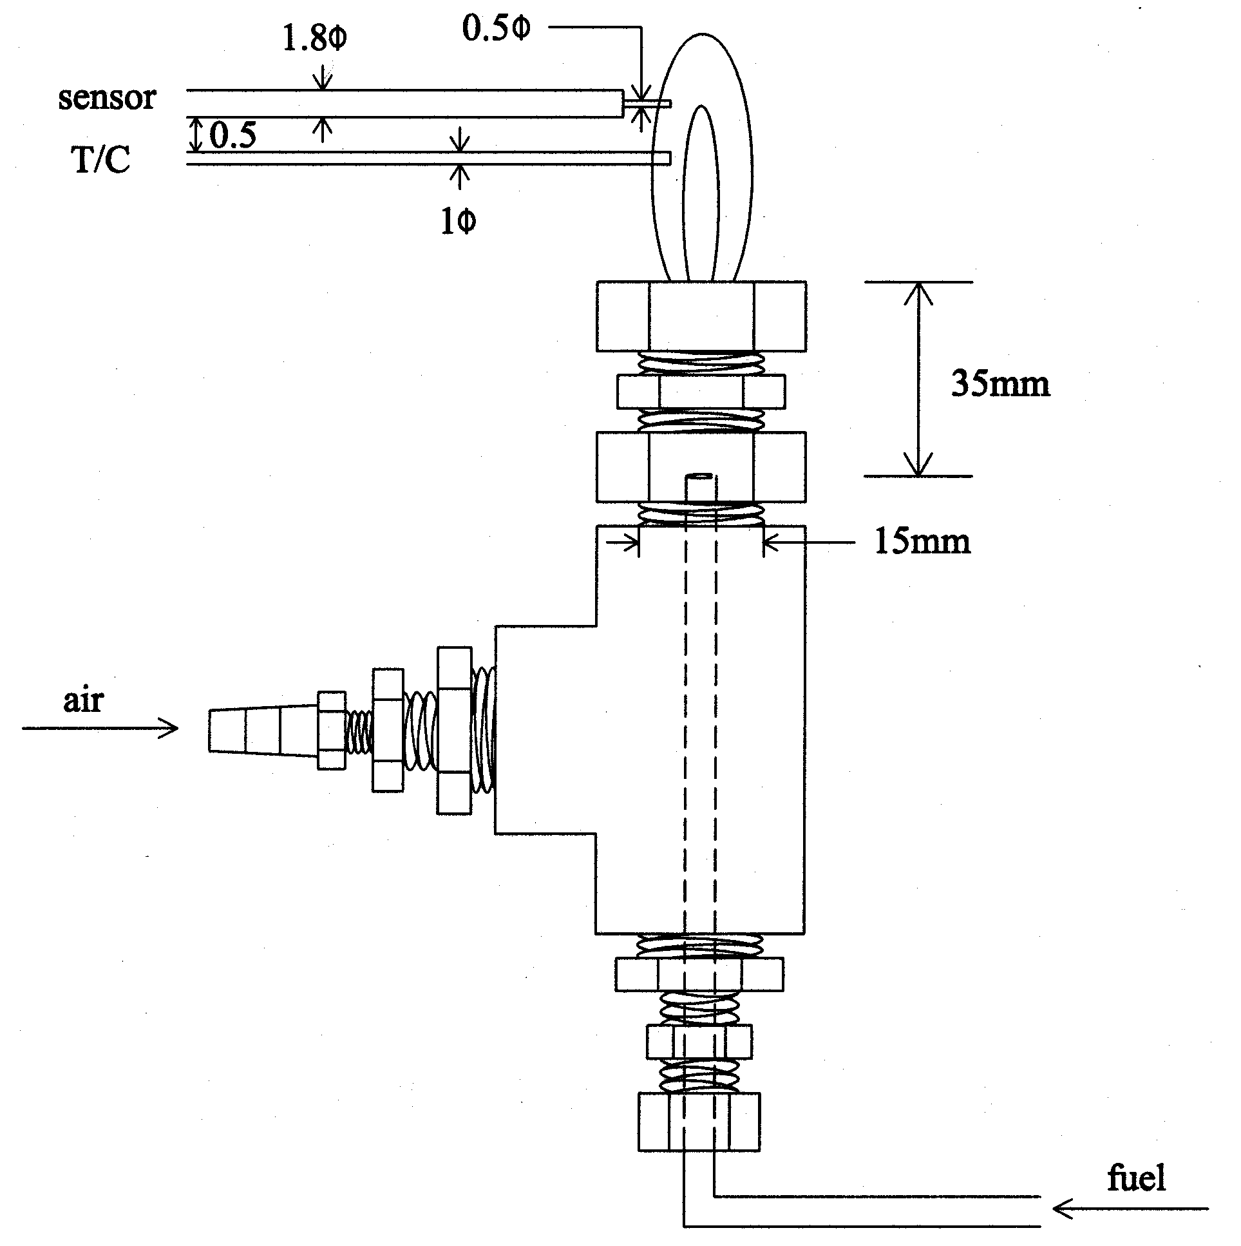

Figure 2. Schematic diagram of electrostatic probe, T/C thermometer, and burner.

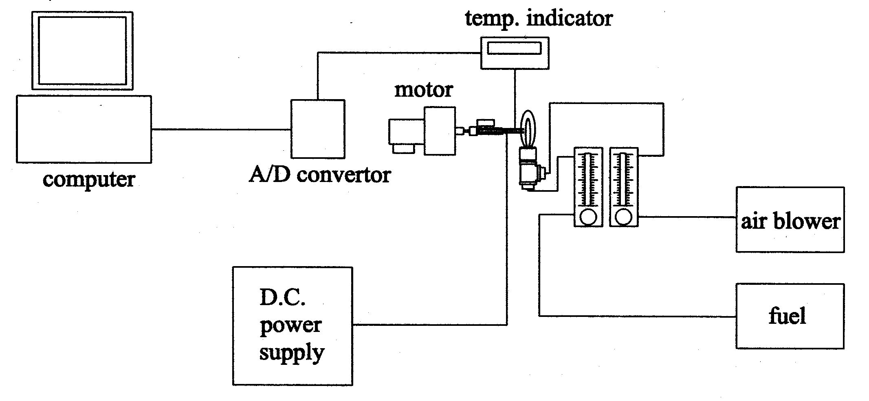

Figure 3. Schematic of experimental setup.

Figure 4. Measurement of current, probe position, and temperature.

Figure 5. Distribution of current measurement in microamperes for fuel supply of 30 cm³/minute.

Figure 6. Distribution of current measurement in microamperes for fuel supply of 60 cm³/minute.

