Taylor Instability 를 이용한 중간 세공 크기를 갖는 나선형 구조물의 제조

김원종, 양승만, 유룡*
한국과학기술원 화학공학과, 화학과*
대전광역시 유성구 구성동 373-1, 305-701

Taylor Cells-Enhanced Inorganic Mesoporous Helical Tubules

Won-Jong Kim, Seung-Man Yang, and Ryong Ryoo*
Department of Chemical Engineering, Department of Chemistry*
Korea Advanced Institute of Science and Technology, , Kusong-dong 373-1 Yusong-ku, Taejon, 305-701, Korea

INTRODUCTION
Molecular self-assembly is important for the preparation of advanced materials and has the potential to enable the fabrication of technologically useful microstructures¹⁻³, such as optical devices, electronic components, and separation process. Self-assembled systems, such as polymer, surfactants, construct ordered domains with length scales on the order of 1 to 100nm. The helicity and chirality of macromolecules are common in biomaterials. These have long been studied in controlling of helicity, which is an attractive goal for applications in materials science, chemical sensing, and enantio-selective or shape-selective catalysis. Several researches have been reported in supramolecular chirality assisted by interaction with enantiomers⁴, organization of three-dimensional helical structures⁵, synthesis of inorganic helical structure with metal complex⁶, optically active stiff polymers⁷, and chiral lipid tubules ⁸. Here we present the experimental approaches of the preparation of a helical tubule by using the Taylor instability⁹. Inorganic helical materials might be able to perform various functions, but their occurrence is not reported. We observe the formation of mesoporous helical tubule in SEM and TEM images and pore geometry is controlled by the flow intensity. The dimensions of helical structure are above micrometer in length and 100nm in width and pore size is about 3-5nm in hexagonal or lamellar geometry.
Our basic idea is to use surfactant-templating procedure to deposit an inorganic porous helical tubule at the exterior of flow instability in Couette cell. This method takes advantage of the fact that helical tubule is easily formed under flow field and controllable the orientational conformation by flow intensity. When the combination of angular velocity of inner and outer cylinder come under the unstable region, Taylor cells appear and endow the porous inorganic materials with the uni-directional helical structures. Furthermore, worm-like micelles experience the stretching to the direction of flow by primary shear flow and induced the helical structure by secondary rotating flow.

EXPERIMENTAL
Cationic surfactant molecules form the micron-order flexible chains, called as worm-like micelle, in the presence of the structure-forming additives such as sodium salicylate (NaSal). The worm-like micelles experience the complicated microstructural behavior under an external field, depending on the surfactant and additive concentrations. It fully stretched to the direction of flow and observed the unusual morphologies with alkoxide precursors¹⁰. The experimental conditions were reported in ref. (10). Instability occurs because there is some disturbances of the equilibrium of the external forces, inertia and viscous stresses of fluid. Taylor studied the stability of the circular Couette flow generated by the rotation of two coaxial cylinders⁹. When the circulation around the inner cylinder is greater in magnitude than that around the outer, the centrifugal force tends to throw out the fluid near the inner cylinder as an overturning instability. Instability depends on the angular velocity and cell geometry, radii of inner and outer cylinder. Fig. 1 shows Taylor instability enhanced the counter-direction rotating flow and non-uniform size of rotating cells.

RESULTS AND DISCUSSION
We observe that wormlike micelle of cationic cetyltrimethlyammonium bromide (CTAB) with structure-enhancing additive sodium salicylate creates the extended helical tubules under shear flow. Scanning electron micrographs in Fig. 2 show that the smoothly twisted structure is formed at a fixed shear rate and its dimension is above micrometer in length and 100-150nm in width. The effect of flow intensity does not distinctly observed in these SEM images, but could be confirmed from the mesoporous geometry in TEM images, which treated in Fig. 3. Fig. 2 shows that the helical tubules have the left-handed structure but some are opposite-handedness. In addition, the size of helical tubules is different owing to the existence of various sizes of Taylor cells. Why occurring the formation of these helical tubules under shear flow? Simply put, many of factors for the flow-induced instability are reported in fluid flow for various geometry, flow types, and materials. To discriminate whether our experimental window is stable or not, we compare this window with the diagram for instability conditions of rotating Couette flow. Stability analysis shows that the region of unstable flow appears broadly as the velocity difference between inner and outer cylinder increases. When the outer cylinder is stationary and inner cylinder rotates, Taylor instability is frequently occurrence. We perform our experiments on these flow conditions, which dimension of flow cell is 4cm and 4.4cm in each inner and outer radius and the height is 10cm. In addition, Reynolds number, which corresponds to the case considered above of only the inner cylinder rotating, is about 500 to 1300, which is far above the critical value, 110, from the stability analysis.
Inorganic helical materials might be able to perform various functions, but their occurrence is not reported. It is meaningful that our experiment shows the inorganic helical materials and mesoporous structure. Unfortunately, our helical tubules by using Taylor cells have some insufficient aspects, such as non-uniformity of handedness shown in Fig. 2 and the existence of non-helical region due to the heterogeneous reaction. Firstly, this non-uniform handedness comes from the counter-rotating Taylor cells (Fig. 1). In Taylor instability region, vortices of alternate senses circulate between the two cylinders. Each vortex extends toroidally right round the annulus, so the overall flow is axisymmetric. Uniform handedness, chirality, is strongly applicable to separation media of shape-selectivity, chemical sensing, and materials science. It is still possible that separation of each handedness materials could endow the potential of inorganic helical structure and this possibility remains a subject for further research. Second, we performed the surfactant-templated reaction at room temperature.
To investigate closely the effects of flow on the templated-mesoporous geometry, the TEM images are taken for the same samples prepared in Fig. 2 and the results are shown in Fig. 3. Of special interest is that the samples prepared in the presence of worm-like micelle under shear flow exhibit the overlapped, twisted, and anisotropic features of well-defined layers in Figs. 3 (a) and (b). We observe this helical structure consists of 3-5nm ordered hexagonal pore (a) or disordered hexagonal one (b), which is formed from the calcination of worm-like micelles in surfactant templating methods. Template-based synthesis methods for mesoporous structure have been extensively studied, especially for its potential applications as catalysts, thin films and membranes, adsorbents, and electronic and optical devices. As noted from Fig. 2, the effects of flow intensity did not affect the formation of regular-handed helicity. It dominantly affects the mesoporous geometry inside the helical structure as shown in Fig. 3. Fig. 3(b) shows not only the twisted and zigzag patterns in shading region but also indistinct inorganic structure in ravine. The pore geometry also indicated the disordered hexagonal patterns, which indicate none of typical orientation
From SEM and TEM images, we have seen that the worm-like micelles endow the structural stability of dilute surfactant solutions under a shear flow and well-defined helical tubules are easily formed. Taylor cells-enhanced preparation of inorganic materials is a productive and useful technique to produce the mesoporous and inorganic helical tubules, which is combinatorial applications in chemical sensing, and enantio-selective or shape-selective catalysis for helical tubules and optical devices, electronic components for mesoporous materials.

참고문헌
- Kresge, C. T., Leonowicz, M. E., Roth, W. J., Vartuli, J. C. & Beck, J. S. Ordered mesoporous molecular sieve synthesized by a liquid-crystal templated mechanism. Nature 359, 710-712 (1992).
- Tolbert, S. H., Firouzi, A., Stucky, G. D. & Chmelka, B. F. Magnetic field alignment of ordered silicate-surfactant composites and mesoporous silica. Science 278, 264-268 (1997).
- Ying, J. Y., Mehnert, C. P. & Wong, M. S. Synthesis and application of supramolecular templated mesoporous materials. Angew. Chem. Int. Ed. 38, 56-77 (1999).
- Yashima, E., Maeda, K. & Okamoto, Y. Memory of macromolecular helicity assisted by interaction with achiral small molecules. Nature 399, 449-451 (1999).
- Gier, T. E., Bu, X., Feng, P. & Stucky, G. D. Synthesis and organization of zeolite-like materials with three-dimensional helical pores. Nature 395, 154-157 (1998).
- Harrison, W. T. A., Gier, T. E., Stucky, G. D., Broach, R. W. & Bedard, R. A. NaZnPO₄H₂O an open-framework sodium zincophosphate with a new chiral tetrahedral framework topology. Chem. Mater. 8, 145-151 (1996).
- Green, M. M. et al. A helical polymer with a cooperative response to chiral information. Science 268, 1860-1866 (1995).
- Spector, M. S. et al. Controlling the morphology of chiral lipid tubules. Langmuir 14, 3493-3500 (1998).
- Taylor, G. I. Stability of a viscous liquid contained between two rotating cylinders. Phil. Trans. Roy. Soc. A 223, 289-343 (1923).
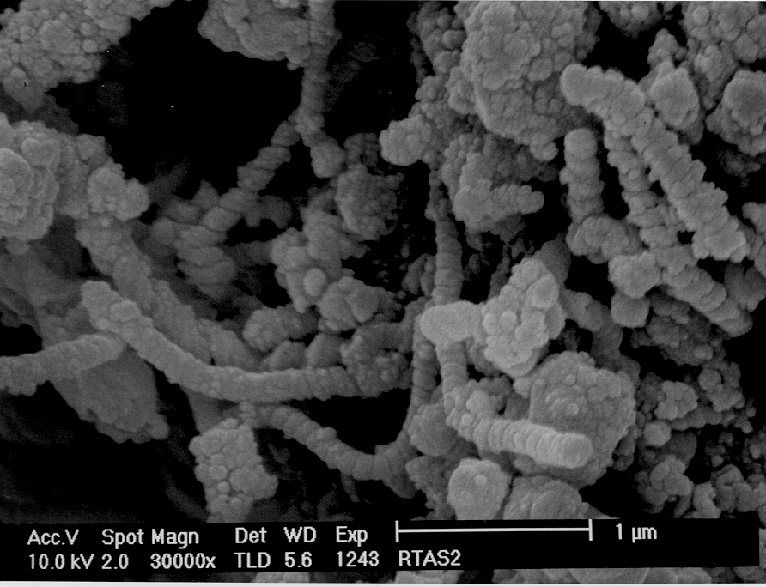
- Kim, W.-J. & Yang, S.-M. Flow-induced silica structure during in situ gelation of wormy micellar solutions. Langmuir in press (2000).
Ω_{i}
R_{o}
R_{i}
Figure 1. Schematic diagram of Talyor cells. Figure 2. SEM image taken from the samples
prepared in Couette flow at Re=320.
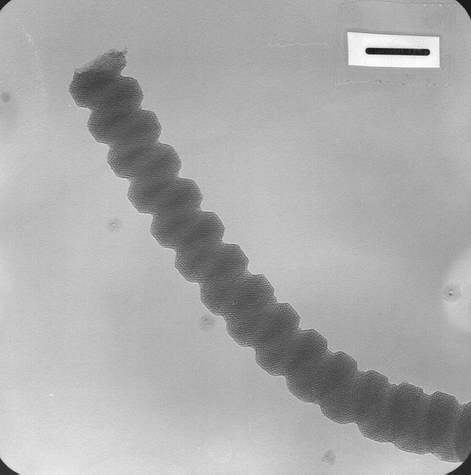
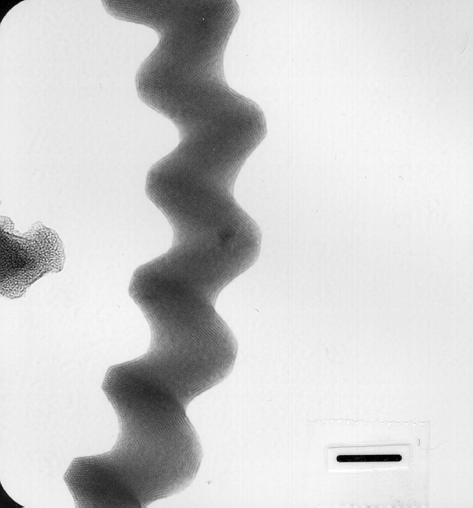

Figure 3. TEM images taken from the sample prepared in Couette flow at different Reynolds numbers. (a) Re=640; (b) Re=320.

