Continuous Electrostatic Dehydrator에 의한
Water-in –Crude oil Emulsions의 Demulsification

김병윤, 문준혁, 성태현, 김종득, 양승만
KAIST 화학공학과

Demulsification of Water-in –Crude oil Emulsions
by a Continuous Electrostatic Dehydrator

Byoung-Yun Kim, Jun-Hyuk Moon, Tae-Hyun Sung, Jong-Duk Kim and Seung-Man Yang
Department of Chemical Engineering, KAIST

INTRODUCTION
In the offshore oil industry, demulsification of crude oil is essential to remove the water which is dispersed as the small droplets in the crude oil.
Among the many different methods of demulsification, the electrostatic method in a high voltage field is one of the most effective and simplest demulsification methods. The electrostatic forces caused the coalescence of fine water drops and their growth to larger drops which then readily fell by electric forces or gravity.
In this study, a continuous electrostatic dehydrator was constructed and continuous demulsification of water-in-crude oil emulsions by application of a high voltage ac field was performed. The demulsification rates were investigated under various operating conditions.

THEORY
Coalescence of droplets consists of three steps: (1) Motion and approach of droplets due to gravity; (2) drainage of the film separating the droplets; and (3) breakdown of the film and coalescence of the droplets, or of both, the droplets and the boundary layer.
The electrical demulsification effect is primarily related to the first step, that is, an increased rate of motion of the droplets in an electric field, but the breakdown of the film can be influenced by electrical forces, particularly, at higher frequencies. The electrostatic method is based on the coalescence and precipitation of water droplets. As shown in the figure 1, when the electric field is applied, the water droplets are polarized by the induced dipole. And as the distance between the droplets become closer, they combine and become larger droplets. The combined droplets are liable to precipitate while the precipitation rate of the droplets is proportional to the square of droplet diameter.
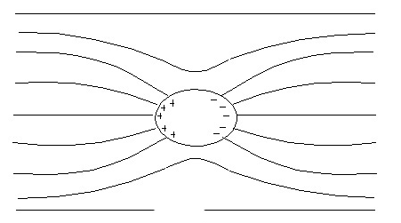
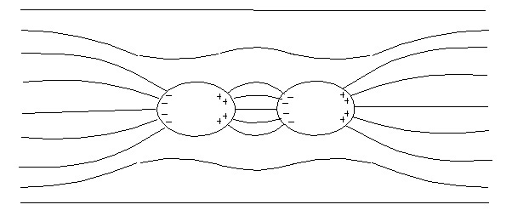
(a) Induced dipole
(b) Dipole-dipole interaction
Figure 1. Induced dipole and dipole-dipole interaction

EXPERIMENTAL

Preparation of water-in-crude oil emulsion
The water-in-crude oil emulsion was prepared as the following procedure. 80ml of crude oil was placed in the 250ml PYREX beaker and stirred by a electronic stirrer (Heidolph RZR 2051, Germany) at 1000rpm. 20ml of distilled water was added slowly to this crude oil with stirring and stirring was continued for ten minutes to form the complete emulsion. The emulsion was gathered up to 1L for continuous demulsification. The shape of the emulsion was investigated by optical microscope.

The Continuous Dehydrator
The demulsification apparatus used in this study is schematically shown in figure 2. The apparatus was made of PYREX glass with inside dimensions of 6.5cm in diameter and 10cm in height. A bare copper electrode made of perforated plate was installed at the bottom of the apparatus. The high voltage glass-insulated electrode was made of a Pyrex glass cup of 5cm outside diameter and 0.5cm thickness. The cup was filled with a saturated sodium chloride aqueous solution into which a copper wire was immersed. For insulation purposes, mineral oil was placed in the upper layer of the cup. The distance between the electrodes could be changed from 3 to 5cm by modulating the size of two glass tubes which are supporting the lower electrode. Figure 2 represents the 4cm distant case.

- 1. AC high voltage amplifier
100
100
50
40
1
2
4
4
5
7
6
1
2
2. Upper electrode
3. Lower electrode
- 4. Glass tubes
- 5. W/O emulsion inlet
3
- 6. W/O emulsion outlet
130
- (The demulsified emulsion)
7. Water outlet
(size in mm)
Figure 2. Experimental apparatus (Continuous Dehydrator)

Continuous demulsification
After 1L of water-in-crude oil emulsion was prepared, chemical demulsifier(EW 251: Hyundai Oil Bank, Korea) was added and stirred for 5min at 500rpm. Then this emulsion was put into the water bath to set the desired temperature with aging of demulsifier for 15min. This emulsion was fed through the W/O emulsion inlet into the apparatus by the Masterflex pump. A high AC electrical potential of 2.5-10kV (60Hz) was applied between the two electrodes by AC high voltage amplifier(TREK 20/20B). The flow rate of the pump was adjusted for emulsion to have 3min of contact time in the apparatus and then effuse out. The demulsified emulsion effused from the apparatus through the W/O emulsion outlet. The separated water effused out from the apparatus through the water outlet and the amount of separated water was measured with mass cylinder. The demulsification rates were measured for various operating conditions (applied potential, temperature, distance between the electrodes, the amount of demulsifier, contact time-related with feed rate).

RESULTS AND DISCUSSION
The size of water droplets in water-in-crude oil emulsion was 15~60㎛(figure3).

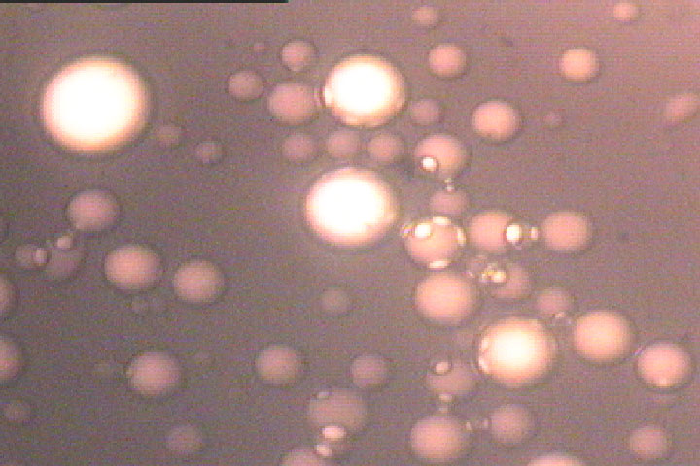
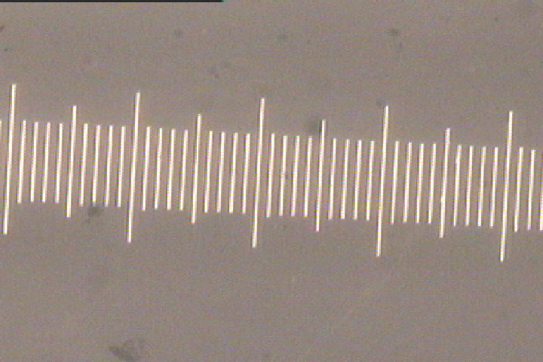
Water-in-crude oil emulsion(1000rpm, 10min) Scale bar (one scale: 10㎛)
Figure 3. The photograph of water-in-crude oil emulsion
1L of water-in-crude oil emulsion contained 200ml of water(20% water). After continuous demulsification, the amount of separated water was measured with mass cylinder and water separation % (WS%) was calculated. Figure 4 shows the effect of the applied potential on the water separation (%). WS% increases with applied potential, but after 5kV the WS% value does not change and 5kV seems to be the critical value. Figure 5 shows the effect of the demulsifier concentration (ppm) on the water separation (%). Without demulsifier, the water was not separated. But, WS% increases with demulsifier concentration.
Figure 4. Effect of applied potential Figure 5. Effect of demulsifier concentration

REFERENCES
[1]Shin Sheng Wang et al., Separation Science and Technology, 29(2), 159-170(1994).
[2]Tadashi Hano et al., Journal of Chemical Engineering of Japan, 21(4), 345-351(1988).
[3]Takeshi Kataoka et al., Separation Science and Technology, 25(1&2), 171-185(1990).

ACKNOWLEDGEMENT
This work was supported by Hyndai Heavy Industries Co. (Korea).

