Methylsilsesquioxane 의 반응 aging 정도에 따른 구조적-열적

특성 변화

이충봉, 민경욱, 이춘근, 한학수
연세대학교 화학공학과 전자재료개발연구실

The aging effect for the structural and thermal properties of Methylsilsesquioxane as Low dielectric material

Choong Pong Lee, Kyungwook Min, Chunkeun Lee, Haksoo Han
Dept. of Chemical Engineering, Yonsei University

Introduction

As devices continue to be scaled down in IC (integrated circuits), the dimension of wiring pitch decreases and the number of interconnect levels increase simultaneously [1-9]. In addition, as IC technology moves into the deep sub-micrometer regime, the signal propagation delay in the interconnect becomes an appreciate fraction in the total time delay [1,2,4,6,8,9]. Problems with interconnect resistance-capacitance (RC) delay, power consumption, and cross-talk become more significant as feature sizes in the integrated circuits approach to < 0.15㎛[1,2,6,8,9]. Integration of low dielectric constant materials will partially diminish these problems. Low dielectric constant interlayer dielectric (ILD) materials are required to meet these demands. Implementation of low-K materials is developing more slowly than many suppliers originally expected. IC fab’s hesitation to use the materials and numerous technical challenges have resulted in the delay of low-K material adoption. Low K materials consumption will gradually increase and by 2003, the global low-K material market should reach $150 million and expand rapidly [3].
Development of materials with low dielectric constants of < 3.0 with stability at > 450℃ have been focused on [2,9]. Current chip manufacturing processes require the insulating materials to be thermally stable to at least 400 ℃ ( including high Tg ), to have lower moisture absorption, to have good adhesion to metals and passivation coating ( oxides and nitrides ), to have mechanical toughness to prevent crack propagation, and to exhibit coating hardness to withstand the rigors of chemical mechanical planarization (CMP), to name just a few of the requirements [3,6,9].
Although there are a wide variety of low dielectric constant materials, based either on spin-on deposition or chemical vapor deposition (CVD) process, having been developed or reported, a commercially available spin-on polymer (SOP), methylsilsesquioxane is one of the most promising materials for intermetal applications [1-9].
Methylsilsesquioxane polymer, (CH₃SiO_{1.5}) exhibit good adhesion to silicon, CVD oxides, and aluminum. After curing, films of methylsilsesquioxane are very resistant to ambient moisture with little or no variation in the dielectric constant over the relative humidity range of 40 to 80%. Furthermore, methylsilsesquioxane provides superior flow and excellent gap fill capability down to small gaps of 0.06㎛. The out-of plane dielectric constant of methylsilsesquioxane has been determined by capacitance-voltage to be 2.5 at 1 MHz [1]. Fully cured PMSSQ shows intrinsic dielectric constants between 2.7 and 2.9 and low moisture absorption and exhibits good thermal stability to 500°C and high mechanical hardness. Increasing the porosity of poly(silsesquioxanes) can decrease their dielectric constant, while maintaining the other desired properties [1,2,9].

Theoretical

Sol-Gel methods and Emulsion polymerization, which can easily produce a three-dimensional inorganic network by chemical reaction at relatively low temperature, are attractive due to their potential application in the presentation of these target materials [10]. The sol-gel chemistry in low temperature conditions can be used to produce organic-inorganic materials nanocomposite from the in-situ formation of silica-rich phase in a polymer matrix [11]. Basic Mechanism follows [10-12]:

Sol-gel processing of materials is plagued by shrinkage during polymerization of the alkoxide monomers and processing (aging and drying) of the resulting gels [12]. Especially, when methylsilsesquioxane is applicated to organic/inorganic hybrid for nanofoam matrix for low dielectric material, material’s structure (ladder or cage) and stability (mechanical and thermal) is very significant. So, this study was focused on aging and drying time. The preparation of Methylsilsesquioxane was obtained by polymerization from organo-alkoxysilane monomers in aqueous solution.

Experimental

A. Reagent

MTES (methyltriethoxysilane, 99%, Aldrich co.), DMDES (dimethyldiethoxysilane, 98%, TCI co.) and Sodium hydroxide were used without further purification. Sodium- dodecylbenzenesulfonic acid (TCI co., hard type, 95%)

B. Preparation

A mixture of methyltriethoxysilane (0.91mol, 16.22g) and dimethyldiethoxysilane (0.10mol, 1.482g) was added dropwise into pure water (83.16ml) and 48% sodium hydroxide (0.65g) over a period of 20min, maintaining the two layers. The mixture was slowly stirred at 7-8℃. After 50min, 5% sodium dodecylbenzensulfonic acid (6.0g) was added dropwise into reaction mixture. After 18h, separation of resulting precipitates by centrifugation, washing with pure water and drying for 12h under reduced pressure (90℃/1torr).
Before centrifugation, , each samples were obtained with the different aging time, 18h, 96h, 256h, at 7-8℃. A sample with aged for 256h at 7-8℃ was dried 12h under reduced pressure at 100℃.

Result

Each sample was a white powder, but had the different shape. The 18h aged simple was similar to a 96h aged sample that are distinguished to 256h aged thing. Although SEM was not used in this analysis (scheduled), particles (or powder) obtained by the polymerization of methyltriethoxysilane and dimethylethoxysilane do not undergo topological metamorphosis of the particle shape.
Figure 1. shows the distinguished peaks of Methylsilsesquoxane between 18h aged and 256h . The Si-O stretching frequencies of these materials transmit in the region 1200-1000 ㎝⁻¹. The Si-CH3 group displays three bands 780㎝⁻¹ , 1270 ㎝⁻¹ , 2900㎝⁻¹ and the Si-OH band displays peak in 900㎝⁻¹ . IR data shows the distinguished peaks and shape of Mssq from aged with different time.

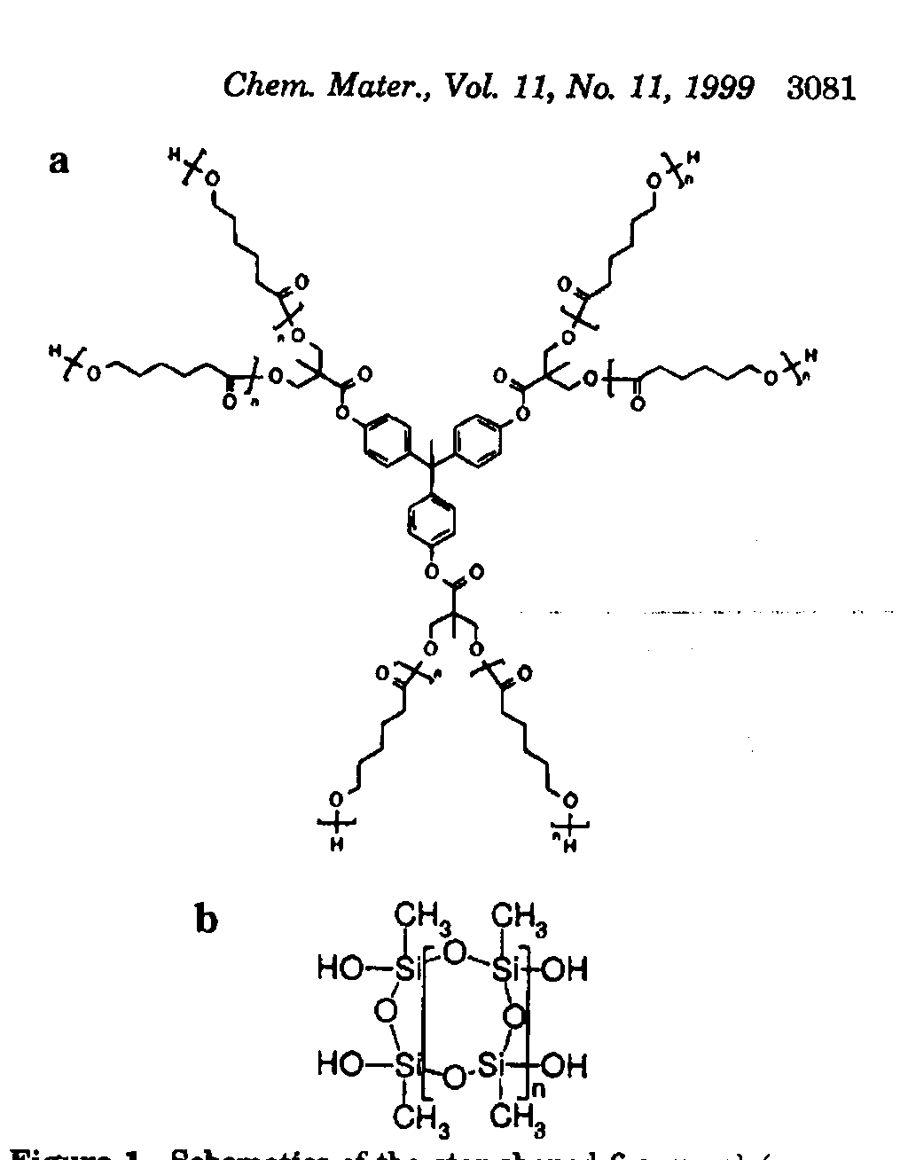
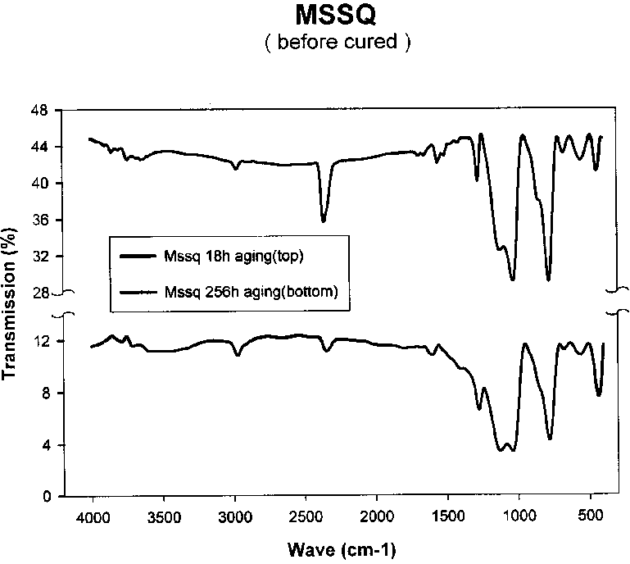
Fig.1. The FT-IR of 18h and 256h aged Mssq. Fig.2. Methylsilsesquioxane
(Before Cured)

In TGA data, Figure.3-5, the aging effect shows its changed properties thermally. Thermal behavior was also shown the distinguished properties among the samples. In 5% decomposition, 310℃ for 18h aged, 350.4℃ for 96h, 385.2℃ for 256h. In 10% decomposition, its temperature was shown the similar behaviors.

Conclusion

Under the different aging time and drying condition, Materials show the distinguished behaviors structurally and thermally. In structural analysis, Si bonds with CH₃- or O- were revealed with the changed peaks. Thermally, temperature of decomposition with various percentage was shown the same behavior from ageing time and condition. These properties and characteristics have many significant on applicated to Nano-porous dielectric matrix or hybrid. Furthermore, many experiments such as dielectric constant measurement, NMR characterizaztion, water sorption with cahn balance and so on., are scheduled.

Reference

[1] C.T Chua, G. Sarkar, and X. Hu, J. Electrochem. Soc., Vol.145, No.11, November, 1998
[2] Satoshi Mikoshiba and Shuzi Hayase, J. Mater. Chem., 1999,9,591-598
[3] Shiuh-Kao Chiang and Charles Lassen, Article Print Screen, Vol.42, Issue.10, October, 01, 1999
[4] C. Y. Wang, Z. X. Shen, and J. Z. Zheng, Applied Spectroscopy, 209-213, Vol.54, No.2, 2000
[5] N. P. Hacker, J. S. Drage, R. Katsanes and P. Sebahar, Pro. The Panar 95: The Dielectric Conf., Santa Clara, CA, 81, 1995
[6] James L. Hedrick, Robert D. Miller, Craig J. Hawker, Kenneth R. Carter, Willi Volksen, Do Y. Yoon, and Mikael Trollsas, Adv. Mater. 1998, 10, No.13
[7] James L. Hedrick, Craig J. Hawker, Robert D. Miller, R. Tweig, S.A.Srinivasan, and M. Trollsas, Macromolecules, 1997, 30, 7607-7610
[8] US patent, US4399266, Japan Synthetic Rubber Co., Ltd
[9] Cattien V. Nguyen, Kenneth R. Carter, Craig J. Hawker, James L. Hedrick, Richard L. Jaffe, Robert D. Miller, Julius F. Remenar, Hee-Woo Rhee, Philip M. Rice, Michael F. Toney, Mikael Trollsas and Do Y. Yoon, Chem. Mater. 1999, 11, 3080-3085
[10] Ippei Noda, Takeshi Kamoto, Yosuke Sasaki, and Masahiko Yamada, Chem. Mater. 1999, 11, 3693-3701+
[11] H. Kaddami, J. F. Gerard, J.P. Pascault, 51-61, Mat.Res.Soc.Symp.Pro. Vol.576, 1999
[12] Kamyar Rahimian and Douglas A. Loy, 63-67, Mat.Res.Soc.Symp.Pro. Vol.576, 1999

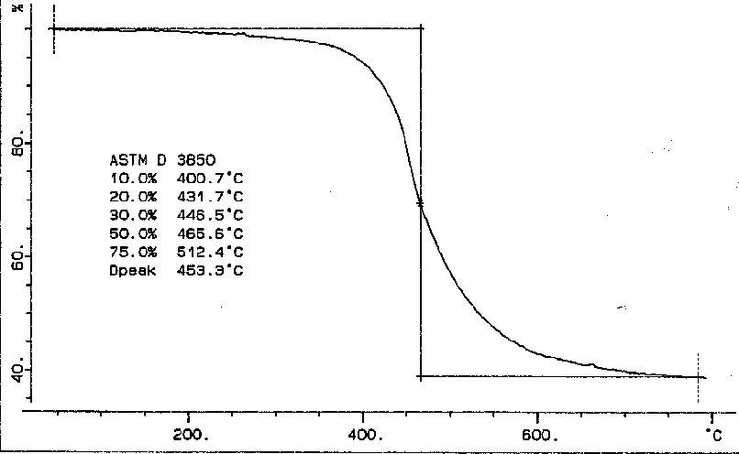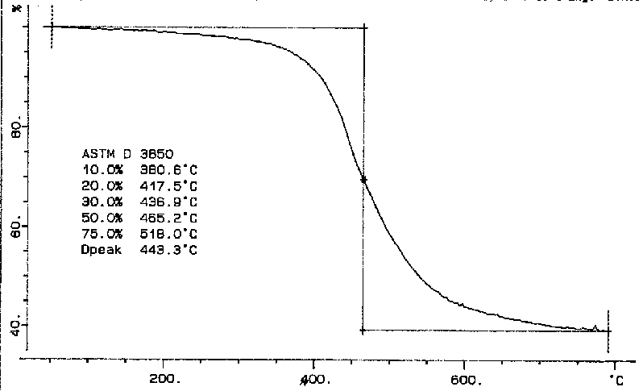Fig.3 TGA diagram of 18h aged Mssq. Fig. 4.TGA diagram of 96h aged Mssq.

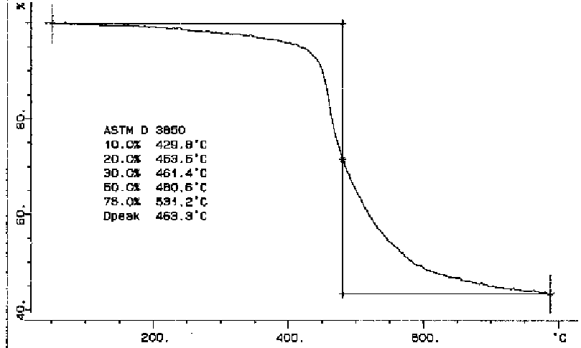 Fig.6. Chemical structure of silicone family
Fig.5 TGA diagram of 256h aged Mssq. Where R is commonly CH₃- or C₆H₅-

