DMFC의 메탄올 crossover 감소를 위한 전해질 막의 개질에 관한 연구

최원춘, 김주담, 우성일*
한국과학기술원 화학공학과

Modification of Proton Conducting Membrane for
Reducing Methanol Crossover in DMFC

Won Choon Choi, Ju Dam Kim and Seong Ihl Woo*
Department of Chemical Engineering, Korea Advanced Institute of Science and Technology

1. Introduction
Direct methanol fuel cell (DMFC) is one of the most interesting power sources of clean energy and is expected to be used as a portable power source. Methanol is liquid at room temperature, has high energy density and is inexpensive [1]. However, one of the main drawbacks limiting the practical realization of DMFC as a portable power source is the crossover of methanol through the proton conducting polymer membrane resulting in the poor fuel cell performance [2,3]. Considerable efforts have recently made in the research area of DMFC proton conducting membrane, especially methanol crossover [4,5,6], and the review paper of the state-of-art was published [7].
It is accepted that NafionTM has a separated structure with a hydrophobic region interspersed with ion-rich hydrophilic domains [8], whose pore sizes are inaccessible for decane (and octane) molecules but accessible for water molecules [9] and known that methanol diffuses primarily through the water-rich domains. The morphology of the pores at the water-rich domains must affect the rate of methanol crossover.
We report here a new method for reducing methanol crossover, plasma-modification of membrane surface and Pd sputtering. The decrease in the pore diameter, the increase in the methanol permeation length, and the decrease in the hydrophilicity of membrane surface will decrease methanol crossover.

2. Experimental
The following three kinds of proton conducting membrane were prepared and compared: i) plasma-etched membrane; ii) Pd-sputtered membrane and; iii) plasma-etched and Pd-sputtered membrane.

2.1. Preparation of the plasma-modified membrane
In order to fabricate a plasma-etched proton conducting membrane, Ar plasma etching was used. The reactor is a conventional parallel plate diode type with the lower electrode coupled to a 13.56 MHz rf power supply through an impedance matching network. Typical plasma condition is as follows: Ar gas pressure = 5 mTorr, Ar flow rate = 30 sccm, rf power = 100 W, and bottom power = 100 W. For the preparation of a Pd-sputtered proton conducting membrane, metallic Pd was deposited on the surface of NafionTM 117 membrane under Ar pressure of 5×10⁻³ torr at 30 W by sputtering a Pd target (99.9 % ; Toshima Co. Japan). Pd was deposited on Si(111) wafer at the same condition described above and the thickness was measured by SEM to be 20 nm. Pd was also deposited on the plasma-etched NafionTM by sputtering method in the same manner as described above.

2.2. Methanol permeability measurement
By analogy with the reported procedure [10], the methanol permeability of the above membranes was measured in a glass cell containing the membrane clamped between two compartments. One compartment (V_{A} = 18.03 mL) was filled with a solution of methanol (8 vol. %) and 1-butanol (0.2 vol. %) balanced in deionized water and the other (V_{B} = 19.75 mL) was filled with a 1-butanol (0.2 vol. %). Both compartments were vigorously stirred during permeation experiment. The concentrations of methanol of the compartment (B) were analysed with a capillary (SUPELCO, VocolTM) gas chromatograph (HP5890) at various times. The methanol permeability is calculated from the slope of the straight line in the plot of methanol concentration vs. permeation time.

2.3. Membrane/Electrode assembly
Anode and cathode gas diffusion electrodes were prepared from carbon paper (TORAY) coated on one side with a layer of electrocatalyst (Electrochem) and PTFE binder. The electrocatalysts used for fabricating anode and cathode were 20% Pt & 10% Ru/C and 20% Pt/C, respectively. The average Pt loading of the each electrode was 2 mg/cm². After activating the electrodes, they were assembled with three kinds of modified membrane and hot pressed at 120 ºC and 100 kg/cm² for 2 min.

2.4. Single cell testing
The single cell was installed in a fuel cell test station equipped with provisions for pressure control and flow rate control of 2 M methanol and O₂ flow. Because the main concern of these experiments is about the modification of proton conducting membrane to reduce the methanol crossover, this single cell testing was designed to feed the gas phase methanol solution and to maintain the pressure of compartment cathode to be 1 atm. The detailed explanation of single cell testing is described elsewhere [11, 12].

3. Results and Discussion
In Fig. 1 the concentrations of methanol permeated through the clamped membrane are reported as a function of time, and the permeability values at room temperature are reported in Table 1. It can be noted that the surface-modified NafionTM membranes reduced methanol permeability remarkably. The permeability of the Pd-sputtered membrane is lower than that of the plasma-etched membrane. The membrane modified by both plasma etching and Pd-sputtering shows the lowest methanol permeability. The AFM surface images of plasma-etched NafionTM membrane and unmodified membrane are in Fig 2. Etch process increased the surface roughness, resulting in the specific surface area. Methanol permeation rate is proportional to the permeability and surface area and inversely proportional to the permeation length. The decrease in the permeability might be due to the decrease in the pore size after plasma etch and to the increase in the hydrophobicity arising from the preferential etching of –SO₃H group.
Pd was chosen to plug the pores of membrane, because Pd is known to be very effective to store H₂, and easy to form palladium hydride. As expected, the methanol crossover rate decreased without decreasing the proton transfer rate, resulting in the better I-V performance as shown in Fig. 3.

Table 1. Methanol permeabilities at room temperature of the membranes investigated.

Type of  membrane | Unmodified membrane | Plasma-etched membrane | Pd-sputtered membrane | Plasma-etched and Pd-sputtered membrane
Permeability  (cm² / sec) | 2.392 × 10⁻⁶ | 2.106 × 10⁻⁶ | 1.700 × 10⁻⁶ | 1.598 × 10⁻⁶
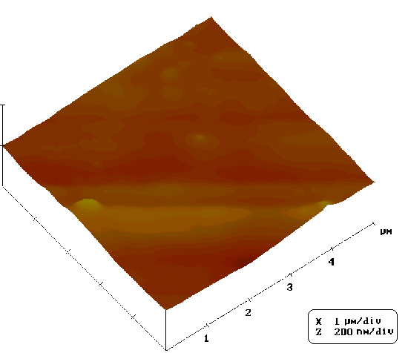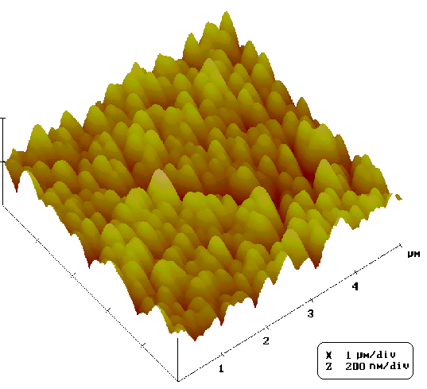Fig. 1. The concentrations of methanol at the compartment B permeated through the clamped membrane as a function of time; unmodified membrane (), plasma-etched membrane (), Pd- sputtered membrane (), and plasma-etched and Pd-sputtered membrane().
Fig. 2. AFM surface images of unmodified NafionTM membrane (A) and plasma-etched NafionTM membrane (B).

The current-voltage (I-V) curves in the single cell fabricated with modified membranes as well as open-circuit voltage (OCV) were obtained. Methanol diffuses from anode to cathode through the proton conducting membrane with the change of the OCV. Methanol crossover makes the cathode potential shift from oxygen reduction potential to a mixed potential arising from the electrooxidation of methanol in cathode side. The OCV’s as well as the I-V performances of the fuel cell fabricated with modified membrane are higher than that of the fuel cell fabricated with unmodified membrane. Especially, the fuel cell with the Pd-sputtered NafionTM membrane exhibited the best performance. It should be noted that there could be a negative effect by plasma etch, due to the possibility that –SO₃H functional group of NafionTM membrane can be affected by this treatment, resulting in the decrease in the ion conductivity of the membrane. The fuel cell fabricated with Pd-sputtered membrane shows the best I-V performance, because during the deposition of Pd by sputtering, -SO₃H group was not affected and methanol crossover was reduced. Despite the largest reduction in methanol crossover, the OCV of both Pd-sputtered and plasma-etched membrane is lower than that of Pd-sputtered membrane. The exact explanation for this cannot be given here. It can be speculated that uneven Pd-deposition on very rough plasma-etched membrane might increase the contact resistance between electrocatalyst layer and membrane.

4. Conclusion
The surface modification of NafionTM membrane by the plasma etching, Pd-sputtering and the combination of plasma etching and Pd-sputtering decreased the methanol crossover significantly. The OCV’s and I-V performances of the fuel cell fabricated with the membranes after plasma etching and Pd-sputtering improved significantly, compared with those of the fuel cell fabricated with unmodified membrane. It is necessary to make the optional balancing between methanol crossover rate and the ion conductivity of surface-modification of membranes.

References
[] X. Ren, M. S. Wilson, and S. Gottesfeld, J. Electrochem. Soc. 143 (1996) L12.
[2] C. Pu, W. Huang, K. L. Ley, and E. S. Smotkin, J. Electrochem. Soc. 142 (1995) L119.
[3] G. T. Burstein, C. J. Barnett, A. R. Kucernak, and K. R. Williams, Catal. Today 38 (1997) 425.
[4] C. Pu, W. Huang, K. L. Ley, and E. S. Smotkin, J. Electrochem. Soc. 142 (1995) L119.
[5] A. Küver, and W. Vielstich, J. Power Sources 74 (1998) 211.
[6] M. K. Ravikumar and A. K. Shukla, J. Electrochem. Soc. 143 (1996) 2601.
[7] A. Heinzel and V. M. Barragán, J. Power Sources 84 (1999) 70.
[8] R. S. Yeo and H. L. Yeager, Mod. Aspects Electrochem. 16 (1985) 437.
[9] J. Divisek, M. Eikerling, V. Mazin, H. Schmitz, U. Stimming, and Y. M. Volfkovich, J. Electrochem. Soc. 145 (1998) 2677.
[10] V. Tricoli, J. Electrochem. Soc. 145 (1998) 3798.
[11] M. Hogarth, P. Christensen, A. Hamnett, and A. Shukla, J. Power Sources 69 (1997) 113.
[12] M. Hogarth, P. Christensen, A. Hamnett, and A. Shukla, J. Power Sources 69 (1997) 125.

