호스레디쉬 퍼록시데이즈에 의해 합성된 폴리아닐린의 구조와 물성

임철현, 유영제
서울대학교 응용화학부

Structure Analysis and Properties of Polyaniline
Catalyzed by Horseradish Peroxidase

Chul Hyun Lim and Young Je Yoo‡
School of Chemical Engineering, Seoul National University

Aniline and derivatives were polymerized by horseradish peroxidase in organic solvent and buffer mixture. The proportion of ortho-directed unit to para-directed unit could be controlled by the reaction condition such as the pH of the buffer or the type of organic solvent. polyaniline synthesized in basic buffer and water-immiscible solvent or highly dielectric organic solvent had the higher portion of ortho-directed unit, in which conditions neutral aniline radicals participated in the chain progress more preferentially than cationic anilinium radicals. Polymers composed of ortho-directed unit and para-directed unit alone were obtained with para-position substituted p-toluidine and ortho-position substituted 2,6-dimethylaniline. Ortho-form was more thermally processible, electrically conductive and soluble in aqueous solution than para-form.

Introduction
Polymerization of aniline has received a great deal of attention only in the last 20 years or so, because polyaniline(PANI) was the first conducting polymer whose electronic properties could be reversibly controlled by both protonation and charge-transfer doping.
With hazardous waste becoming increasingly expensive to treat, biochemical reactions are becoming more attractive as alternative synthetic routes.[1] HRP has been used for the synthesis of PANI and polyphenols through oxidative free radical coupling. [2]
In the presence of hydrogen peroxide, horseradish peroxidase(HRP) catalyzes the oxidation of aromatic amines and phenols to generate their respective free radicals. These free radicals undergo coupling to produce dimers. Successive oxidation and coupling reations result in the polymer.[3] The polymerization reaction is known to be both ortho and para directed and typically results in branched polymeric materials which are intractable and have poor electrical properties. Among them, ortho-directed structure is unique in enzymatically catalyzed PANI, but there has been few work about detailed structure and properties.[4]

(A) (B)
Figure 1. The repeated unit in PANI catalyzed by HRP, (A) para directed unit, (B) ortho directed unit
Biological polymerization of aniline has been tried many times, but These were focused mainly on increasing the solubility of PANI, there is few researches about the structure, properties, and their relationships. This paper addresses the structure and properties of the PANI and substitutes polymerized by HRP in various reaction conditions.

Materials and methods
HRP (EC 1.11.1.7, Type II) was purchased form Sigma, hydrogen peroxide (30 wt% solution in water) was purchased from Junsei Chemical. Aniline, p-toluidine and 2,6-dimethylaniline were purchased from Aldrich. All solvents were purchased from Junsei Chemical.
Aniline and its derivatives (12.5mmol) and HRP (20mg) in a mixture of 40mL (25mL) of organic solvents and 10mL(25mL) of 0.1M sodium phosphate buffer (pH7) were placed in a 250mL flask. Hydrogen peroxide(142μL, 1.25mmol) was added to the mixture every 5min for 10 times at room temperature. After 24h, the solvent in the reaction mixture was evaporated under reduced pressure. The residue was washed successively with water and methanol, and dried.
Perkin elmer FTIR spectrometer was used for FTIR measurement. KBr pellets made from a 1% (by weight) polymer/KBr mixture were used for recording the spectra of the polymers. DSC measurement was made at a 10℃/min heating rate under nitrogen using a Dupont 2000 reference standard. The UV-vis spectra of the polymers were recorded using a Kontron UVIKON spectrometor 930.[5]

Results and Discussion

Structrual analysis of PANI by IR spectra.
Ortho-directed form is 1,2,3-trisubstituted in benzene ring and has primary amine, while para-directed form 4-disubstituted with secondary amine. Therefore each form takes absorption differently, and the absorption peak in the IR spectrum is a important key to estimate the portion of each form and the structure of PANI finally. Oop region is the C-H out-of bending absorption region and lets us know the substitution type of benzene ring. When the benzene rings are 1,2,3-trisubstituted, doublet peak appears in 750 ~ 700 cm⁻¹, while 1,4-disubstituted benzene rings absorb in 850~800 cm⁻¹.

PANI synthesized in buffer of various pH and dioxane
Figure 2 represents IR spectra and UV-Vis curves of PANIs synthesized in dioxane and buffer of pH 9.0 (A) and pH 5.0 (B). PANIs which were polymerized in basic and acidic condition showed different spectra. PANI synthesized in basic buffer took absorption in primary amine, N-H bending and oop region-trisubstitution. The absorption in benzene ring deformation, C-N-C bending region was negligible. But the other in secondary N-H bending, benzene ring deformation, C-N-C bending region, but oop region was unclear. Therefore it could be concluded that pH of buffer has an effect on the polymer structure, that is to say, PANI synthesized in basic buffer is ortho-directed mainly, while that in acidic buffer is ortho and para-directed. PANI synthesized in basic condition did not show any peaks within protonated amine region while the other showed broad peaks. The protonation level of amine groups was presumed to be something to do with structural difference.
In UV-Vis curves of both polymers, strong and red-shifted absorption in π↔π* transition region appeared in PANI synthesized in the basic condition. But there was little absorption in the other. Absorption in π↔π* transition region indicates the electric conductivity. There was no absorption among 600~700nm in both curves, so it was confirmed that quinoid unit does not exist in enzymatically synthesized PANI.
In aqueous phase, Neutral aniline radicals and cationic anilinium radicals are formed by the reaction of HRP and hydrogen peroxide. However basic condition tends to oxidize the cationic radicals, which are converted to neutral radicals. Therefore the more amount of neutral radicals are being dissolved in aqueous system, and these radicals go across the phase boundary and into the organic solvent phase, In organic solvent phase coupling and radical transfer steps take place. Two types of radicals undergo different coupling step - neutral aniline radicals couple into ortho-form, but cationic aniline radicals into para-form -. So the basic reaction condition induce the aniline to be coupled into ortho-form.

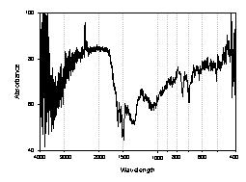
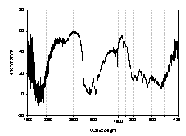

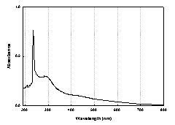
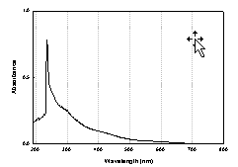

(A) (B)
Figure 2. FTIR spectra (top) and UV-Vis curves (down) of PANI synthesized in a mixture of 20% phosphate buffer and 80% dioxane at (A) pH 9.0 and (B) pH 5.0.

PANI synthesized in buffer and various organic solvents
Aside from the pH of buffer and composition, other solvents were applied, and among lots of solvents, highly dielectric and water-immiscible solvents were found to induce the polymer to be ortho-directed.
IR spectum and UV-Vis curve of PANI synthesized in pH 7.0 buffer and acetonitrile which is a highly dielectric solvent (ε=38.8) were similar to the basic buffer system, in which system ortho-form was dominant in a polymer chain, and amine groups remained intact unprotonated. Absorption in π↔π* transition and polaron band region appeared, but quinoid group did not appear. Other highly dielectric solvents such as acetone, DMFA etc were applied and similar results could be obtained. To compare, polymerization was tried in solvents with low dielectric solvents, but they showed different tendency.

Thermal and electrochemical properties of polymer
Branched PANI composed of only one unit was obtained from p-toluidine and 2,6-dimethylaniline. p-Toluidine has a methyl group in the para position of the aromatic ring and polymerization of it led to a polymer composed of only ortho-directed unit. In contrast to this, a para-directed polymer could be obtained from 2,6-dimethylaniline which has two methyl groups in the ortho position. Figure 3 represents the DSC trace of poly p-toluidine(PTD) and poly 2,6-dimethylaniline(PDMANI). PTD had the glass transition temperature and melting temperature near 100℃ and 200℃, whereas PDMANI had none of these temperature, instead crosslinking took place from 160~240℃.
Figure 4 represents the UV-vis spectrum for PANI, PTD, PDMANI. In this spectrum, 300~320nm is the π↔π* transition region, and 500~600nm exiton band of quinoid unit. PTD was the most conjugated, PDMANI was less conjugated than PANI. From the fact that There was no absorption near 500~600nm, It was concluded that These polymers had none of quinoid unit.

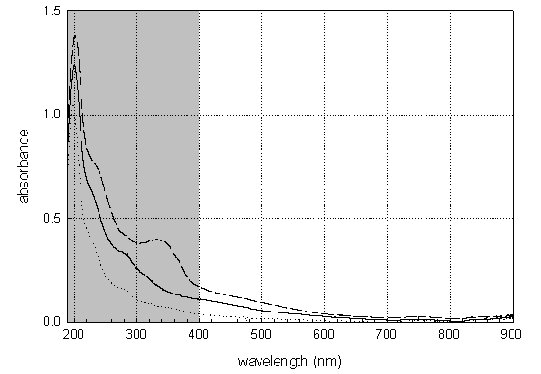
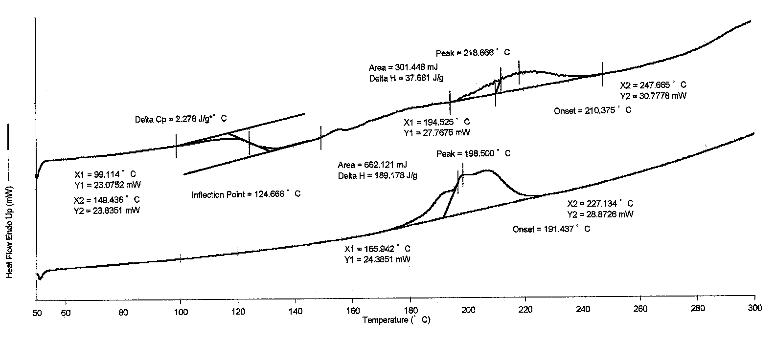
(A)
(B)
(C)
(B)
(A)

Figure 3. DSC thermogram of Figure 4. Absorption spectra of
(A) PTD, (B) PDMANI (A) PTD, (B) PANI, (C) PDMANI

References
- Samuelson, L.A., Anagnostopoulos, A., Alva, K. S., Kumar, J. and Tripathy, S.K.,
“Biologically Derived Conducting and Water Soluble PANI”, Macromolecules, 31, 4376 (1998).
- Ayyagari, M. S., Marx, K. A., Tripathy, S. K., Akkara, J. A. and Kaplan, D. L.,
“Controlled Free-Radical Polymerization of Phenol Derivatives by Enzyme-Catalyzed Reactions in Organic Solvents”, Macromolecules, 28, 5192 (1995).
- Xu, Y. P., Huang, G. L. and Yu, Y. T., “Kinetics of Phenolic Polymerization
Catalyzed by Peroxidase in Organic Media”, Biotechnol. Bioeng., 47, 117 (1995).
- Ikeda, R., Sugihara, J., Uyama, H. and Kobayashi, S., “Enzymatic Oxidative
Polymerization of 2,6-Dimethylphenol”, Macromolecules, 29, 8702 (1996).
- Joo, H., Chae, H. J., Yeo, J. S. and Yoo, Y. J., “Depolymerization of Phenolic
Polymers Using Horseradish Peroxidase in Organic Solvent”, Process Biochemistry, 32, 291 (1997).

