Transient Absorption을 이용한 생체소자의 전자전달특성

조 경상, 남 윤석, 최 정우, 이 원홍, 조 현선∗, 김 동호*
서강대학교 화학공학과, 한국 표준과학연구원 분광그룹*

Electron Transport Rate Measurement of Bio Device using
Transient Absorption Technique

K. S. Cho, Y. S. Nam, J.-W. Choi, W. H. Lee, H. S. Cho* and D. Kim*
Department of Chemical Engineering, Sogang University
Spectroscopy Laboratory, Korea Research Institute of Standards and Science*

INTRODUCTION

A great deal of interest has been paid to the photoinduced electron transport properties in the artificial molecular organizations. Photoinduced electron transport properties are important function because they can be applied to the molecular photodiode, photoswitching device in the artificial molecular electronic and molecular memory system. The concept or idea in the artificial photoinduced electron transport is inspired from the biological system such as electron transfer chain or photosynthetic reaction center. In the initial process of photosynthesis, a biological electron transfer system, photoelectric conversion occurs and then long-range electron transfer takes place very efficiently in one direction through the biomolecules. The specific energy and electron transfer take place on a molecular scale due to the redox potential difference as well as the electron transfer property of functional molecules, especially the electron acceptor, sensitizer and electron donor.
The authors have been observed the photoswitching and photodiode effect of MIM device consisted of electron donor (D)/sensitizer (S)/relay (R)/acceptor (A) hetero LB film and charge separation and photoinduced electron transport properties in the S/A hetero LB film have been investigated by measuing time-resolved fluorescence. The effect of acceptor layer, redox potential difference between S and A and interface structure on charge separation rate have been observed. The measurement of photoinduced electron transport rate based on fluorescence decay curves is a kind of indirect measurement method. Using transient absorption technique, direct measurement of charge separation and charge transport rate are possible. This technique have not been performed yet, due to the low OD (optical density) values of LB film. In this study, the photoinduced electron transport properties in the S/R/A hetero LB film have been investigated using transient absorption technique. Based on decay profiles of OD change in the hetero LB films at 440 and 500 nm wavelength, intermolecular electron transport from S to A via R was investigated.

EXPERIMENTAL DETAILS

1. Materials
Flavin (7,8-dimethyl-10-dodecyl isoalloxazine), viologen (N-allyl-N'-[3-propylamido-N",N"-di (n-octadecyl)]-4,4'-bipyridinium dibromide) and TCNQ (N-docosylquinolinium tetracyanodimethan) are used as an electron S, R and A unit, respectively. Flavin, viologens were synthesized and TCNQ was supplied from Hongik-university. The deposition of LB films were carried out using circular-type Langmuir trough (Model 2011, Nima Tech., UK). The substrate was quartz. The UV-Visible spectrums were measured with the UV/VIS spectrophotometer (JASCO V-570, Japan).
2. Transient Absorption Measurement
The dual beam femtosecond time-resolved transient absorption spectrometer consisted of a self-mode-locked femtosecond Ti:Sapphire laser (Clark MXR, NJA-5), a Ti:sapphire regenerative amplifier (Clark MXR, CPA-1000) pumped by a Q-switched Nd:YAG laser (ORC-1000), a pulse stretcher/compressor, OPG-OPA system, and an optical detection system. A femtosecond Ti:sapphire oscillator pumped by a CW Nd:YVO₃ laser (spectra physics, Millenia) produces a train of 60 fs mode-locked pulses with an averaged power of 250 mW at 800 nm. The seed pulses from the oscillator were stretched (~ 250 ps) and sent to a Ti:sapphire regenerative amplifier pumped by a Q-switched Nd:YAG laser operating at 1 kHz. The femtosecond seed pulses and Nd:YAG laser pulses were synchronized by adjusting an electronic delay between Ti:sapphire oscillator and Nd:YAG laser. Then the amplified pulse train inside the Ti:sapphire regenerative amplifier cavity was cavity-dumped by using Q-switching technique, and about 30 000-fold amplification at 1 kHz was obtained. After recompression, the amplified pulses were color-tuned by optical parametric generation and optical parametric amplification (OPG-OPG) technique. The resulting laser pulses had a pulse width of ~ 250 fs and an average power of 5-30 mW at 1 kHz repetition rate in the range 550-700 nm. The pump beam was focused to a 1 mm diameter spot and the laser fluence was adjusted from 0.09 to 1.2 mJ/cm² by using a variable neutral-density filter. The fundamental beam remained in OPG-OPA system was focused onto a flowing water cell to generate white continuum, which was again split into two parts. The one part of the white light continuum was overlapped with the pump beam at the sample to probe the transient, while the other part of the beam was passed through the sample without overlapping the pump beam. The monitoring wavelength was selected by putting an approciate interference filter (fwhm = 10 nm). With the chopping the pump pulses at 43 Hz, the modulated probe pulses as well as the reference ones were detected by a photodiode, respectively. The output current was amplified with a homemade fast preamplifier, and then the resultant voltage of the probe pulses was normalized by a boxcar averager with pulse-to-pulse configuration. The resultant signal modulated by a chopper was measured by a lock-in amplifier and then fed into a personal computer for further signal processing.

Fig. 1 Schematic Diagram for Transient Absorption Experiment.
BBO
VND
CF
CF
Flowing
water cell
P1
P6
P5
P4
P3
P2
ND
BOXCAR
LOCK-IN
PD1
PD2
PD3
Chopper
Delay Stage
1 W @800 nm
Sample
Polarizer
WP
ND
Polarizer
BS
CM
CM
Lens
M
M

RESULTS AND DISCUSSION

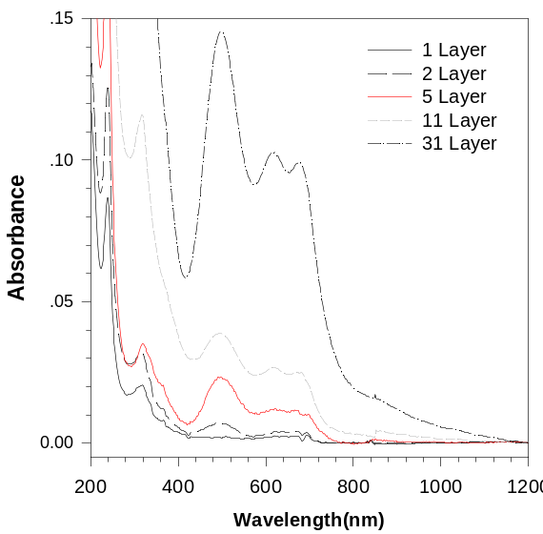
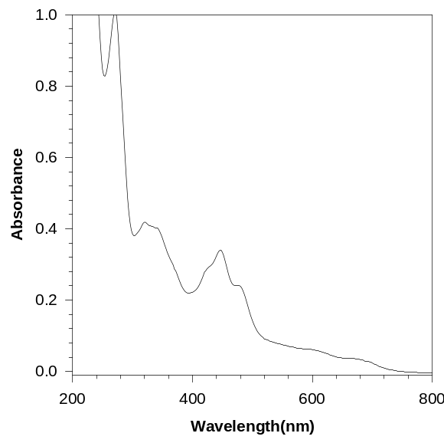
- UV-vis Spectrum of A Home and S/R/A Hetero LB Film
(a) (b)
Fig. 2 UV-Vis Absorption Spectrum; (a) A Homo LB Film; (b) S (30 Layer)/R (10 Layer)/
A (31 Layer) Hetero LB Film.

Fig. 2 shows the UV-vis absorption spectrum of A homo LB film and S (30 layer)/R (10 layer)/A (31 layer) hetero LB film. In A homo LB film, as film thickness increases, OD values are increases. The absorption band observed at 500 nm represent TCNQ° dimmers ((TCNQ°)₂) and that of 680 nm represents TCNQ anion radical dimmers ((TCNQ•⁻)₂). In 1 and 2 layer A LB film, no dimmer bands are appeared while other multilayer films show dimmer bands. This is due to the head (hydrophilic head group)-head contact structure of LB film. In the 1 and 2 layer LB film, there is no head-head contact structure. But more than 3-layer LB film, there exist head-head contact structure as shown in Fig. 3. In S/R/A hetero LB film, no new bands except the bands of S, R, A were shown. 240 and 320 nm bands were absorption peaks of A and 350 and 450 nm bands were that of S. It could be concluded that the ground state energy level (redox potential) didn’t change in the S/R/A hetero LB film.
Fig. 3 Structure of Multilayer LB Film.
Dimmer form of TCNQ
Fig. 4 shows the decay of absorption spectrum in the S/R/A hetero LB films at 440 and 500 nm wavelength. Fast decay component is shown at 440 nm while only slow decay component is exist at 500 nm. The absorption maximum of S is 350 and 450 nm. When 400 nm laser pulses are irradiated, ground state electrons are excited. So short component decay of photoinduced absorption change at 440 nm is expected to be the bleaching of S. We have measured the photoinduced absorption change in the S (31 Layer) homo LB film (data is not shown). And we observed same fast decay component. It is expected that the photoinduced excited electrons of S by irradiation of 400 nm laser pulse might be transferred to A via R through their redox potential difference. In this case, (TCNQ°)₂ absorption signals may be decreased by receiving electrons The direction of OD change maybe same with that of bleaching and the decay rate maybe much slower than that of bleaching. At 500 nm, only slow decay of photoinduced absorption change is shown. The decay rate of photoinduced absorption change corresponds to the electron transport rate of S/R/A hetero LB film. By measuring decay profiles of photoinduced absorption change in the S/R/A hetero LB films which have different R layer, it is expected that the photoinduced electron transport rate from S to A can be directly measure.
(a) (b)
Fig. 4 Decay Profile of OD change in the S/R/A Hetero LB Film; (a) 440 nm; (b) 500 nm.

