플루로닉 F127 수용액의 졸-겔 전이시의 유전적 거동
송미정, 김성철
한국과학기술원, 기능성 고분자 연구센터
Dielectric Behavior during Sol-Gel Transition of Pluronic F127 Aqueous Solution

M. J. Song, S. C. Kim
Korea Advanced Institute of Science & Technology,
Center for Advanced Functional Polymers
Introduction
Temperature-sensitive sol-gel transition and micellization of PEO-PPO-PEO triblock copolymer (known as Pluronic®, BASF) aqueous solution has been studied by many authors since Schmolka(1) had reported its interesting thermoreversible sol-gel transition. At low temperature, Pluronic F127 is homogeneous unimer solution as PPO-water interaction is favorable. As temperature increases, PPO-water interaction becomes unfavorable, which drives phase separation between PPO and water. There appears micelle with PPO core and PEO shell at critical micelle temperature. As temperature increases, number of micelles increases. Above critical micelle concentration and temperature, gel phase having high modulus appears. Gel phase is ascribed to the repulsive micelle-micelle interaction (2) above critical gelation concentration and temperature. At high temperature, interaction of PEO and water becomes unfavorable, therefore, gel-to-sol transition occurs due to dehydration and shrinking of PEO shell. Above PEO-water LCST temperature, phase separation between polymer and water is observed.
In this study, we intended to obtain micelle volume fraction in Pluronic F127 aqueous solution using the dielectric spectroscopy. There are many authors who studied micelle volume fraction by the dynamic light scattering, small angle neutron scattering(3-4) considering hard sphere interaction model.
Micelle system of hydrophilic-hydrophobic-hydrophilic triblock copolymer hydrogel can be considered as a heterogeneous polymer system where copolymer micelles are dispersed in the medium. Many authors have studied relationship between the volume fraction and the morphology of the dispersed phase and matrix by dielectric spectroscopy(6).
In the present study, we measured the change of dielectric constant during the micellization and sol-gel transition of Pluronic F127 aqueous solution and intended to calculate the micelle volume fraction using Hanai's relationship(7). Calculated micelle volume fraction was compared to those obtained by SANS etc(9).

Experimental
Pluronic F127(BASF) was dissolved in methylene chloride and precipitated in diethyl ether. Before experiments, Pluronic F127 was dried under vacuum for 2 days. Pluronic F127 aqueous solution was prepared by dissolving the Pluronic in the Milli-Q water (conductivity = 1.6×10⁻⁶ S/cm). The concentration of Pluronic F127 solution was as following: 5, 10, 14, 16, 18, 20, 22 % by weight.
Using FRA (Frequency Response Analyser 1260, Solartron) and homemade liquid dielectric cell, complex impedance was measured in the frequency range of 0.1 to 10MHz. Impedance measurement was carried out from 5ºC to 92ºC at the heating rate of 0.8ºC/min using temperature controllable water circulating chamber. Dielectric cell was calibrated with reference liquids according to standard procedure(8). Hanai equation(eq.(1)) provides the relationship between the volume fraction of the suspended spheroid particles and the dielectric constant of the mixture and medium (6-7).$\frac{e^{'}−e_{2}^{'}}{e_{1}^{'}−e_{2}^{'}}{\left(\frac{e_{1}^{'}}{e^{'}}\right)}^{1/3}=1−v_{2}$
(1)
where e' is the dielectric constant of the solution,
e₁' is the dielectric constant of the medium,
e₂' is the dielectric constant of the dispersed spheroid, v₂ is the volume fraction of the dispersed spheroid.

Sol-gel transition temperature of 20% sample was monitored by the conventional tube tilting method.(10)

Results and discussion
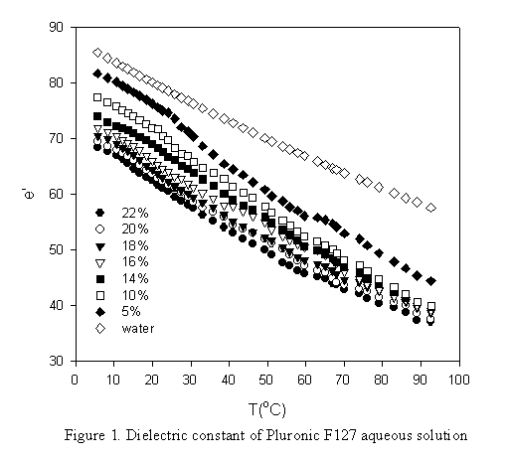
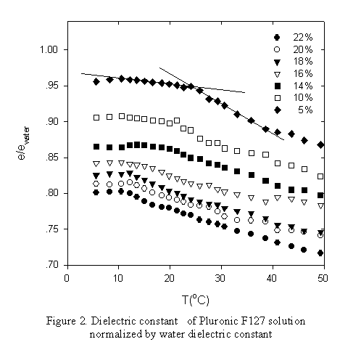
Dielectric constant of Pluronic F127 solution was nearly constant in the experimental frequency range. As relaxation of water is observed at 10GHz range, and MWS relaxation frequency range is lower than experimental frequency range. We concluded that dielectric constant in the experimental frequency range was the dielectric constant of the solution. For convenience, dielectric constant at 1.2MHz was used in the further calculation as the solution dielectric constant. For a solution with spherical particles, Hanai derived an equation relating the dielectric constant of the solution (eq.1), dispersed micelle and the volume fraction of the micelle. Hanai's equation has been verified for several systems such as water in oil (6), mitochondria in the buffer solution(7) etc. Figure 1 shows the dielectric constant of Pluronic F127 solution. With increasing temperature, dielectric constant decreases due to decreasing dielectric constant of the water that is the media of solution.
Figure 2 shows the dielectric constant normalized by the water dielectric constant around critical micelle temperature. There was observed rather sharp step decrease of dielectric constant around 10ºC to 30ºC. Graphical method in the figure 2 determines the temperature from which dielectric constant decreases sharply. Table 1 summarizes these temperatures for all samples. Referring to Wanka et al(2), critical micelle temperature monitored by DSC was observed nearly the same as the present result. From critical micelle temperature, phase separation starts due to increasing hydrophobicity of PPO, which induces micelle formation with PPO core and PEO shell. Increasing hydrophobicity of PPO seems to reduce the dielectric constant of the solution. Critical micelle temperature(CMT1) could be determined from the step decrease of solution dielectric constant. Figure 3 shows the solution dielectric constant at critical micelle temperature with varying concentration.
Table 1. Critical micelle temperature determined from dielectric spectroscopy
conc.(wt %) | CMT_{ε'} | CMT_{DSC}
5 | 24 | 19.6
10 | 21 | 16.9
14 | 16.5 | -
16 | 14 | -
17 | - | 13.9
18 | 13 | 12.8
20 | 12 | -
22 | 10.5 | -
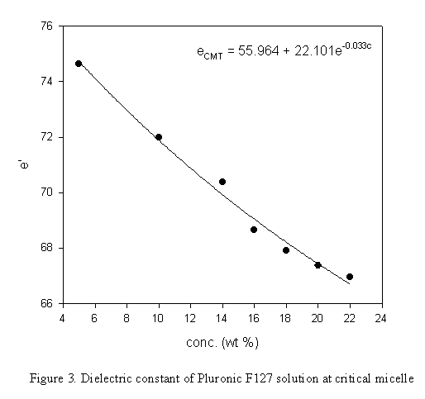  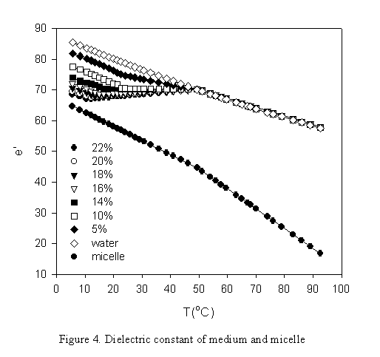  25 | - | 8.4
From CMT1, unimer to micelle transition starts. With increasing temperature, equilibrium shifts from the unimer dominant solution to the micelle dominant solution. From CMT1 to maximum packing temperature(CMT2), polymer exists in the medium as a unimer solution. Above CMT2, medium dielectric constant can be considered as that of pure water. Medium dielectric constant of unimer-micelle mixture solution was assumed as the linear regression of these two values at CMT1 and CMT2. For convenience, CMT2 for all concentration was adopted as 50ºC which is the mid point temperature of two sol-gel transition temperature in the symmetric phase diagram. Figure 4 shows medium dielectric constant for all concentration sample and micelle dielectric constant.
For 20% sample, we could calculate two e₂' values at two gel temperatures at which micelle volume fraction might be that of the simple cubic packing of spherical particles(0.523). Referring to Mortensen et al.(9), micelle volume fraction showed the maximum between two sol-gel transition temperatures. We expected that from CMT1 to CMT2, unimer to micelle equilibrium drove increase of micelle number density that was reflected on the increase of the micelle volume fraction. At the maximum packing temperature(CMT2), micelle dielectric constant was obtained on the assumption that the micelle volume fraction had the maximum, which was the volume fraction of bcc packing(0.68). e₂' was linearly interpolated with whole temperature range using three e₂' data of 20% solution. As temperature increased, micelle dielectric constant was reduced due to the decreasing dielectric constant of water that is the medium of micelle. Above CMT2, micelle dielectric constant decreasing tendency was higher than that below CMT2. As we assumed there was no unimer-to-micelle transition over CMT2, only dehydration form the micelle might progress over CMT2, which seemed to accelerate the decrease of micelle dielectric constant.

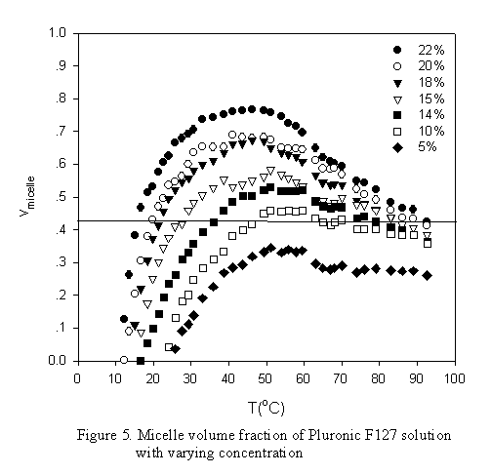
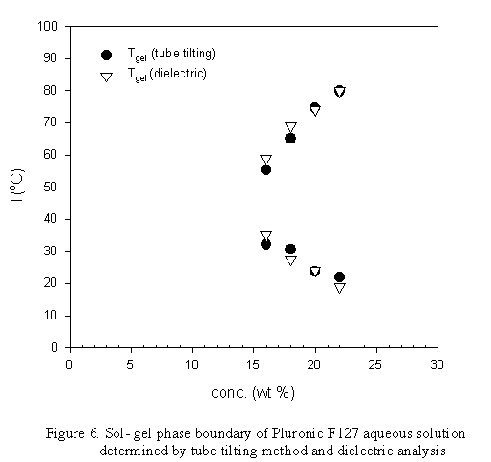
Gel phase is ascribed to the repulsive micelle-micelle interaction (3) above critical micelle volume fraction. At high temperature, interaction of PEO and water becomes unfavorable, therefore, gel-to-sol transition occurs due to dehydration and shrinking of PEO shell. Above PEO-water LCST temperature, phase separation between polymer and water is observed.
Figure 5 shows micelle volume fraction calculated by Hanai equation with solution dielectric constant, medium dielectric constant and micelle dielectric constant. It shows that in the gel region micelle volume fraction is higher than critical volume fraction(0.523). Referring to Mortensen and Talmon's SANS data, in the gel state region, micelle volume fraction exceeded the critical value, 0.523. In the present study, micelle dielectric constant of 20% was calculated on the basic assumption that at gel temperature micelle volume fraction is higher than 0.523 and at the mid point of two sol-gel transition temperature, micelle volume fraction has maximum value, that of bcc packing(0.68). For all concentration, micelle volume fraction is higher than 0.523 in the gel region and shows good fitting with sol-gel transition temperature using micelle dielectric constant calculated for 20% solution. This means that micelle dielectric constant is independent of concentration, which implies that micelle dimension is not a function of concentration but that of temperature.

Figure 6 shows the sol-gel transition phase diagram which contains observed T_{gel} measured by conventional tube-tilting method and calculated T_{gel} by dielectric spectroscopy. T_{gel} calculated by dielectric spectroscopy meets well with that obtained by tube-tilting method.

References
- Schmolka I. R., J Biomed Mater Res 6, 571,1972.
- Mortensen K., Pdersen J. S. Macromolecules 26,805,1993.
- Wanka G., Hoffmann H., Ulbricht W., Macromolecules, 27,4145,1994.
- Wanka G., Hoffmann H., Ulbricht W. Colloid Polymer Science, 268:101,1990.
- Havriliak S. Jr., Havriliak S.J., Dielectric and Mechanical Relaxation in Materials, Hanser, Geottingen, 1997.
- Hanai T. Kolloid Z ,177,59, 1961.
- Bottomley P. A. J. Phys. E11,413,1978.
- Asami K, Irimajiri A, Hanai T, Shiraishi N, Utsumi K Biochim. Biophys. Acta, 778,559,1984.
- Mortensen K., Talmon Y., Macromolecules, 28,8829,1995

