망간이 첨가된 니켈계 촉매상에서의 메탄의 이산화탄소 개질 반응

석승호, 이재성
포항공과대학교 화학공학과

Stable Carbon Dioxide Reforming of Methane over Mn-Modified Ni-Al₂O₃ Ccatlyst

Seung-Ho Seok, Jae Sung Lee
Departmant of Chemical Engineering,
Pohang University of Science and Technology(POSTECH)

Introduction
In the recent years, catalytic reforming of methane with carbon dioxide into synthesis gas(CO₂+CH₄→2CO+2H₂) has received considerable attention[1-4]. This reaction has very important environmental implications since both CH₄ and CO₂, which are the greenhouse gases contributing to global warming, can be converted to a valuable synthesis gas. In addition, syngas with low H₂/CO ratios for alcohol synthesis or oxo-synthesis can be obtained therefrom. Therefore, this reaction is one of the promising technologies for the use of these two greenhouse gases as carbon-containing materials. However, one major obstacle to the successful industrial application is the coke formation via Boudouard reaction(2CO→C+CO₂) and/or methane decomposition (CH₄→ C+2H₂) which leads to catalyst deactivation, plugging of the reactor, and breakdown of the catalyst.
A number of studies has been focused on the development of a catalyst for this reaction. It has been reported that noble metal catalysts are less sensitive to coke deposition than nickel-based catalyst, probably due to the lower solubility of carbon in noble metals[1,3-5]. However, considering the aspects of high cost and limited availability of noble metals, it is more practical from the industrial standpoint, to develop an improved nickel-based catalyst that exhibits stable operation for a long period of time.
Recently we have reported the additive effects on the performance of a commercial nickel catalyst(ICI 46-1)[6]. The best effect in securing stability without sacrificing much activity was obtained when manganese was used as modifying additive among various additives, such as Co, Cu, Zr, Mn, Mo, Ti, Ag and Sn. So, in this study, Ni-Mn-Al₂O₃ catalyst prepared by coprecipitation are tested compared with Ni-Al₂O₃ and characterized.

Experimental
To elucidate the role of Mn as the additive, the Ni-Mn-Al₂O₃(mole ratios Ni:Mn:Al=1:1:6) catalyst was prepared by coprecipitating nickel nitrate and manganese nitrate aqueous solution with potassium carbonate aqueous solution. After being filtered and washed with hot water, the precipitate was dried overnight at 120ºC and then calcined in air at 850ºC for 10h. The same preparation method was also applied to the Ni(17wt%)-Al₂O₃ catalyst.
The CO₂ reforming of methane was carried out using a conventional flow type quartz reactor. A thermocouple that was connected to a PID temperature controller was placed on top of the catalyst bed. All catalysts were reduced in situ with H₂ for 1h at 800ºC. After reduction, the temperature was lowered under He flow to the reaction temperature. The reaction mixture of CH₄:CO₂=1:1 was introduced into the reactor at a total flow rate of 81.7 μmol/s. The total pressure was kept at atmospheric pressure in all cases. The reaction products were analyzed using a gas chromatograph(Hewlett-Packard 5890) equipped with a Porapack Q and a thermal conductivity detector. The XRD spectra were recorded on a Rigaku Dmar-B diffractometer with Cu Kα radiation. H₂ chemisorption was determined in a constant-volume high vacuum apparatus(Micrometrics, Accusorb 2100E) at room temperature. Dynamic carbon deposition on catalysts was studied at 650ºC using a thermogravimetric analysis technique. Temperature- programmed desorption (TPD) and temperature-programmed oxidation(TPO) were also employed to study the effect of Mn addition to nickel catalyst for CO₂ reforming of methane.

Results and Discussion
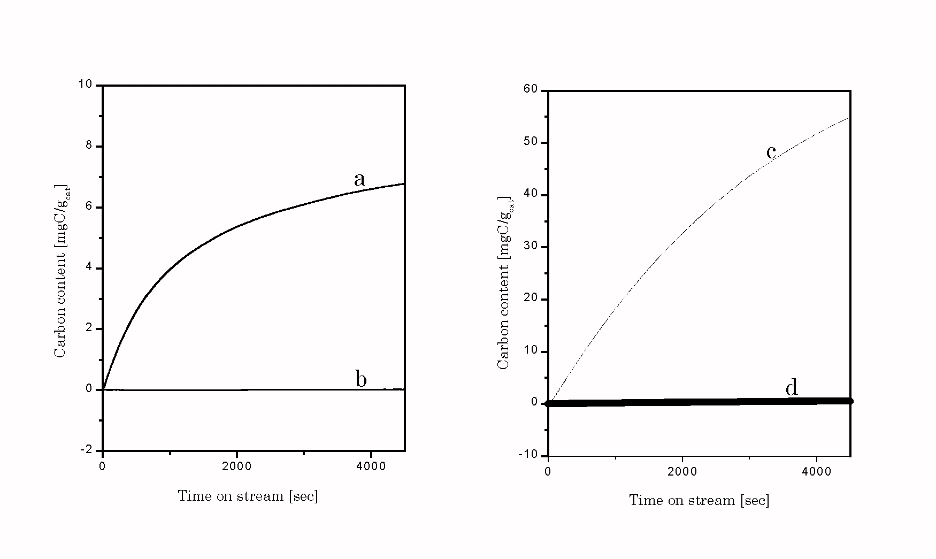As shown in figure 1, temperature gravimetric analysis(TGA) were performed for the dynamic analysis of carbon formation during CO₂ reforming of CH₄ on modified and unmodified nickel catalyst. To further elucidate the role of manganese itself, Ni-Mn-Al₂-O₃ catalyst (mole ratios Ni:Mn:Al=1:1:6) and Ni(17wt%)-Al₂O₃ were prepared by coprecipitation and tested. The sample weight was increased linearly with the time on stream over commercial catalyst (ICI) and Ni(17wt%)-Al₂O₃. But no carbon was accumulated on Mn(3wt%)/ICI and Ni-Mn-Al₂O₃ at 923K. It was found that Mn-addition to Ni/Al₂O₃ showed excellent resistance to carbon deposition in the CO₂ reforming of methane. The amount of carbon deposition was Ni(17wt%)-Al₂O₃ > ICI ≫ Mn(3wt%)/ICI ≈ Ni-Mn-Al₂O₃ under our reaction conditions.
Figure 1. Carbon content of various catalysts versus time on stream by TG analysis at 650ºC during CH₄-CO₂ reaction: Catalyst:0.015g; CH₄/CO₂/N₂=1/1/2; flow rate: 400ml/min. a:fresh ICI46-1; b:Mn(3wt%)/ICI; c: Ni(17wt%)/Al₂O₃; d:Ni-Mn-Al₂O₃(mole ratios 1:1:6)

A comparison of fresh catalyst chemisorption results for Ni-Mn-Al₂O₃ with other catalyst of similar concentrations[Ni(17wt%)Al₂O₃, ICI] shows Ni-Mn-Al₂O₃ to have much lower H/Ni ratio. The BET surface area of Mn-added Ni/Al₂O₃ is two to three times lower than that of Ni-Al₂O₃, however, so that larger nickel particles might be expected from the Mn-promoted samples. X-ray diffraction measurements on the Mn-added Ni-Al₂O₃ samples provided some indication for a metal-support interaction although the evidence was not conclusive. For Ni-Mn-Al₂O₃ prepared by coprecipitation, XRD of the 1073 K-reduced sample shows sharp peaks due to Ni metal. Estimation of the nickel particle size by X-ray line broadening on the nickel peak at 2θ of 44.3º gave a value of 39nm. Using the surface-to-volume relationship, 1=6/sd for particle size and assuming the value of 0.068nm² for the area of nickel atom, particle size of 138nm is calculated from H₂ adsorption on the fresh catalyst. The comparison of XRD and chemisorption results suggests that chemisorption is suppressed because adsorption results are indicative of a larger particle size than is determined from XPD. Thus, the interaction of nickel metal and manganese oxide can affect both catalytic activity and activity maintenance by inducing the migration of MnO_{x} species to the metal surface. MnO_{x} species formed during reduction decorate the metal particle surfaces, thereby geometrically destroying large ensembles of nickel atoms necessary for carbon deposition. Also, the sites created at the metal-MnO_{x} interface can promote catalyst performance.
Figure 2. Catalytic stability of Mn-promoted nickel catalysts under 650ºC and atmosphere of CH₄/CO₂=1/1; WHSV=36,000 l/(kg h); atmospheric pressure.

Carbon dioxide reforming involves the adsorption and dissociation of CO₂ on catalysts. Because CO₂ is an acidic gas, adsorption and dissociation of CO₂ may be improved with a basic catalyst[7,10-12]. The CO₂ temperature-programmed desorption(TPD) patterns of Mn-promoted Ni-Al₂O₃ catalyst and the reference Ni-Al₂O₃ reveals that the addition of Mn results in the increase of the amount of adsorbed CO₂ and the formation of high temperature peak. Presumably, the interaction of CO₂ and the catalyst can be enhanced by the moderate basicity of MnO and the creation of a large number of interfacial sites formed by MnO_{x} decorating Ni surfaces. Hence, carbon dioxide can be activated more easily on Mn-added Ni-Al₂O₃ catalyst and it plays an important role in the inhibition of carbon formation by removing intermediate carbon species.
The stability of catalytic activity was examined at 650ºC for Mn-promoted catalysts for an extended period of 100h. A space velocity of 36,000 l/(kgh) and reaction mixture of CH₄:CO₂=1:1 were employed. As shown in figure 2, CO₂ conversion slightly decreased during this period, however there was no severe coke deposition on these catalysts. According to the thermodynamic calculation done by Gadalla and Bower[2], high temperature operation above 870ºC is needed to prevent carbon deposition when the feed gas ratio of CH₄/CO₂ is 1 and the total pressure is 1 atm. Hence, the reaction conditions employed for experiments shown in figure 2 are rather severe in terms of carbon deposition. Further, other methods to reduce carbon deposition by sulfur passivation or replacement of nickel catalyst with noble metal catalysts have several restrictions as mentioned above. Hence, Mn-modified nickel catalyst looks promising as a coke-resistant nickel catalyst in CO₂ reforming of methane.

References
- A.T.Ashcroft, A.K. Cheetham, M.L.H.Green and P.D.F.Vernon, Nature 352, 225 (1991)
- A.M.Gadalla and B.Bower, Chem.Eng.Sci. 43, 3049 (1988)
- M.C.J.Bradford and M.A.Vannice, Catal.Rev.Sci.Eng. 41, 1 (1999)
- J.R.Rostrup-Nielsen and J.-H.B.Hansen, J.Catal. 144, 38 (1993)
- J.T.Richardson and S.A.Paripatyadar, Appl.Catal. 61, 293 (1990)
- J.S.Choi, K.I.Moon, Y.G.Kim, J.S.Lee, C.H.Kim and D.L.Trimm, Catal.Lett. 52, 43 (1998)
- T.Horiuchi, K.Samura, T.Fukui, Y.Kubo, T.Osaki and T.Mori, Appl.Catal.A 144, 111 (1996)
- D.L.Trimm, Catal.Rev.Sci.Eng. 16, 155 (1977)
- J.R.Rostrup-Nielsen and D.L.Trimm, J.Catal. 108, 155 (1977)
- Z.L.Zhang, V.A.Tsipouriari, A.M.Efstathiou, X.E.Verykios, J.Catal. 158, 51 (1996)
- O.Yamazaki, T.Nozaki, K.Omata and K.Fujimoto, Chem.Lett. 1953 (1992)
- Y.G.Chen, K.Tomishige, K.Yokoyama and K.Fujimoto, J.Catal. 184, 479 (1999)
- H.C.Dibbern, P.Olesen, J.R,Rostrup-Nielsen, P.B.Tottrup and N.R.Udengaard, Hydrocarbon Process. 65, 71 (1986)

