SBA를 이용한 반도체 제작 공정에 대한 스케쥴링

복 진광, 이 승권, 박 선원

한국과학기술원 화학공학과

SCHEDULING OF SEMICONDUCTOR FABRICATION PROCESSES
USING SEQUENCE BRANCH ALGORITHM (SBA)
Jinkwang Bok, Seungkwon Lee, and Sunwon Park
Department of Chemical Engineering, KAIST

Introduction
One of typical scheduling problems of wafer fabrication processes is addressed in this paper. Wafer fabrication starts with a silicon wafer, a few inches in diameter. The production process consists of imprinting several layers of chemical patterns on the wafer, and the final end product can be regarded as a multi-layered sandwich. The processing is done layer by layer. Each layer in turn requires several steps of individual processing, such as deposition, photolithography, etching etc. Moreover, many of the steps are repeated at several of the layers. The machines to perform these individual steps are very expensive. Currently a state-of-the-art plant costs about a billion dollars, and this cost is expected to increase dramatically as feature sizes decrease. The machines are not replicated but revisited by wafers for processing at different layers. A station is a set of machines that can do same process operation, so there may be one or more than one machines in the stations. The distinguishing characteristic of the wafer fabrication process is that lots re-visit several stations at several stages of their life. This type of a manufacturing system is called a re-entrant line. The main consequence of the re-entrant nature is that wafers at different stages of their life have to compete with each other for the same machines - reminiscent of cars at a traffic light. Thus, wafers can and do spend a considerable portion of their time simply waiting for machines, rather than actually being processed.
Lu et al. (1994) presented an aggregated model of the full scale semiconductor fabrication line (Fig. 1) consisting of 12 stations having one or more identical machines. The total number of stages is 60 and process flows are complicated with re-entrant flows as Figs. 1 shows. Table 1 shows the number of machines at each station, the number of visits to each station, and the processing times at each station.
The prevailing approach that can handle such a large size problem was simulation analysis for the purpose of minimizing the mean cycle time and the variation of cycle time (Wein, 1988; Lu et al., 1994). Though the simulation analysis may indirectly minimize the makespan, it cannot directly minimize the makespan of semiconductor scheduling problems. Even though minimizing the makespan is an important objective of manufacturing scheduling, it has rarely been challenged because the mathematical models can be made but they cannot be solved due to expensive computational requirements. For such large scale problems, Bok et al. (1997) and Lee et al. (1998) proposed sequence branch algorithm (SBA). The sequence branch algorithm (SBA) generates the schedule tree dynamically and searches for the optimum schedule among all the possible candidates so as to minimize the objective value of the system. A consistent model setup for various production policies makes it possible to solve complex jobshop scheduling problems. A heuristic function is inserted in the SBA for enhancing the efficiency for the large scale problems. Although the SBA has a defect that the solution may not be optimal, it can find a near optimum solution for large scale complex scheduling problems that are intractable by mathematical programming approaches.

Sequence Branch Algorithm (SBA)
The SBA is an algorithm to make the schedule tree dynamically, and find a near optimum complete schedule list. We define a schedule list pool as a group of frontier schedule lists that outward from the root of the schedule tree.
− d(n) : length of schedule list n (the number of schedule elements in the schedule list n)
− TR(n) : lower bound estimation of minimum remaining time, which is the sum of the smallest processing time of the remaining schedule elements
− f(n): objective function used in SBA, f(n)=MS(n)+h(n)
− MS(n): makespan of schedule list n
− h(n): heuristic function used in SBA, h(n) = w_{r} TR(n) - w_{d} d(n), where w_{r} is the weighting factor of TR(n), and w_{d} is that of d(n).

From the given information of a scheduling problem SBA works as follows:
- step 1 : Generate the initial schedule lists from an empty list by adding a schedule element for each job and save the schedule lists in the schedule list pool. The number of initial schedule lists are the same as the number of jobs, (i.e. |I|). For each stage j of product i at unit k, schedule element S_{ij}^{k} is generated, where k is selected by comparing processing time T_{ij}^{k}, and calculate f() for each schedule list.

- step 2 : Sort the schedule lists in the schedule list pool in an ascending order of f()

- step 3 : Remove the first schedule list from the schedule list pool. Denote this schedule list as n.

- step 4 : If d(n)=TOTLEN, print the results, and terminate.

- step 5 : Generate new schedule list n' by adding a schedule element S_{ij} for each job at the tail of the schedule list n and calculate f(n'). The schedule list n' should be a valid schedule list and the length of which is d(n)+1. Machine k for the last schedule element s in n' is determined at this step (The machine that can most early process jobs in schedule list n' is selected), and the start time and end time of schedule element s and f(n') are calculated by timing constraints (a)--(d)).

- step 6 : If there is a schedule list left that can be expanded from schedule list n, and then it to the schedule list pool, and go to step 5, otherwise go to step 2.

- step 7 : Go to step 2.
In the SBA, a heuristic function is used for improving the searching efficiency. TR(n) is a minimum remaining time that will be necessary to process the schedule elements that are not included in schedule elements n. As d(n) increases, the value of objective function f(n) decreases because of h(n). Therefore, h(n) makes the SBA prefer schedule lists that are nearer to the final node.
Table 1. Plant data for example (Lu et al., 1994)
Station | No. of machine | No. of visit | Processing data (hr)
1 | 4 | 14 | 0.5
2 | 3 | 12 | 0.375
3 | 10 | 7 | 2.5
4 | 1 | 1 | 1.8
5 | 1 | 2 | 0.9
6 | 2 | 3 | 1.2
7 | 1 | 1 | 1.8
8 | 4 | 8 | 0.8
9 | 1 | 3 | 0.6
10 | 9 | 5 | 3.0
11 | 2 | 3 | 1.2
12 | 2 | 1 | 2.5

Table 2. Computational statistic for example.
No. of lots | Iteration | CPU (sec) | MS | w_{d} | w_{r}
5 | 300 | 298.1 | 73.9 | 4 | 0.6
6 | 360 | 779.5 | 77.9 | 4 | 0.6
8 | 480 | 1629.5 | 83.8 | 4 | 0.6
10 | 600 | 3750 | 90 | 4 | 0.6
The scheduling results from the SBA are shown in Table 2. The numbers of jobs are from 5 to 10. Figure 2 gives the Gantt chart of the generated schedule with |I|=8.
The required number of binary variables in mathematical formulation for MILP based methods should amount to at least several 100,000, for example, |I| x |J| x |K| x (no. of time slots) = 10 x 60 x 40 x 10 = 240,000. Therefore this example is computationally very expensive to solve with MILP based methods. Even though the computation time increases as the number of repeating jobs grows, the results show the potential of providing the scheduling results for real production lines.

Acknowledgment
The authors would like to acknowledge partial financial support from the Korea Science Engineering Foundation through Automation Research Center at POSTECH.

Literature Cited
Bok, J.: Lee, S.; Park, S. Short-term Scheduling of Batch Processes Using STM (Sequence Tree Method), KIChE Fall meeting, 1997
Lee, S.; Bok, J.; Park, S. A New Algorithm for Large Scale Scheduling Problems: Sequence Branch Algorithm, Ind. & Eng. Chem. Res., submitted
Lu, S. C.; Ramaswamy, D.; Kumar, P. R. Efficient Scheduling Policies to Reduce Mean and Variance of Cycle-Time in Semiconductor Manufacturing Plants. IEEE Trans. Semicond. Manuf.1994, 7 (3), 374.
Wein, L. Scheduling Semiconductor Wafer Fabrication.IEEE Trans. Semicond. Manuf. 1988, 1, 115.
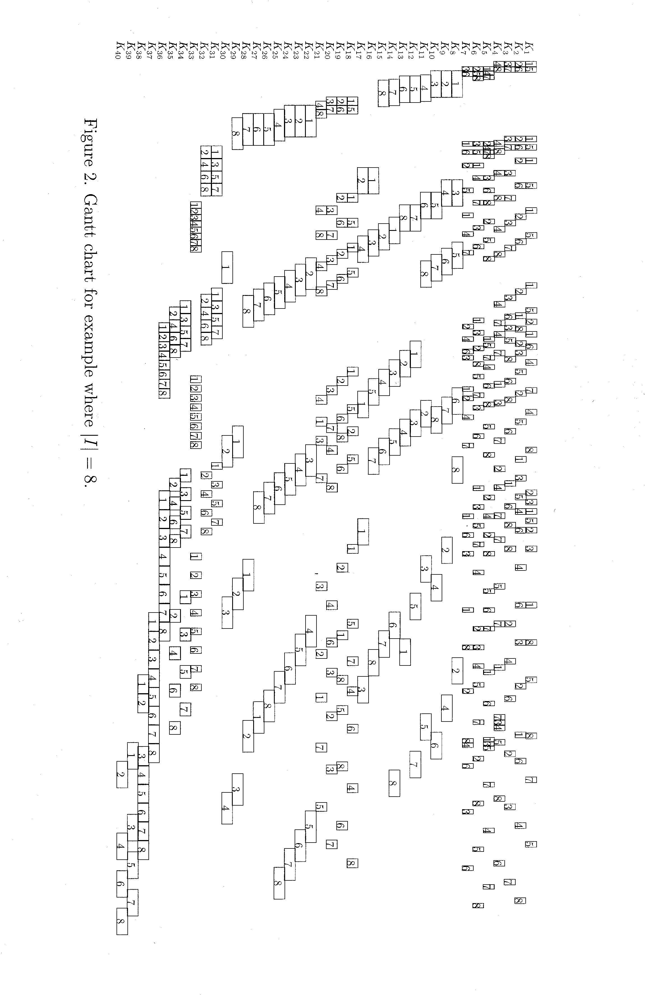
Figure 1. An aggregated model of production line by Lu et al. (1994).

