QCR/AFM을 이용한 나노영역의 점탄성특성 측증

김 종민, 한 대상, 장 상목, 村松宏*
동아대학교 화학공학과,일본 세이코 첨단기술연구소*

Scanning Nanometer scale Local viscoelasticity using QCR/AFM

Jong-min Kim, Dae-Sang Han, Sang-Mok Chang, Muramatsu. H*
Dept. of Chem. Eng., Dong-A Univ., Pusan, Korea
Advanced Technology Center, Seiko Inst Inc., Chiba 271, Japan*

Introduction
The field of scanning probe microscopy (SPM) has become firmly established over the past ten years in a broad range of fundamental science and real application. In its many forms, atomic force microscopy (AFM) allows the quantitative study of topography, adhesion, compliance, and friction, all correlated on the nanometer length scale¹. Recent approaches in SPMs have advanced on the simultaneous imaging methods of topography and physical properties or chemical properties such as pulsed forced microscopy (PFM) for mapping the electrical double layer force², chemical force microscopy (CFM) for imaging functional group distinction³, magnetic force microscopy for mapping magnetic dissipation⁴, and scanning near-field optical microscopy (SNOM) for imaging localized optical property ^{5,6}.
Quartz crystal resonators (QCR) are widely used to investigate surface/interface processes and physical property changes, e.g. to monitor mass transfer processes in electrochemistry ^{7,8}, to detect atomic scale friction on surfaces ⁹, to measure internal stress ¹⁰ and to detect phase transition ^{11,12} in thin organic film. Previous reports showed that the resonant frequency of a QCR does shift when the tip of a scanning tunneling microscopy (STM) ¹³ and a AFM ¹⁴ are scanned over the surface of QCR.
In this report, we will show the measuring method of local viscoelasticity combined with AFM and QCR.

Experiment
Figure 1 shows a schematic diagram of scanning system. The overall setup is similar with the report of Yamada et.al.¹⁴ except partial difference
The oscillation circuit used in this measurement is based on the previously reported paper by E. Hwang and Y. Lim ¹⁵ though core circuit (oscillation part) for oscillation is redesigned. This circuit is using two-port (reference and work) oscillation circuit and can produce the differential (dF) of these two channels with frequency stability under 0.1 Hz/min. The cantilever used in this experiment was rectangular and made of SiN4 with force constant about 40 N/m. Two quartz crystals of 9 MHz (AT-cut, Au, prepared by sputtering method) are used in working and referential oscillators. The working quartz crystal is placed on the sample stage of the AFM (SPI 3700, Seiko Instruments Inc.). The difference of two oscillating frequencies is monitored by a frequency counter (TR5822 with gate time 0.005 s, Advantest), which has a D/A converter. The signals from photodetector, piezo scanner and the frequency counter are collected by the AFM controller through subinput channels of the AFM unit.
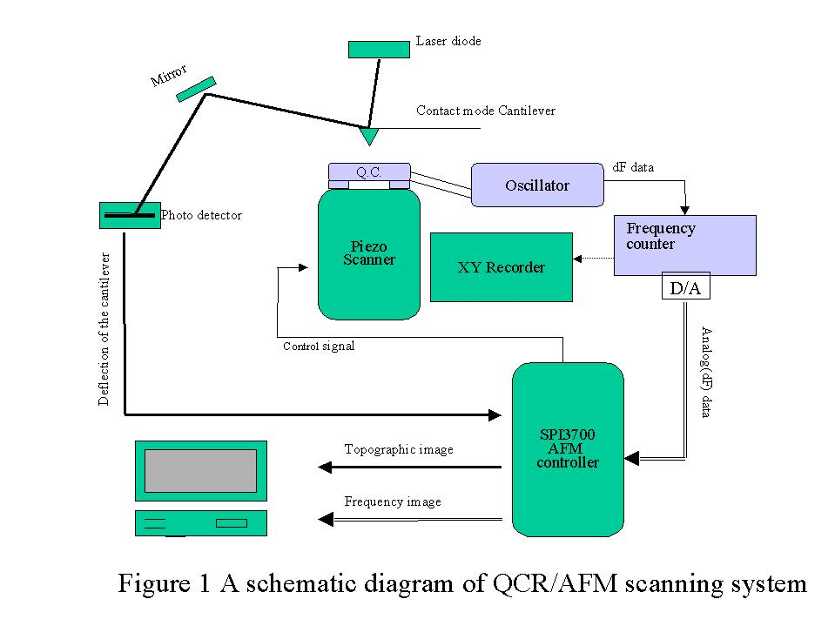
A X-Y recorder(RY-101A, RiKaDenKi Co.) was partly used for detecting the change of resonant frequency during the measurement of force curve. Polystyrene beads (PSBs, mean diameter:0.2 m) was spin coated and heat treated at the temperature of 300℃ during 2 hrs for enhancing the adhesion of PSBs on the quartz crystal.

Results and Disscussions
Figure 2 shows an AFM topographic image (a) and corresponding frequency shift image (b) of PS cast quartz crystal when the tip was scanned over the QCR surface in the constant force (3 N) mode at scan rate of 0.1 Hz. In Fig. 2(a), the PSBs are clearly observed but some intersection area of PSBs is not distinguished by the reason of vibration of quartz crystal. Other studies for topographic resolution in the intersection area result that this measurement system has about 30 nm of undistinguished distance especially when two kinds of viscoelastic film are contacted. Frequency shift image of Fig. 2(b) shows that it is possible to distinguish PSBs from gold electrode. In Fig. 2 (b), the PSBs are normally distinguished as lower amplitude except intersection area of PSBs. The intersection area in PSBs has slightly higher amplitude than that of gold or PSBs. This is mainly understood that the tip located between PSBs does not perfectly influence on the frequency of quartz crystal. The line profile analysis, which indicated as A in In Fig. 2, showed a frequency resolution of 80 nm assuming 80 % discrimination compared with topographic image to its resolution. In Fig. 2(b), the frequency shift difference between lowest position and highest position is about 0.15 Hz.
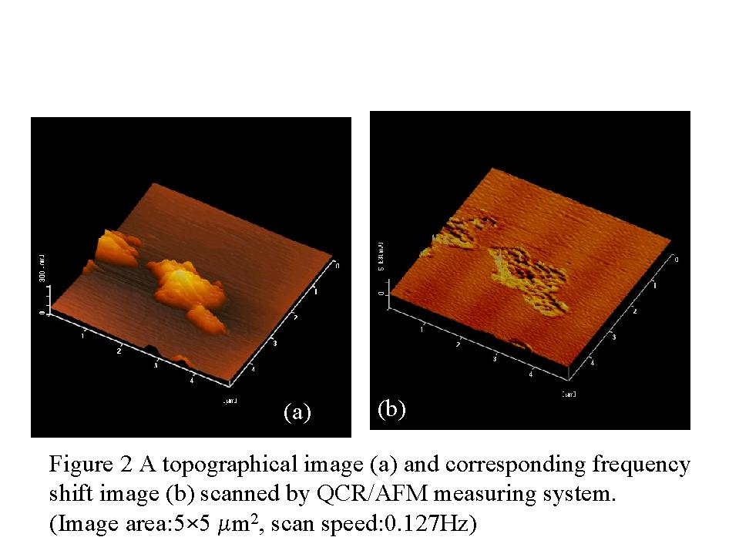

References
1.Scanning Probe Microscopy, edited by R. Wiesendanger (Cambridge University Press, 1994)
2.T. Miyatani, M. Horii, A. Rosa, M. Fujihira, and O. Marti, Appl.Phys.Lett. 71(18), 2632 (1997)
3.C. D. Frisbie, L. F. Rozsnyai, A. Noy, M. S. Wrighton, and C. M. Lieber, Science 265, 2071 (1994)
4.P. Gr tter, Y. Liu, P. LeBlanc, and U. D rig, Appl.Phys.Lett. 71(2), 279 (1997)
5.E. Betzig and J. K. Trautman, Science 257, 189 (1992)
6.H. Muramatsu, N. Chiba, K. Homma, K. Nakajima, T. Ataka, S. Ohta, A. Kusumi, and M. Hujihira, Appl.Phys.Lett. 66, 3245 (1995)
7.D. A. Buttry and M. D. Ward, Chem.Rev. 92, 1355 (1992)
8.H. Muramatsu, E. Tamiya and I. Karube, Anal.Chem. 60, 2142 (1988)
9.C. Daly and J. Krim, Phys.Rev.Lett. 76, 803 (1996)
10.K. E. Heusler, A. Grzegorzewski, L. J kel, J. Pietrucha, Ber.Bunsenges. Phys.Chem. 92, 218 (1988)
11.H. Muramatsu and K. Kimura, Anal.Chem. 64, 2502 (1992)
12.S.M. Chang, J.M. Kim, H. Muramatsu, T. Ataka, W.J. Cho and C.S. Ha, Polymer 37(16), 3757 (1996)
13.A. Sasaki, A. Katsumata, F. Iwata and H. Aoyama, Jpn.J.Appl.Phys. 33, L547 (1994)
14.R. Yamada, S. Ye and K. Uosaki, Jpn.J.Appl.Phys. 35, L846 (1996)
15.E.J. Hwang and Y.R. Lim, Bull.Korean.Chem.Soc. 17(1), 39 (1996)

