Wavelet Transform 의 이론과 적용: 압력 변동 신호 해석

박 성희, 강 용*, L. T. Fan**, 김 상돈
한국과학기술원 화학공학과,충남대학교 화학공학과*
Dept. of Chem. Eng., Kansas State University**

THEORY AND APPLICATION OF WAVELET TRANSFORM: ANALYSIS OF PRESSURE FLUCTUATION SIGNALS

Soung Hee Park, Y. Kang*, L. T. Fan** and Sang Done Kim
Department of Chemical Engineering, KAIST
Department of Chemical Engineering, Chungnam National University*
Department of Chemical Engineering, Kansas State University, USA**

INTRODUCTION
Recently, more powerful and accurate analysis tools are required because reliability, efficiency, safety, productivity and quality control in chemical industry have dramatically increased. More effort is being placed on improving the description and analysis of complex phenomena, from fundamental laboratory studies to industrial applications. Using traditional mathematical tools such as Fourier transform, we have studied the properties of a phenomenon either in the time domain or in the frequency domain. Although the Fourier transform and its inverse allow a passage from one domain to the other, it does not give a simultaneous view of the phenomenon in both domains. To overcome this limit on the analysis, the wavelet transform has been developed in recent years and has attracted growing attention from mathematicians as well as engineers.
In this presentation, we would like to review briefly some basic concepts and methods of this new approach. We will discuss the Fourier transform, followed by a discussion of wavelet theory and its application such as analysis of pressure fluctuations (Park et al., 1998).

Fourier transform
As well known, Fourier transform is a classical analysis tool widely used. The Fourier transform and its inverse establish a one-to-one relation between the time domain, function f(t), and the frequency domain, spectrum F(ω). The Fourier transform and its inverse are defined by:
$\begin{aligned}F(ω)=\int_{−∞}^{+∞}{f(t)e^{−iωt}\text{dt}} \\ f(t)=\frac{1}{2π}\int_{−∞}^{+∞}{F(ω)e^{iωt}dω}\end{aligned}$ (1)
Here the Fourier transform can be viewed as the decomposition of a function f(t) into a sum of frequency components, the coefficients of which are given by the inner product of f(t) and e^{iωt}. This transform uses sine and cosine as its bases to map a time domain function into frequency domain. Thus, the spectrum F(ω) shows the overall strength with which any frequency ω is contained in the function f(t). However, the Fourier transform does not show how the frequencies vary with time in f(t).
In Fourier transform, a function (time series) and its Fouier transform are two faces of the same information. The function displays the time information and hides the information about frequencies. For example, a function corresponding to a musical recording shows how the air pressure (produced by sound waves) changes with time, but it doesn’t tells us what frequencies-what notes-make up the music. The Fourier transform displays information about frequencies and hides the time information: the Fourier transform of music tells what notes are played, but it is extremely difficult to figure out when they are played.

A brief history of Wavelet Theory
In the last few years, interest in the subject of wavelets has grown dramatically, both in the theoretical and applied areas. The wavelet transform was first proposed as a tools for signal analysis by geophysicist Morlet (1982). The numerical success of Morlet’s work prompted Grossmann to make a detailed mathematical study of the continuous wavelet transform. The mathematical study of the discrete case started with the introduction of “frame” by Daubechies, Grossmann and Meyer (1986). Orthonormal bases of wavelets were discovered by Stromberg (1981). Mallat (1989) and Meyer realized that these orthonormal wavelet bases could be constructed systematically from a general framework named, multiresolution analysis, and ended the search for a so-called “miracle” to find an orthonormal basis (Daubechies, 1991).

Wavelet transform
Wavelet transform involves representing general functions in terms of simple, fixed building blocks at different scales and positions, which is named “wavelet” as first suggested by Yves Meyer and Jean Morlet. These billing blocks, actually are a family of “wavelet” functions, or in short the “wavelets”, are generated from a single fixed function called “mother wavelet” by translation and dilation (scaling) operations.

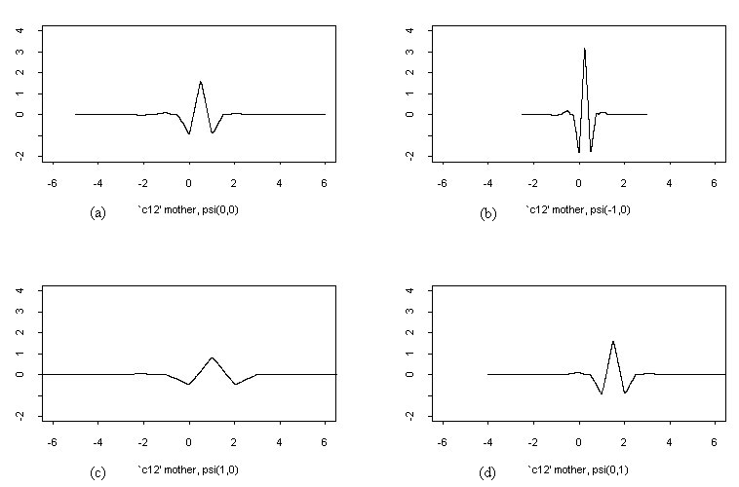
Fig. 1 The mother wavelet and its scaled and translated versions.
The basic building block, known as the “mother wavelet”, is the function Ψ(t) if its Fourier transform Ψ(w) satisfies:
$$\int_{\text{-¥}}^{\text{+¥}}{\frac{{\left|Y(w)\right|}^{2}}{w}\text{dw}=C_{Y}}\text{<+¥}$$
which is called the “admissibility condition”. Performing scaling and translation operations on this mother wavelet Ψ(t) creates a family of scaled and translated versions of the mother wavelet function,
$$Y_{a,b}(t)=\frac{1}{\sqrt{\left|a\right|}}Y\left(\frac{t−b}{a}\right)$$
where a is the scaling and b is the translation parameters respectively.
Figure 1(a) shows an example of a mother wavelet Ψ(t), the Coifman mother wavelet (Daubechies, 1992). In fact, the scaling operation is nothing more than performing “stretching” and “compressing” operations on the mother wavelet, which in turn can be used to catch the different frequency information of the function to be analyzed. The “compressing” version in Figure 1(b) is used to fit high frequency needs, and the “stretching” version in Figure 1(c) is for low frequency requirements. The translation operation, on the other hand, involves “shifting” of the mother wavelet along the time axis. Then the translated version is used to catch the time information of the function to be analyzed, shown in Figure 1(d). In this way, a family of scaled and translated wavelets are created according to the different scaling and translation parameters a and b, which serves as the base, the building blocks, for representing the function to be analyzed. We may notice that the shape of these functions looks like small waves, thus the name, “wavelet”.
The wavelet transform can use short windows at high frequencies and long windows at low frequencies resulting from the family of “wavelet” functions mentioned above. This is called “constant-Q” or constant relative bandwidth frequency analysis. Thus, wavelet transform are capable of “zooming-in” on short-lived high frequency phenomena, and “zooming-out” on long-lived low frequency phenomena. This is one of the main advantages of wavelet transforms over the Short-time Fourier transform. There are several types of wavelet transforms according to the type of input signal, time and scale parameters, namely, continuous, discrete, bi-orthogonal and semi-orthogonal, and orthonormal bases version.

Multiresolution Representation by Wavelet Transform
With multiresolution theory, Stephane Mallat linked orthogonal wavelets with the filters used in signal processing. In this approach, the wavelet is upstaged by a new function, the scaling function, which gives a series of pictures of the signal, each at a resolution differing by a factor of two from the previous resolution. In one direction, these successive images approximate the signal with greater and greater precision, approaching the original. In the other direction, they approach zero, containing less and less information.
In multiresolution representation, the given signal, B_{H}(t), is decomposed into its approximations and details at different resolutions by wavelet transform (Mallat, 1989). The approximation at resolution 2^{-j} of B_{H}(t), i.e., A_{-j}(n), is obtained as
$A_{\text{-j}}(n)\text{ = }2^{−j}\underset{−¥}{\overset{¥}{ò}}B_{H}(t)f(2^{\text{-j}}\text{t-n})\text{dt, j }Î\text{ Z; n }Î\text{ Z}$ (2)
where φ(t) is a scaling function. This scaling function is dilated by 2^{-j} and translated by n to yield the family of functions, φ(2^{-j}t - n), n=1,2,3,...,N, which constitute an orthonormal basis of the transform. The detail at resolution 2^{-j} of B_{H}(t), i.e., D_{-j}(n), is obtained as
$D_{\text{-j}}(n)\text{ = }2^{\text{-j}}\underset{−¥}{\overset{¥}{ò}}B_{H}(t)y(2^{\text{-j}}\text{t-n})\text{, j }Î\text{ Z; n }Î\text{ Z}$ (3)
where ψ(t) is the basic wavelet. Similarly, this wavelet is dilated by 2^{-j} and translated by n to yield the family of functions, ψ(2^{-j}t - n), n=1,2,3,...,N, thereby constituting another orthonormal basis of the transform; ψ(t) and φ(t) are associated in such a way that B_{H}(t) can be reconstructed from A_{-j}(n) and D_{-j}(n). Depending on the nature of application, various wavelet bases may be chosen. Additional information on the subject can be found elsewhere (Daubechies, 1988).
In practice, a physical measuring device can only sense a signal at a finite resolution. The approximation and detail of a signal are not directly obtained from Eqs. 2 and 3. Instead, a fast algorithm with a pyramidal structure has been developed to compute the multiresolution representation (Mallat, 1989). In this algorithm, the original discrete signal, A₀(n), n = 1,2,3,…,N, is first decomposed into its approximation, A₋₁(n), and its detail, D₋₁(n), n = 1,2,3,…,2⁻¹N, at the resolution, 2⁻¹ or 1/2. The approximation, A₋₁(n), may be further decomposed into its approximation, A₋₂(n), and its detail, D₋₂(n), n = 1,2,3,…, 2⁻²N, at the lower resolution, 2⁻², and so on. The algorithm requires that the number, N, of the original discrete signal, A₀(n), be dyadic, i.e., N = 2^{i}, i = 1,2,3,…. The approximation, A_{-j}(n), and the detail, D_{-j}(n), at the resolution, 2^{-j}, are calculated from A_{-(j-1)}(n) at the higher resolution, 2^{-(j-1)}. Thus, the original discrete signal can be represented by the approximation, A_{-J}(n), and the details, (D_{-j}(n))_{1 ≤ j ≤ J}, i.e., the signal, A₀(n), is represented by the set {A_{-J}(n), (D_{-j}(n))_{1≤ j ≤ J}}.

REFERENCES
- Daubechies, I. “Orthonormal basis of compactly supported wavelets.”, Comm. Pure & Applied Math., 41, 909-996 (1988).
- Daubechies, I. “The wavelet transform: a method for time-frequency localization.” Advances in Spectrum Analysis and Array Processing Volume I, Haykin, Simon Ed. Prentice Hall, Englewood Cliffs, NJ., 366-417 (1991).
- Daubechies, I. Ten Lectures in Wavelets Society for Industrial and Applied Mathematics, Philadelphia, Pennsylvania, 1992.
- Daubechies, I., A. Grossmann and Y. Meyer “Painless non-orthogonal expansions.” J. Math. Phys., 27, 293-309 (1986).
- Mallat, S. “A theory for multiresoltuion signal decomposition: the wavelet representation.” IEEE Trans. Pattern Analysis and machine intelligence, 11, 674-693 (1989).
- Morlet, J., G. Arens, I. Fourgeau, and D. Giard “Wave propagation and sampling theory.” Geophysics, 47, 203-236 (1982).
- Park, S. H., Y. Kang, L. T. Fan, and S. D. Kim, “Analysis of Pressure Fluctuations in a Fluidized Bed with Wavelet Transform.” 6th Asian Conference on Fluidized-Bed and Three-Phase Reactors, Kim, P. T. et al., in Print (1998).
- Stromberg, J. O. “A modified franklin system and higher order spline systems on Rn as unconditional bases for hardy spaces.” Conf. In Honor of A. Zygmund, Beckner, W et al. Eds II, 475-492 (1993).

