유기상-수상 경계면에서 2,6-Dimethylphenol의 산화성 축합반응에 있어서
계면활성 리간드의 영향

정영민, 안화승
인하대학교 화학공학과

Effects of Surface-Active Ligand in the Organic-Water Interfacial Oxidative
Coupling of 2,6-Dimethylphenol

Y.M.Chung, W.S.Ahn
Department of Chemical Engineering, Inha University, Inchon, Korea

INTRODUCTION
Biphasic reaction system in which a surface-active complexing agent or ligand is used to draw the catalyst to the organic-water interface where it effect the desired reaction can offer the following advantages over the corresponding homogeneous or heterogeneous reactions : the avoidance of the use of a toxic or environmentally-troublesome solvent, ease of catalyst recovery and substrate recycle, and the attainment of high reactivity, selectivity and reproducibility under mild reaction conditions.
In this work, we demonstrate the importance of surface-active ligand to attain faster reaction rate and higher molecular weight product for the biphasic oxidative coupling synthesis of Poly (2,6-dimethyl-1,4-phenylene oxide) (PPO). We have also studied corresponding homogeneous reaction for comparison purposes. Therefore, the results can show some fundamental differences between the biphasic and the homogeneous reaction.

EXPERIMENTAL
The reaction was carried out batchwise at 1 atm in a 500 ml three-necked flask reactor using chloroform-water as the biphasic mixture, a cuprous chloride-ligand complex as the coupling catalyst, ammonia as the base to deprotonate the substrate 2,6-dimethylphenol, sodium chloride as a solubility enhancer, and dodecyl sulfate, sodium salt (DSS) as the emulsifier with vigorous mechanical stirring.
A representative run was conducted as follows : The reactor was charged with 200 ml of a 1:1 (by volume) chloroform-aqueous solution mixture and the desired amount of the reaction ingredients, except for the catalyst. The reactor was placed in the constant-temperature water bath and purged with oxygen for about 10 minutes and then allowed to equilibrate to the set temperature, which was typically 25℃. The catalyst, cuprous chloride, was then added finally. After the reaction was initiated by starting the mechanical stirrer, the amount of oxygen uptake was monitored using a constant-pressure manometric unit. A similar procedure was used in carrying out the homogeneous reaction, except that no emulsifier was used and the biphasic reaction medium was replaced by chloroform.
After completion of the reaction, the organic and aqueous phase were separated out with an emulsion layer formed in between them upon standing overnight. Each of three portions was slowly dropped to excess volume of methanol solution containing approximately 1 % hydrochloric acid with vigorous stirring. The precipitated polymer was filtered off, washed with methanol, and dried under vacuum at 65℃.
Identification and characterization of the products were conducted using FT-IR and ¹H-NMR spectroscopies and DSC analysis was also performed to measure the glass transition temperature. The molecular weight distribution of the product was measured using GPC equipped with Styragel 4T/3T GPC column. The distribution of the copper in the reaction mixture was determined by ICP. After separating product by precipitating it in acidified methanol and filtering it, the copper containing solution was carefully evaporated to remove the solvent and the residue was digested in a concentrated nitric acid using CEM microwave sample preparation system set at 50℃ and 40 psi for a duration of 10 minutes.

RESULTS AND DISCUSSION
The standard reaction conditions are same as those of our previous study [1]. The variations of reaction rate and the distribution of copper with respect to different reaction conditions are represented in Tables 1-2, respectively. The results suggest that the attribute of the ligand used and the presence of ammonia significantly effect on the molecular weight of product as well as the reaction rate in both biphasic and homogeneous reactions.
In biphasic reaction with Cu-dibutylethylenediamine (DBEDA) complex as a catalyst, the presence of ammonia causes to increase copper concentration in aqueous phase. It can be presumed that a small portion of copper may be transferred to aqueous phase by coordination of ammonia which preferentially dissolves in aqueous phase. The short induction period indicates that the coordination competing of ammonia is negligible, and ammonia serves mainly as a deprotonation agent. Therefore, the highest reaction rate can be obtained with the Cu-DBEDA complex in the presence of ammonia. Without ammonia, the highly segregated copper at the interfacial area strongly supports that DBEDA has good surface-activity. The deficiency of ammonia in biphasic reaction may be favorable to increase the probability of the reaction to occur at the interfacial area. However, the reaction without ammonia progresses slower than that with ammonia, since DBEDA should function as not only the ligand itself but also a deprotonation agent, and the difference of copper concentration at the interfacial area is small between the reactions with or without ammonia. In one-phase mode, ammonia leads to precipitate Cu-DBEDA complex with bluish color, which makes the reaction medium heterogeneously and causes to decrease the frequency of encounter between the reactants, catalyst complex, and polymer chains. At the same time, because aqueous phase does not exist, the coordination competing of ammonia with ligand predominates. Both results may seriously reduce the reaction rate. Without ammonia, on the other hand, the reaction is free of coordination competing and can be considered as a homogeneous reaction. It should be noted that, though the reaction rate is considerably faster than that with ammonia, it is not as fast as that in the biphasic mode in which the reaction mostly occurs at the organic-water interfacial area and ammonia mainly deprotonate substrate. Another remarkable difference between one-phase and biphasic reaction is the cumulative oxygen uptake. The oxygen uptake in biphasic reaction nearly met with the stoichiometric amount of PPO formation independent of the presence of ammonia. On the other hand, almost 30% of excessive oxygen was additionally consumed in one-phase reaction. The relatively low PPO yield in one-phase reaction (82%) in contrast to that in biphasic reaction (95%) make it possible to presumed that the surplus oxygen consumption is due to either the formation of side products or low molecular weight polymer.
When triethyl phosphite (TEP) used as a ligand, the distribution of copper in the reaction mixture indicates that TEP has somewhat lower surface-activity than DBEDA which resulted in reducing the reaction rate in the biphasic reaction scheme. In one-phase reaction, though the reaction can be regarded as a homogeneous one, the coordination competing of ammonia due to the absence of aqueous phase predominates, and it makes the reaction rate slower than that in the biphasic reaction.
When pyridine is used as a ligand, the reaction in one-phase mode can be considered as a homogeneous reaction and is advantageous to attain fast reaction rate. However, analogous to the reaction using DBEDA as a ligand, if ammonia exists, bluish precipitation is occurred. Therefore, the system is no longer homogeneous and coordination competing is dominant, which leads to decrease the reaction rate seriously. Pyridine has lower surface-activity than DBEDA or TEP, and the distribution of copper is strongly dependent upon the presence of ammonia. In the absence of ammonia, Cu-pyridine complex preferentially dissolves in organic phase rather than aqueous phase in the biphasic reaction and there is no coordination competing. Therefore, the reaction mainly proceeds in organic phase where more than a half copper exists. However, since little Cu-pyridine complex dissolves in aqueous phase and the aqueous phase prevents pyridine from deprotonating substrate, the reaction proceeds very slowly. On the other hand, in the reaction with ammonia, the major role of ammonia in aqueous phase is confined as a deprotonation agent and coordination competing considerably decreases. These make it possible to attain higher reaction rate than that without ammonia. However, the biphasic reaction has little advantage over the homogeneous reaction in account of the low concentration of copper at the interfacial area.
Since the coupling site on a growing polymer chain becomes increasingly difficult to reach as the number of chain segments that can obstruct it rises, a higher collision frequency and a shorter diffusion pathlength are important to the formation of high molecular weight product. In biphasic reaction, fine emulsion that can hold more polymer chains in active suspension provides a large interfacial area and a shorter diffusion pathlength, thus, increases the frequency of encounter between the reactants, catalyst complex, and polymer chains. In this regard, biphasic reaction scheme is advantageous to attain high molecular weight product. The variations of the molecular weight with respect to reaction conditions are represented in Fig. 1. The results manifest that biphasic reaction with an appropriate surface-active ligand such as DBEDA is more favorable to formation of higher molecular weight polymer. The presence of ammonia also contributes to increase the molecular weight of product assuming that ammonia chiefly deprotonates the substrate and oligomers without coordination competing. When surface-active DBEDA is used without ammonia, though homogeneous reaction shows faster reaction rate than biphasic reaction, somewhat higher molecular weight of product can be obtained in biphasic reaction. In the case of pyridine which has low surface-activity, on the other hand, homogeneous reaction scheme is suitable to accelerate the reaction rate as well as to attain higher molecular weight product.

Table 1. Oxygen uptake rates in biphasic and one phase modes
Ligand | O₂ uptake rate (M/h)
Ligand | Biphasic mode |  | One phase mode
Ligand | With NH₃ | Without NH₃ | With NH₃ | Without NH₃
Triethyl phosphite | 0.38 | Negligible | 0.22 | Negligible
DBEDA | 4.73 | 2.11 | 0.32 | 3.93
Pyridine | 0.61 | 0.01 | 0.09 | 0.83

Table 2. Distribution of copper in the biphasic reaction mixture
Ligand | Condition | Phase | Copper distribution(%)
DBEDA | Without NH₃ | Organic phase | 5.1
DBEDA | Without NH₃ | Interfacial area | 88.9
DBEDA | Without NH₃ | Aqueous phase | 4
DBEDA | With NH₃ | Organic phase | 2.2
DBEDA | With NH₃ | Interfacial area | 75.6
DBEDA | With NH₃ | Aqueous phase | 19.4
Triethyl phosphite | With NH₃ | Organic phase | 27.4
Triethyl phosphite | With NH₃ | Interfacial area | 50.8
Triethyl phosphite | With NH₃ | Aqueous phase | 20.2
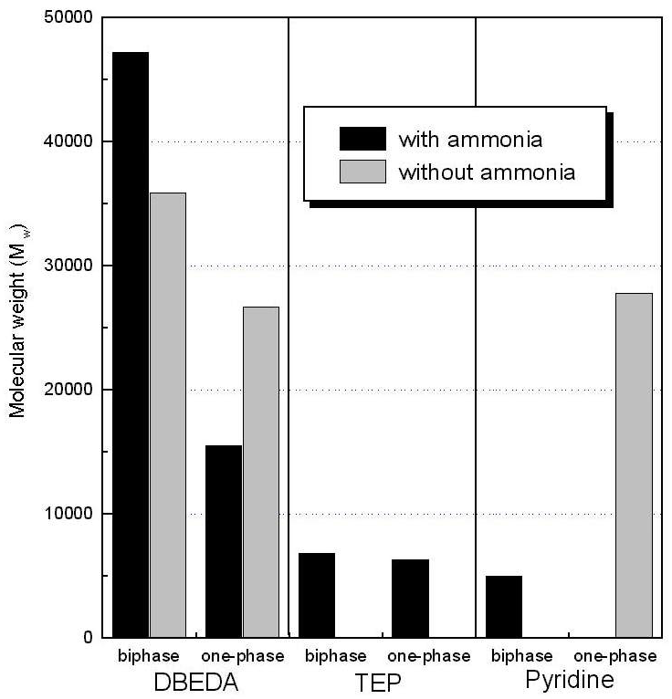  Pyridine  Fig.1. Molecular weight distributions of products  with respect to different conditions | Without NH₃ | Organic phase | 66.5
 | Without NH₃ | Interfacial area | 31.5
 | Without NH₃ | Aqueous phase | 0.6
 | With NH₃ | Organic phase | 0.5
 | With NH₃ | Interfacial area | 48
 | With NH₃ | Aqueous phase | 48.2

REFERENCE
1. Y.M.Chung, W.S.Ahn and P.K.Lim, J.Catal., submitted.

